**Integrating the Healthcare Enterprise**



**IHE Patient Care Coordination/Cardiology**

**Technical Framework Supplement**

**Cross Enterprise Cardiovascular Heart Team**

**Workflow Definition**

**(XCHT-WD)**

**Draft in preparation for Public Comment**

<The IHE Documentation Specialist will change the title to just “Draft for Public Comment” upon publication for public comment; leave “as is” until then.>

Date: April 24th, 2016

Author: Elena Vio ([evio@consorzioarsenal.it](mailto:evio@consorzioarsenal.it)), Mauro Zanardini ([mzanardini@consorzioarsenal.it](mailto:mzanardini@consorzioarsenal.it)), Glauco Brandolino (gbrandolino@consorzioarseanal.it)

Email: [pcc@ihe.net](mailto:pcc@ihe.net), [cardiotech@ihe.net](mailto:cardiotech@ihe.net)

*The following two pages are only here for Public Comment review of the Supplement Template itself and will be deleted prior to publishing this document for use as a template.*

**Supplement Template Review – What’s new?**

* The purpose of this version of the Supplement Template is to incorporate CDA Content Modules into the Supplement Template. This includes significant changes to the Volume 1 (Profiles) material and the introduction of Volume 3 (Content Modules).
* Note that eventually this Supplement Template and Volume 3 Technical Framework shell will be expanded to include other Content Module definitions such as DICOM (Section 7) and the next technology (Volume 8), etc.

**Supplement Template Public Comment Review Instructions**

Comments can be made at <http://ihe.net/ihetemplates.cfm>.

**Open Issues and Questions**

None**Foreword**

This is a supplement to the IHE PCC and IHE Cardiology Technical Framework <VX.X>. Each supplement undergoes a process of public comment and trial implementation before being incorporated into the volumes of the Technical Frameworks.

*<For Public Comment:>*This supplement is published on <Month XX, 201x> for Public Comment. Comments are invited and may be submitted at [http://www.ihe.net/<domain>/<domain>comments.cfm](http://www.ihe.net/Technical_Framework/public_comment.cfm). In order to be considered in development of the Trial Implementation version of the supplement comments must be received by <Month XX, 201X>.

*<For Trial Implementation:>*This supplement is published for Trial Implementation on <Month XX, 201X> and may be available for testing at subsequent IHE Connectathons. The supplement may be amended based on the results of testing. Following successful testing it will be incorporated into the <Domain Name> Technical Framework. Comments are invited and may be submitted at [http://www.ihe.net/<domain>/<domain>comments.cfm](http://www.ihe.net/%3cdomain%3e/%3cdomain%3ecomments.cfm).

This supplement describes changes to the existing technical framework documents and where indicated amends text by addition (bold underline) or removal (bold strikethrough), as well as addition of new sections introduced by editor’s instructions to “add new text” or similar, which for readability are not bolded or underlined.

“Boxed” instructions like the sample below indicate to the Volume Editor how to integrate the relevant section(s) into the relevant Technical Framework volume.

Replace Section X.X by the following:

<Instructions to authors are encapsulated in angled brackets as “< … >” and denoted with italicized text. These instructions are to be deleted in their entirety prior to publication.>

<This Supplement Template is intended for the development of new Profiles. Simple changes or updates to existing Supplements or Profiles should be made using the Change Proposal process. However, the addition of formal Options and significant changes may not be made using the Change Proposal process. In this latter case, this Supplement Template should be used, but a paragraph should be added to the Forward and to the Introduction to the Supplement explaining the situation. Also, see the Technical Framework Development section at <http://wiki.ihe.net/index.php?title=Process#Technical_Framework_Development> for more guidance on CPs versus new Supplements.>

<All of the sections in this document are required. Sections may not be deleted. The outline numbering is intended to be consistent across Profiles and across Domains, so do not adjust the outline numbering. If there is no relevant content for a section, simply state “Section not applicable”, but leave the numbering intact. Sub-sections may be added for clarity.>

<Use of capitalization: Please follow standard English grammar rules-only proper nouns and names are upper case. For example, “Modality Actor” is upper case, but “an actor which fulfills the role of a modality” is lower case. Do not use upper case to emphasize a word/topic.>

*<This Supplement Template includes templates for Volumes 1 (Profiles), 2 (Transactions), 3 (Content Modules), and 4 (National Extensions). Volumes 1, 2, and/or 3 are developed together for Public Comment and Trial Implementation submission. Volume 4, National Extensions, is typically developed at a later point in time, usually at Trial Implementation or later. Templates for all four volumes are included in this document for the sake of completeness. If you are beginning a new profile, you are strongly discouraged from using National Extensions and should instead focus on optional data sets or other alternatives. For more information, see* [*http://wiki.ihe.net/index.php?title=National_Extensions_Process*](http://wiki.ihe.net/index.php?title=National_Extensions_Process)*.>*

General information about IHE can be found at: [www.ihe.net](http://www.ihe.net)

Information about the IHE <Domain Name> domain can be found at: <http://www.ihe.net/Domains/index.cfm>

Information about the structure of IHE Technical Frameworks and Supplements can be found at: <http://www.ihe.net/About/process.cfm> and <http://www.ihe.net/profiles/index.cfm>

The current version of the IHE Technical Framework can be found at: <http://www.ihe.net/Technical_Framework/index.cfm>

Should a form of this stay after publication? Comments may be submitted on IHE Technical Framework templates at any time at <http://ihe.net/ihetemplates.cfm>. Please enter any comments/issues as soon as they are found. Do not wait until a future review cycle is announced.

Contents

Introduction to this Supplement 7

Open Issues and Questions 8

Closed Issues 8

Volume 1 – Profiles 9

<*Copyright Permission>* 9

<*Domain-specific additions>* 9

X <Profile Name (Acronym)> Profile 10

X.1 <Profile Acronym> Actors, Transactions, and Content Modules 11

X.1.1 Actor Descriptions and Actor Profile Requirements 12

X.1.1.2 <Actor Y> 12

X.2 <Profile Acronym> Actor Options 13

X.2.1 <Option Name> **Errore. Il segnalibro non è definito.**

X.3 <Profile Acronym> Required Actor Groupings 13

X.4 <Profile Acronym> Overview 15

X.4.1 Concepts 16

X.4.2 Use Cases 26

X.4.2.1 Use Case #1: <simple name> 26

X.4.2.1.1 <simple name> Use Case Description 27

X.4.2.1.2 <simple name> Process Flow 29

X.5 <Profile Acronym> Security Considerations 45

X.6 <Profile Acronym> Cross Profile Considerations 45

Appendices 46

A: Appendix A - Actor Summary Definitions 46

B: Appendix B - Transaction Summary Definitions 46

Glossary 49

Volume 2 – Transactions Errore. Il segnalibro non è definito.

3.Y <Transaction Name [domain acronym-#]> **Errore. Il segnalibro non è definito.**

3.Y.1 Scope **Errore. Il segnalibro non è definito.**

3.Y.2 Actor Roles **Errore. Il segnalibro non è definito.**

3.Y.3 Referenced Standards **Errore. Il segnalibro non è definito.**

3.Y.4 Interaction Diagram **Errore. Il segnalibro non è definito.**

3.Y.4.1 <Message 1 Name> **Errore. Il segnalibro non è definito.**

3.Y.4.1.1 Trigger Events **Errore. Il segnalibro non è definito.**

3.Y.4.1.2 Message Semantics **Errore. Il segnalibro non è definito.**

3.Y.4.1.3 Expected Actions **Errore. Il segnalibro non è definito.**

3.Y.4.2 <Message 2 Name> **Errore. Il segnalibro non è definito.**

3.Y.4.2.1 Trigger Events **Errore. Il segnalibro non è definito.**

3.Y.4.2.2 Message Semantics **Errore. Il segnalibro non è definito.**

3.Y.4.2.3 Expected Actions **Errore. Il segnalibro non è definito.**

3.Y.5 Security Considerations **Errore. Il segnalibro non è definito.**

3.Y.5.1 Security Audit Considerations **Errore. Il segnalibro non è definito.**

3.Y.5.1.(z) Actor Specific Security Considerations **Errore. Il segnalibro non è definito.**

<Appendix letter> Appendix Name Errore. Il segnalibro non è definito.

Volume 2 Namespace Additions Errore. Il segnalibro non è definito.

Volume 3 – Content Modules Errore. Il segnalibro non è definito.

5. Namespaces and Vocabularies Errore. Il segnalibro non è definito.

6. Content Modules Errore. Il segnalibro non è definito.

6.3.1 CDA Document Content Modules **Errore. Il segnalibro non è definito.**

6.3.1.D <Content Module Name (Acronym)> Document Content Module **Errore. Il segnalibro non è definito.**

6.3.1.D.1 Format Code **Errore. Il segnalibro non è definito.**

6.3.1.D.2 Parent Template **Errore. Il segnalibro non è definito.**

6.3.1.D.3 Referenced Standards **Errore. Il segnalibro non è definito.**

6.3.1.D.4 Data Element Requirement Mappings to CDA **Errore. Il segnalibro non è definito.**

6.3.1.D.5 <Content Module Name (Acronym, if appl)> Document Content Module Specification **Errore. Il segnalibro non è definito.**

6.3.1.D.5.1 <Header Element or Section Name> <Vocabulary Constraint or Condition> **Errore. Il segnalibro non è definito.**

6.3.1.D.5.2 <Header Element or Section Name> <Vocabulary Constraint or Condition> **Errore. Il segnalibro non è definito.**

6.3.1.D.5.3 <Header Element or Section Name> <Vocabulary Constraint or Condition> **Errore. Il segnalibro non è definito.**

6.3.1.D.5.4 <Header Element or Section Name> <Vocabulary Constraint or Condition> **Errore. Il segnalibro non è definito.**

6.3.1.D.5.1 <Template Title name> <Vocabulary Constraint or Condition> **Errore. Il segnalibro non è definito.**

6.3.1.D.5.2 <Template Title name> <Vocabulary Constraint or Condition> **Errore. Il segnalibro non è definito.**

6.3.1.D.6 <Document and Acronym Name> Conformance and Example **Errore. Il segnalibro non è definito.**

6.3.2 CDA Header Content Modules **Errore. Il segnalibro non è definito.**

6.3.2.H <Header Element Module Name> Header Content Module **Errore. Il segnalibro non è definito.**

6.3.2.H.1 <Description Name> <e.g., Responsible Party> <Specification Document *or* Vocabulary Constraint> **Errore. Il segnalibro non è definito.**

6.3.2.H.2 <Description Name> <Specification Document OR Vocabulary Constraint> **Errore. Il segnalibro non è definito.**

6.3.2.H.3 <Description Name> <Specification Document OR Vocabulary Constraint> **Errore. Il segnalibro non è definito.**

6.3.3 CDA Section Content Modules **Errore. Il segnalibro non è definito.**

6.3.3.10.S <Section Module Name> - Section Content Module **Errore. Il segnalibro non è definito.**

6.3.3.10.S.1 <Data Element or Section Name> <Condition, Specification Document, or Vocabulary Constraint> **Errore. Il segnalibro non è definito.**

6.3.3.10.S.2 <Data Element or Section Name> <Condition, Specification Document, or Vocabulary Constraint> **Errore. Il segnalibro non è definito.**

6.3.3.10.S.3 <Data Element or Section Name> <Condition, Specification Document, or Vocabulary Constraint> **Errore. Il segnalibro non è definito.**

6.3.3.10.S Medical History - Cardiac Section 11329-0 **Errore. Il segnalibro non è definito.**

6.3.4 CDA Entry Content Modules **Errore. Il segnalibro non è definito.**

6.3.4.E <Entry Content Module Name> Entry Content Module **Errore. Il segnalibro non è definito.**

6.3.4.E.1 Simple Observation (wall motion) Vocabulary Constraints **Errore. Il segnalibro non è definito.**

6.3.4.E.2 Simple Observation (wall morphology) Constraints **Errore. Il segnalibro non è definito.**

6.4.3.E Result Observation - Cardiac **Errore. Il segnalibro non è definito.**

6.4 Section not applicable **Errore. Il segnalibro non è definito.**

6.5 <Domain Acronym> Value Sets **Errore. Il segnalibro non è definito.**

6.5.x <Value Set Name> <oid> **Errore. Il segnalibro non è definito.**

6.5.1 Drug Classes Used in Cardiac Procedure 1.3.6.1.4.1.19376.1.4.1.5.15 **Errore. Il segnalibro non è definito.**

Volume 4 – National Extensions Errore. Il segnalibro non è definito.

4.I National Extensions for <Country Name or IHE Organization> **Errore. Il segnalibro non è definito.**

4.I.1 Comment Submission **Errore. Il segnalibro non è definito.**

4.I.2 IHE-<Country name> Scope of Changes **Errore. Il segnalibro non è definito.**

4.I.2.1 <Profile Name><Profile Acronym> **Errore. Il segnalibro non è definito.**

4.I.2.1.1<Profile Acronym> <Type of Change> **Errore. Il segnalibro non è definito.**

4.I.2.1.2<Profile Acronym> <Type of Change> **Errore. Il segnalibro non è definito.**

4.I.2.2 <Profile Name><Profile Acronym> **Errore. Il segnalibro non è definito.**

4.I.2.2.1<Profile Acronym> <Type of Change> **Errore. Il segnalibro non è definito.**

4.I.2.2.2<Profile Acronym> <Type of Change> **Errore. Il segnalibro non è definito.**

<Note: The Introduction, and Open and Closed Issues sections below (up to the “Volume 1” heading) of this document will be deleted prior to inclusion into the Final Text version of the Technical Framework volumes.>

<Note: There are editing conventions, such as diagram numbering and how to use Microsoft Word tools, etc., at <http://wiki.ihe.net/index.php?title=Writing_Technical_Frameworks_and_Supplements>.Please review this prior to beginning a new Supplement. This is especially useful for first time authors.>

# Introduction to this Supplement

Cross Enterprise Cardiovascular Heart Team Workflow Definition Profile (XCHT-WD) is a profile built upon the ITI Cross Enterprise Document Workflow (XDW) Profile. It establishes a common set of rules related to process (workflow) focused on the collaboration of the members of a dynamic network of cardiovascular professionals that belong to different structures, called Heart Team (HT). The aim of HT is to facilitate appropriate decision making on the treatment or intervention of patients and to better manage the knowledge exchange.

The definition of a workflow with fixed rules and task is needed in a cross enterprise scenario in which many actors are involved in the same process. The workflow is applicable to many different sharing infrastructures. However, this document presents specific XDS.b based use-cases.

In Volume 1, we present the typical use-cases, describing many possible evolutions of the related workflow. We define the Workflow Participants involved and their responsibilities within the workflow itself.

In Volume 2, we explain how to use an instrument the XDW Workflow Document (See ITI Technical Framework and supplements) to track and manage this workflow. In particular, we analyze in detail features of each step of the workflow, and rules to follow to go through these steps.

## Open Issues and Questions

None

## Closed Issues

None

<Note: The sections following this Introduction will eventually be added as Final Text to Volumes 1 – 4 of the Technical Framework. The material above this note will be deleted when this Supplement is moved to Final Text.>

Volume 1 – Profiles

## <*Copyright Permission>*

<General copyright licenses and permissions are listed in the IHE Technical Frameworks General Introduction. Add information on any standards referenced in the profile that are not already addressed in the permission section.>

Add the following to the IHE Technical Frameworks General Introduction Copyright section:

## <*Domain-specific additions>*

<Some domains have specific sections, added as subsections to Sections 1 or 2, in their Technical Frameworks. An example is RAD TF-1 Table 2.3-1 Integration Profiles Actors matrix. Because the Radiology domain has a large number of both Profiles and Actors, they have chosen to additionally represent this data in tabular form. These types of additions are allowed as long as they do not adjust the overall numbering scheme which needs to remain consistent across domains. If there are such additions, they should be included here.>

Add to Section …

<Reserve a subsequent section number in the current domain Technical Framework Volume 1 (DOM TF-1). Replace the letter “X” with that section heading number. This number should not change when this supplement is added to the Final Text Technical Framework. In this manner, references should be able to be maintained going forward.>

# X Cross-Enterprise Cardiovascular Heart Team (XCHT-WD) Profile

The XCHT-WD profile is a profile built upon XDW profile. It establishes a common set of rules related to a process (workflow) focused on the collaboration of the members of a dynamic network of cardiovascular professionals that belong to different structures, called Heart Team (HT). The aim of HT is to facilitate appropriate decision making on the treatment or intervention of patients and to better manage the knowledge exchange.

In many countries, for example Italy, resources are nationalized and some specializations such as Cardiac Surgery, are centralized in few highly-specialized hospitals. For this reason, many community hospitals need support from these specialized hospitals to guarantee an optimal treatment strategy. This profile focuses on enabling the enhanced collaboration between members of a multidisciplinary and dynamic HT that will analyze clinical cases involving cardiovascular diseases like stable CAD (Coronary Artery Disease), NSTEMI (non-ST elevation myocardial infarction), Cardiogenic Shock (CS), and aortic valve disease to ensure whole population has access to specialists. The main output of the HT is a report containing the collective clinical observations, findings, conclusions and recommendations for further treatment or intervention of the patient.

The management of the workflow related to clinical processes is a critical component in establishing an effective use of the HT. It is critical that different types of documents and information are easily accessible while the HT is making its evaluation. IHE ITI has defined the Cross-Enterprise Document Workflow (XDW) profile which will be leveraged as the infrastructure for these cardiology specific workflows. This XCHT-WD profile will define the cardiology specific workflow definition for the HT. This HT will be based on the XDW infrastructure, including the exchange of critical information needed by the HT for its clinical workflow processes. This profile needs to be supported by

* XDS.b and XDS-I profiles to allow for the sharing of clinical documents and workflow documents
* DSUB profile to allow for the notification of availability

XCHT-WD profile will be one alternative to help to fill the gap in workflow management, providing links for relevant/required clinical information to specific workflow tasks of the HT.

This workflow is involved in many clinical and organizational processes for its important role in the process of digitalization and sharing of information. The definition of a workflow with fixed rules and tasks is needed in a cross enterprise scenario in which many participants are involved to support a referral process

## X.1 XCHT-WD Actors, Transactions, and Content Modules

This section defines the actors, transactions, and/or content modules which are required to implement this profile. General definitions of actors are given in the Technical Framework General Introduction Appendix A at <http://www.ihe.net/Technical_Framework/index.cfm>.

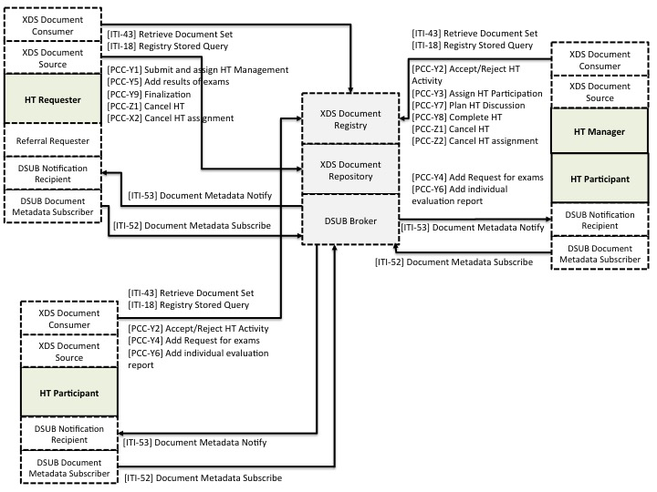

Figure X.1-1: XCHT-WD Actor/Transaction Diagram

Figure X.1-1 shows only the actors and transactions involved in the creation, updating and sharing of Heart Team Workflow Document, in order to allow a better readability of the figure. Transactions and actors involved in the creation and sharing of clinical documents, images, videos etc are not showed in this figure.

Table X.1-1 lists the transactions defined in this profile for each actor directly involved in the XCHT-WD Profile. To claim support of this Profile, an implementation of an actor must perform the required transactions (labeled “R”) and may support the optional transactions (labeled “O”). Actor groupings are further described in Section X.3.

<Actors from other profiles represented in dotted boxes, such as Actor C in the example above, should not be listed in Table X.1-1.>

Table X.1-1: XCHT-WD Profile - Actors and Transactions

| Actors | Transactions | Optionality | Section in Vol. 2 |
| --- | --- | --- | --- |
| HT Requester | [PCC-Y1] Submit and assign HT Management | R |  |
| [PCC-Y5] Add more clinical information | R |  |
| [PCC-Y9] Finalization | R |  |
| [PCC-Z1] Cancel HT | R |  |
| [PCC-Z2] Cancel HT assignment | R |  |
| HT Manager | [PCC-Y2] Accept/Reject HT Activity | R |  |
| [PCC-Y3] Assign HT Participation | R |  |
| [PCC-Y7] Plan HT Discussion | R |  |
| [PCC-Y8] Complete HT | R |  |
| [PCC-Z1] Cancel HT assignment | R |  |
| [PCC-Z2] Cancel HT | R |  |
| HT Participant | [PCC-Y2] Accept/Reject HT Activity | R |  |
| [PCC-Y4] Add Request of more clinical information | R |  |
| [PCC-Y6] Add individual evaluation report | R |  |

### X.1.1 Actor Descriptions and Actor Profile Requirements

Normative requirements are typically documented in Volume 2 (Transactions) and Volume 3 (Content Modules). Some Integration Profiles, however, contain requirements which link transactions, data, and/or behavior. Those Profile requirements are documented in this section as normative requirements (“shall”).

#### X.1.1.1 Heart Team Requester

The Heart Team Requester (HT Requester) is responsible for initiating the workflow of HT process. It initiates the XCHT-WD.

The HT Requester is responsible for assigning the management of HT to a HT Manager actor initiating the Assign HT Management transaction.

The HT Requester is responsible for making available more clinical information (reports, images or eReferral workflow) that HT Participants requires as part of the Add results of exams Transaction, to all members of HT.

The HT Requester is responsible for completing the workflow by receiving the Final Report and acknowledging the receipt of the report, and making available also new clinical results if requested as part of the Finalization transaction. This transaction closes the workflow.

#### X.1.1.2 Heart Team Manager

The Heart Team Manager (or HT Manager) is responsible for accepting/refusing the management of HT received from HT Requester initiating the Accept/Reject HT Management transaction.

HT Manager is responsible for staffing of HT initiating Assign HT Participation transaction. The process of defining the list of participants is outside the scope of this profile.

The HT Manager is also responsible for performing the HT, deciding the date and time of videoconferences, initiating Plan HT Discussion transaction, and creating Final Report as part of the Perform HT evaluation transaction.

#### X.1.1.3 Heart Team Participant

Heart Team Participant (HT Participant) is responsible for accepting or refusing to participate in HT and possibly providing request of new exams and initiating the Accept/Reject HT. Participation transaction and Add Request of more clinical information transaction, and providing individual preliminary evaluation reports, which will be needed in preparation for HT discussion, initiating the Add Individual Preliminary Evaluation Report transaction. The HT participant also attends HT meetings.

## X.2 XCHT-WD Actor Options

None.

## X.3 XCHT-WD Required Actor Groupings

When a profile mandates that an Actor be grouped with another Actor(s), the mandated grouping requirement is defined in this section. The “grouped Actor”, specified as the second half of the pairing, may be from this profile or a different domain/profile. These mandatory groupings, plus pointers to further descriptions and content bindings, if necessary, are given in the table below.

An Actor from this profile (Column 1) must implement all of the required transactions and/or content modules in this profile ***in addition to*** all of the transactions required for the grouped actor (Column 2). If this is a content profile, and actors from this profile are grouped with actors from a workflow or transport profile, “content bindings” required by the transport profile may be defined to describe how data from the content module is mapped into data elements from the workflow or transport transactions.

In some cases, required groupings are defined as at least one of an enumerated set of possible actors; this is designated by merging column one into a single cell spanning multiple potential grouped actors. Notes are used to highlight this situation.

Section X.5 describes some optional groupings that may be of interest for security considerations and section X.6 describes some optional groupings in other related profiles.

The grouping of XDW actors with each of the XCHT-WD actors is specified in table X.3-1. These XDW actors support the creation, consumption and update of the XDW workflow document, which is the shared data structure, that tracks the evolution of the workflow. This allows the workflow definition actors at any point in the workflow to access the most current status of the workflow and share the tasks performed with all other workflow definition actors.

Note: See IHE ITI TF-1: Section 30.3 (XDW Supplement) for other groupings that are needed for the XDW Actors to permit sharing of a Workflow Document with IHE XDS, XDR or XDM Profiles.

XCHT-WD actors shall be grouped with DSUB actors to grant an interoperable system for task status update notification. The DSUB infrastructure is intended to provide specific notifications to the participants of the HT using a XDS.b environment with a XDW infrastructure for workflow sharing infrastructure.

Table X.3-1: XCHT-WD Required Actor Groupings

| XCHT-WD Actor | Actor to be grouped with | TF Volume and Section | Content Bindings Reference |
| --- | --- | --- | --- |
| HT Requester | XDW Content Creator | ITI TF-1: 30.1.1 | ITI TF-3:5 |
| XDW Content Updater | ITI TF-1: 30.1.3 | ITI TF-3:5 |
| XDW Content Consumer | ITI TF-1: 30.1.2 | ITI TF-3:5 |
| XDS Document Source | ITI TF-1: 10.1.1.1 | -- |
| XDS Document Consumer | ITI TF-1: 10.1.1.2 | -- |
| DSUB Document Metadata Subscriber | ITI TF-1: 26.1.1.2 | -- |
| DSUB Notification Recipient | ITI TF-1: 26.1.1.4 | -- |
| HT Manager | XDW Content Updater | ITI TF-1: 30.1.3 | ITI TF-3:5 |
| XDW Content Consumer | ITI TF-1: 30.1.2 | ITI TF-3:5 |
| XDS Document Source | ITI TF-1: 10.1.1.1 | -- |
| XDS document Consumer | ITI TF-1: 10.1.1.2 | -- |
| XDS-I Image Document Consumer | RAD TF-1: 18 | -- |
| DSUB Document Metadata Subscriber | ITI TF-1: 26.1.1.2 | -- |
| DSUB Notification Recipient | ITI TF-1: 26.1.1.4 | -- |
| HT Participant | XDW Content Updater | ITI TF-1: 30.1.3 | ITI TF-3:5 |
| XDW Content Consumer | ITI TF-1: 30.1.2 | ITI TF-3:5 |
| XDS Document Source | ITI TF-1: 10.1.1.1 | -- |
| XDS document Consumer | ITI TF-1: 10.1.1.2 | -- |
| DSUB Document Metadata Subscriber | ITI TF-1: 26.1.1.2 | -- |
| DSUB Notification Recipient | ITI TF-1: 26.1.1.4 | -- |
| XDS-I Image Document Consumer | RAD TF-1: 18 | -- |

**Note 1: The XCHT-WD actor defined in this profile, in order to receive notifications, SHALL be grouped with at least one of the this two actors: DSUB Notification Recipient , DSUB Notification Puller.**

The following sections identify how DSUB functionalities shall be used to notify workflow Status updates. Other additional uses of DSUB filters for subscriptions are not forbidden, however the following shall be considered implementation requirements for XCHT-WD actors.

## X.4 XCHT-WD Overview

In many countries, the high healthcare specialization is centralized in few hospitals in order to make limited health resources widely available, because they are often very expensive. For example, in the cardiac field, there are many community hospitals without cardiac surgical services. Community hospitals need remote support of many professionals that work in other structures, in order to guarantee an optimal treatment strategy in a specific clinical situation such as stable CAD (Coronary Artery Disease), NSTEMI (non-ST elevation myocardial infarction), Cardiogenic Shock (CS), or aortic valve disease. Many countries are moving to create dynamic and multidisciplinary teams of professionals who are able to perform a complete analysis of the more complex clinical cases. We are grateful for this network of hubs. The team is typically called “Heart Team” (HT) in the cardiac arena and they are responsible for the management of the clinical pathway for patients with cardiac disease. However, it is difficult to manage and coordinate remote interaction among healthcare professionals involved in an Heart Team, that belong to different structures and that use different systems. The aim of HT is to facilitate appropriate decision making on the treatment or intervention used for patients. For this reason, we need a flexible common workflow that define rules and activities of each systems used by the members in the management of HT.

The XCHT-WD profile defines the workflow, intended as a common set of rules and activities, related to the collaboration of the members of a dynamic network of cardiovascular professionals that belong to different hospitals, called Heart Team (HT), to facilitate appropriate decision making on the treatment or intervention used for patients and to better manage the knowledge exchange. This profile is based on XDW profile.

**X.4.1 Concepts**

### X.4.1.1 Heart Team

Heart Team (HT) is a dynamic network of professionals in the cardiovascular field. They can belong to different hospitals, and they aim to facilitate appropriate decision making on the treatment or intervention of patients and to better manage the knowledge exchange.

Examples of cardiovascular diseases that can require the input of the HT according to Class I recommendation as required by American and European professional organizations guidelines are:

* complex coronary artery disease1, 2
* Severe valvular heart disease (Aortic and/or Mitral valve)3
* Other Cardiovascular diseases that can benefit from the discussion with a HT approach are:

- heart rhythm disorder (arrhythmia)

- Advanced or Chronic Heart Failure

- Cardiogenic Shock

Note 1: 2011 ACCF/AHA/SCAI Guideline for Percutaneous Coronary Intervention: a report of the American College of Cardiology Foundation/American Heart Association Task Force on Practice Guidelines and the Society for Cardiovascular Angiography and Interventions. Circulation. 2011;124:e574–e651.

Note 2: 2014 ESC/EACTS Guidelines on myocardial revascularization, The Task Force on Myocardial Revascularization of the European Society of Cardiology (ESC) and the European Association for Cardio-Thoracic Surgery (EACTS) Developed with the special contribution of the European Association of Percutaneous Cardiovascular Interventions (EAPCI). Eur Heart J. 2014 Oct 1;35(37):2541-619.

Note 3: Nishimura RA, Otto CM, Bonow RO, et al. 2014 AHA/ACC guideline for the management of patients with valvular heart disease: executive summary: a report of the American College of Cardiology/American Heart Association Task Force on Practice Guidelines. J Am Coll Cardiol 2014;63:2438–88. *Vahanian A, Alfieri O, Andreotti F, et al. Guidelines on the management of valvular heart disease (version 2012): the Joint Task Force on the Management of Valvular Heart Disease of the European Society of Cardiology (ESC) and the European Association for Cardio-Thoracic Surgery (EACTS). Eur J Cardiothorac Surg 2012; 42:S1–44.

#### X.4.1.2 HT Documents

In this section we present the documents involved in the HT process.

The HT process specifies the usage of document types in the table below:

|  |  |
| --- | --- |
| Document Types | Definition |
| **Workflow Document** | Technical document that contains a list of tasks that each actor carries out or assign to other actors, the owner of task, the list of documents that task needs in input and in output (in italic in this table), and all other information related to the task. This document have to be read by systems which translates contained workflow document in activities. The content of the below documents is outside the scope of this profile. |
| ***HT Request Document*** | Document that contains the reason for involvement of HT to discuss a clinical case. It can also contain clinical data on the state of patients. This document is requested in order to start the HT process. |
| ***Image Manifest*** | Document identifying the image set subject of the HT Request |
| ***Image Set*** | Clinical images referenced in the Image Manifest. |
| ***Clinical Documents*** | Clinical Document useful to make decision on clinical case. This may include the original Referral, a supporting Laboratory Report, Image Manifests and image reports of prior imaging studies. |
| ***Request of more information document*** | Document that contains the list of exams that HT participant suggests to carry out to provide all data useful to make decision |
| ***eReferral Workflow Document*** | Workflow document related to requested exams |
| ***Individual preliminary report*** | Individual preliminary report is the document that contains the evaluation of an HT Participant on the clinical case based on the available clinical Documents and Images, before the common discussion and before making decision. An Individual preliminary report is created for each HT participant. |
| ***Final Report*** | Final report is the document that contain the decision of HT and the list of exams required for the further treatment of the patient |

**X.4.1.3 XDW Workflow Definition Profile representation**

When a cardiologist from a Community Hospital decides that additional support to care for a patient is necessary, assistance from the HT will be requested. The HT is composed of professionals selected based on the specific clinical need of the case, including the originating cardiologist. This workflow profile will define how the manager of the HT is selected, how team members will be selected, and how the members collaborate to ensure the best possible outcome for the patient. The HT will analyse all the information that the originating physician has provided, and may require new exams/tests before a final decision is made. Each HT member will provide a preliminary evaluation. The HT may discuss the clinical case through a videoconference or through an exchange of text. The HT involvement concludes with a final report, containing the collective findings, conclusions and recommendations for further treatment or intervention of the patient. Meaningful documentation is included with this final decision.

This profile is built upon the ITI XDW Profile to manage the Cardiovascular Heart Team Workflow. XDS/XDS-I is the default underlying Document and Image Sharing Infrastructure. The Document Metadata Subscription (DSUB) profile provides the workflow and document availability notification infrastructure.

The Cross-Enterprise Cardiovascular HT modeled workflow tasks are represented in figure X.4.1.4-1 and are explained below.

1. HT Request Task: The HT Requester, where usually user is the patient’s cardiologist that requests the involvement of the HT to discuss the clinical case, initiates the HT to be performed. HT Requester traces in the workflow document the creation and sharing of HT Request Document (which includes all useful clinical documents or images as attachments or links) with the HT Manager.
2. HT Lead Task: An HT Manager (where a user can be a Cardiac Surgeon) can accept or reject the management of HT and therefore the take in charge of HT Request. Accepting or rejection is notified to the HT Request. This task can be repeated until an HT Manager takes charge of the HT Request.
3. HT Involvement Task: The HT Manager invites some HT Participants (where users can be for example another Cardiac Surgeon, or/and an Interventional Cardiologist involved in the treatment of the patient) to involve in HT. The HT Participants can accept or reject the invitation, and accepting or rejection is notified to the HT Manager. When the HT Participant accepts, it can order new exams and request new information useful for decision making to the HT Requester. The requests of new exams are notified to the HT Requester. All individual evaluation reports will be provided by each HT Participant and the HT Manager is notified on availability of these reports. The workflow document contains an HT Involvement Task for each HT Participant invited.
4. HT Preparation Task: HT Requester ensures the additional needed exams, tests, and information requested by the HT Participants are performed and provided to the HT through an eReferral workflow document. The workflow document contain an HT Preparation Task for each exams requested by the HT Participant.
5. HT Perform Task: The HT Manager can plan a videoconference with the HT Participants and the HT Requester so a common decision on the treatment of patient can be made, and the HT Requester and the HT Participants are notified. The output of this task is a final report that contains the HT treatment decision and potential orders for exams/tests needed for the treatment (for example, a diagnostic cath might be required in order to prepare operational room). The HT Requester and HT Participants are notified.
6. Finalization Task: the HT Requester retrieves the final report, and if need, it provides the results of exams required in final report through an eReferral workflow document. The HT Manager and the HT Participants are notified.

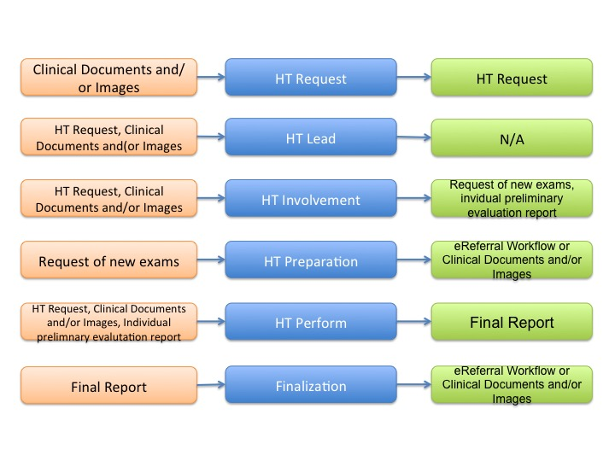

Figure X.4.1.3-1: Workflow Tasks for the Heart Team process

The XCHT-WD process flow, including the task states/status is shown in Figure X.4.1.4-2.

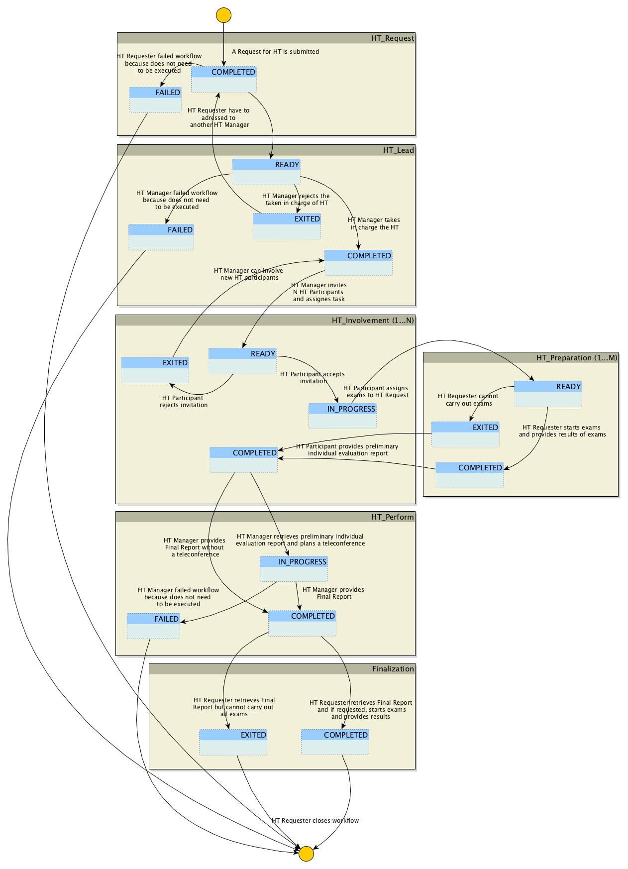

Figure X.4.1.3-2: Cross-Enterprise Cardiovascular HT Workflow Definition complete process flow

The following table X.4.1.4-1 lists the various documents that shall, conditionally, or may be referenced as either input or output documents for each task/status pair defined by the XCHT-WD.

The values used in the Option column are defined as follows:

**R:** Required. Compliant source systems shall provide the document as referenced.

**RE**: Required if present.

**C:** Conditional. Compliant source systems shall provide the document referenced if the document is available.

**O:** Optional. Compliant source systems may choose to provide the document reference.

**N/A:** Not Applicable.

|  |  |  |  |  |  |  |
| --- | --- | --- | --- | --- | --- | --- |
| **Task** | **Workflow Participant** | **Task Status** | **Input docs** | **Option** | **Output docs** | **Option** |
| HT_Request (1..1) | HT Requester | COMPLETED | Clinical Documents and images | R | HT Request | R |
| FAILED | N/A | - | N/A | - |
| HT_Lead (1..n)  n= number of HT Manager invited to manage HT | HT Manager | READY | Clinical Documents and images | R | N/A | - |
| HT Request | R |
| COMPLETED | N/A | - | N/A | - |
| EXITED | N/A | - | N/A | - |
| FAILED | N/A | - | N/A | - |
| HT_Involvement (1..m)  m=number of HT Participant invited to participate to HT | HT Participant | READY | Clinical Documents and images | R | N/A | - |
| HT Request | R |
| IN_PROGRESS | N/A | - | Referral Request | O |
| COMPLETED | eReferral Workflow Document | C if there is HT_preparation=COMPLETED | Individual preliminary evaluation report | R |
| EXITED | N/A | - | N/A | - |
| HT_Preparation (0..r)  r=number of requested exams | HT Requester | READY | Referral Requests | R | N/A | - |
| COMPLETED | N/A | - | eReferral Workflow Document or Clinical documents/ Images | R |
| EXITED | N/A | - | N/A | - |
| HT_Perform (1…1) | HT Manager | IN_PROGRESS | Clinical Documents and Images | R | N/A | - |
| HT Request | R |
| eReferral Workflow Document or Clinical documents/ Images | C if there is HT_preparation=COMPLETED |
| Individual preliminary evaluation report | R |
| COMPLETED | N/A | - | Final Report | R |
| FAILED | N/A | - | N/A | - |
| Finalization (1…1) | HT Requester | COMPLETED | Final Report | R | eReferral Workflow Document or Clinical documents/images | RE |
| EXITED | N/A | - | N/A | - |

Table X.4.1.3-1: Tasks/Documents related to the Cross-Enterprise Cardiovascular HT process

The Workflow Actors involved in the XCHT-WD process are shown with the workflow task/status transactions in Figure X.4.1.4-3.

A Workflow Participant Actor is an abstraction of system along with users involved in the XCHT process. They can be identified based on their roles in the process as one of four specific IHE Actors. Each of these workflow participants has specific rights and duties in the process. They drive the process from one step to another, performing determinate actions on the workflow.

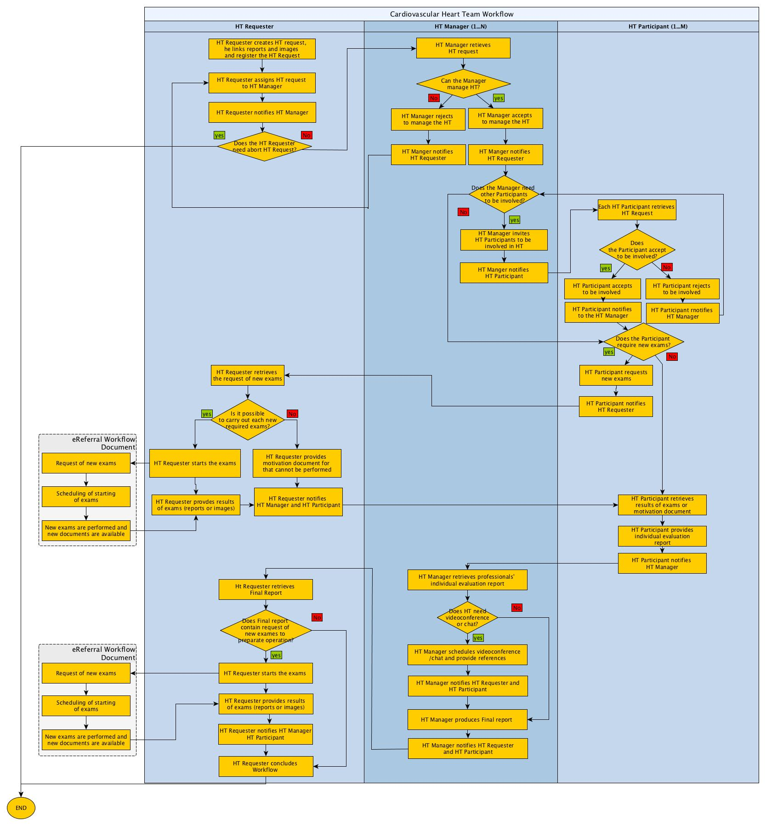

Figure X.4.1.3-3: XCHT-WD Actor Workflow Transitions Diagram

#### X.4.1.4 Delivery of Notifications

XCHT-WD actors are grouped with actors in the DSUB profile to enable sending notifications about workflow status updates.

The following sections identify how DSUB subscriptions should be used in the context of the Heart Team workflow by actors involved in the XCHT-WD profile. Other uses of DSUB filters for subscriptions are not forbidden.

#### X.4.1.4.1 Workflow Status Update Notification for the HT Requester

Once a Heart Team Workflow is submitted, the HT Requester may require progress notifications on the workflow.

The HT Requester would create a related subscription that identifies the specific Workflow Instance Id as a filter parameter for the creation of notifications for the patient just submitted. This subscription shall be submitted via transaction [ITI-52] Document Metadata Subscribe characterized by the following parameters:

* *TerminationTime =* unspecified. This allows to create a subscription without an expiration date/time;
* *topics* = “ihe:FullDocumentEntry”. This allows receiving notifications that convey the full documentEntry metadata related to the Workflow Document published.
* *Subscription Filter* = “urn:uuid:aa2332d0-f8fe-11e0-be50-0800200c9a66” (Subscriptions for DocumentEntry metadata). This allows to subscribe for documents published with specific metadata.
* *$XDSDocumentEntryReferenceIdList filter* = workflow Instance Id.

From this time, any update to the workflow document is notified to the HT Requester.

#### X.4.1.4.3 HT Lead Workflow Task Assignment Notification

The HT Requester assigns the management of HT to HT Manager. The Workflow Document updated by the HT Requester is published identifying the HT Manager as intended recipient for the submission (using the intendedRecipient submissionSet metadata). The HT Manager shall create a subscription characterized by the following parameters.

* *TerminationTime =* unspecified. This allows to create a subscription without an expiration date/time;
* *topics* = “ihe:SubmissionSetMetadata”. This allows receiving notifications that convey the submissionSet metadata, related to a submission of documents targeted to the HT Manager itself.
* *Subscription Filter* = “urn:uuid:868cad3d-ec09-4565-b66c-1be10d034399” (Patient-Independent Subscriptions for SubmissionSet metadata). This allows subscribing for submissions intended to a specific recipient.
* *$XDSDocumentEntryReferenceIdList filter* = workflow Instance Id.

From this time forward, any update of the workflow document notifies the HT Manager.

#### X.4.1.4.3 Workflow Status Update Notification for the HT Manager

Once a HT Manager accept to manage, the HT may require progress notifications on the workflow.

The HT Manager would create a related subscription that identifies the specific Workflow Instance Id as a filter parameter for the creation of notifications for the patient just submitted. This subscription shall be submitted via transaction [ITI-52] Document Metadata Subscribe characterized by the following parameters:

* *TerminationTime =* unspecified. This allows to create a subscription without an expiration date/time;
* *topics* = “ihe:FullDocumentEntry”. This allows receiving notifications that convey the full documentEntry metadata related to the Workflow Document published.
* *Subscription Filter* = “urn:uuid:aa2332d0-f8fe-11e0-be50-0800200c9a66” (Subscriptions for DocumentEntry metadata). This allows to subscribe for documents published with specific metadata.
* *$XDSDocumentEntryReferenceIdList filter* = workflow Instance Id.

From this time forward, any update of the workflow document notifies the HT Manager.

#### X.4.1.4.4 HT Involvement Workflow Task Assignment Notification

The HT Manager assigns the performance of HT to HT Participant. The Workflow Document updated by the HT Manager is published identifying the HT Participant as intended recipient for the submission (using the intendedRecipient submissionSet metadata). The HT Participant, once configured, shall create a subscription characterized by the following parameters.

* *TerminationTime =* unspecified. This allows to create a subscription without an expiration date/time;
* *topics* = “ihe:SubmissionSetMetadata”. This allows receiving notifications that convey the submissionSet metadata, related to a submission of documents targeted to the HT Participant itself.
* *Subscription Filter* = “urn:uuid:868cad3d-ec09-4565-b66c-1be10d034399” (Patient-Independent Subscriptions for SubmissionSet metadata). This allows subscribing for submissions intended to a specific recipient.
* *$XDSSubmissionSetIntendedRecipient* = the HT Participant actor. It is out of scope for this profile to define how to identify the HT Participant. This should be defined by local policies and by Affinity Domain configurations.

The HT Participant is notified when a HT Manager identifies the Participant to HT as intended recipient in the submission of the HT Workflow Document. The HT Participant integrates this request to its local workflow process.

#### X.4.1.4.5 Workflow Status Update Notification for the HT Participant

Once a HT Participant accept to be involved in the HT, there may be a require progress notifications on the workflow.

The HT Participant would create a related subscription that identifies the specific Workflow Instance Id as a filter parameter for the creation of notifications for the patient just submitted. This subscription shall be submitted via transaction [ITI-52] Document Metadata Subscribe characterized by the following parameters:

* *TerminationTime =* unspecified. This allows to create a subscription without an expiration date/time;
* *topics* = “ihe:FullDocumentEntry”. This allows receiving notifications that convey the full documentEntry metadata related to the Workflow Document published.
* *Subscription Filter* = “urn:uuid:aa2332d0-f8fe-11e0-be50-0800200c9a66” (Subscriptions for DocumentEntry metadata). This allows subscription for documents published with specific metadata.
* *$XDSDocumentEntryReferenceIdList filter* = workflow Instance Id.

From this point forward, any update to the workflow document notifies the HT Participant.

### X.4.2 Use Cases

Two completed use cases on HT collaboration are described in this profile. The first is based on a basic HT composed by the requester of support, an interventional cardiologist, and the clinician that can provide support and manage the HT. The second use case is related to a HT composed of the requester of support and many professionals. This is a complex cardiovascular clinical case. This complex use case also describes rejection of involvement in the HT by manager or participants.

This section also contains two exceptions. The first exception describes the cancellation of the process by the requester or manager. The second exception describes the invitation rejection by the requester to manage the HT, or the invitation rejection of the manager to participate in the HT.

In each use cases and exceptions, professionals perform the following roles:

* requester of support by HT for choosing the best treatment strategy for the patient; the use of a system that supports the HT Requester actor
* manager of the HT that support the requester; the use of a system that support the HT Manager and HT Participant actors
* participants of the HT that collaborates with each other; the use of a system that support the HT Participant actor

#### X.4.2.1 Use Case #1: Basic Heart Team Coordination

The following Use Case illustrates the workflow of management of the Cross-enterprise Cardiovascular Heart Team. This HT is composed only of requester and manager of HT without involvement of other professionals. The use case is similar to a tele-consultation, when the requester and manager collaborate with each other through many interaction points such as sharing of documents (reports, results of exams, videos and images) and/or video/teleconference.

In this use case, the requester, Dr. Brown, an interventional cardiologist authorized to perform PCI, needs support from the HT to decide how to treat a patient with complex coronary disease (PCI or CABG intervention) avoiding any unnecessary patient transfers to cardiac surgery department. He involves Dr. Johnson, a cardiac surgeon, in order to manage the HT. The HT is composed of the requester, Dr. Brown, and the manager of HT, Dr. Johnson. Other professionals are not included in this workflow.

During the workflow, HT shares several clinical data provided by requester, some of which are required by the manager to have a more complete context of the case. Clinical documentation allows the manager to provide a Preliminary Evaluation Report which is shared with HT. The Preliminary Evaluation Report will be consolidated in a Final Report after a videoconference among requester and manager is completed. The Final Report contains the decision of *a CABG* intervention for the patient and the request of new exams in order to prepare the intervention before the arrival of the patient for the procedure. The workflow is completed when the requester provides exams results that were requested by the manager.

In this use case, Dr. Brown uses a system supported by HT Requester Actor, and Dr. Johnson uses a system supported by HT Manager and HT Participant. The workflow document manages this process and contains links to all documents shared in this use case (HT Request Document, request for new exams, clinical document or report or images, Individual Evaluation Report and Final Report).

##### X.4.2.1.1 Basic Heart Team Coordination Use Case Description

1. **Request start-up of HT**

On Wednesday morning, Dr. Brown, an interventional cardiologist, examines a 67-year-old male patient, diagnosed with hypertension without a previous history of cardiac disease. The patient presents with signs and symptoms of effort angina, CCS class III. The patient undergoes an echocardiogram to evaluate cardiac function. The systolic function of the left ventricle is normal with an ejection fraction of 60%. Dr. Brown decides to evaluate the patient with a coronary angiography which reveals a critical (90%) stenosis at the ostium of the left anterior descending (LAD) and left circumflex (LCX) coronary arteries, and diffuse disease of the right coronary artery (RCA). SYNTAX score is 20. Class I recommendation in management of patients with complex coronary disease as issued in guidelines by American and European professional organizations require that patients with a multi-vessels stenosis and with SYNTAX score ≤22 be discussed in a HT.

Dr. Brown requests the involvement of the HT in order to decide on the plan and treatment of the patient. Dr. Brown selects the data to share with the HT, and Dr. Brown’s secretary prepares the HT Request to activate the HT through his software. Through IT infrastructure (supported by XDS, DSUB, and XDW profiles) and on the basis of local policies, the HT Request is available for a cardiac surgeon. The HT Request links the following documents and images: Medical history, Drug therapy, Biochemical profile test blood, Euroscore II and Syntax score, ECG (Image), echocardiogram, Angiography and ventriculography (Cine-loops).

The new workflow document for this case is automatically created when the HT Request is created, and this document is shared with recipient through the same IT infrastructure. Subsequent activity will update this document. This document is a technical document that is not viewable via the UI to the end user.

**B. Definition of Manager of HT**

The cardiac surgeon (Dr. Johnson) software, which is subscribed to receive notifications addressed to itself, receives the notification about the availability of an HT Request for itself using the IT infrastructure, in particular thank to DSUB Profile (ITI-53). Dr. Johnson’s software retrieves documents and images linked to the HT Request and it allows Dr. Johnson to review the clinical case. Dr Johnson decides that he is able to manage the HT request. Dr. Johnson accepts the request electronically which makes Dr. Johnson in charge of the management of the HT for this clinical case. Dr. Brown is electronically notified of Dr. Johnson’s acceptance of the HT Request.

The Dr. Johnson software automatically updates the workflow document by marking the document indicating he is in charge of HT Request.

**C. Involvement of participants to HT**

Dr Johnson considers how to staff the HT and determines that only he and Dr. Brown are needed. Dr. Johnson decides that the staffing of the HT is complete and no any other professionals will be included.

To appropriately treat the patient, Dr. Johnson decides that a new echocardiogram (Cine-loops) is needed. Electronically, Dr. Johnson completes the request for a new echocardiogram which is electronically sent to Dr. Brown.

Dr. Johnson system automatically updates the workflow document indicating that there aren’t other invited professionals and a request of new exams is required for Dr. Brown to perform.

**D. Filling additional requirements of the HT**

Dr. Brown performs a new echocardiogram (Cine-loops).

When the new echocardiogram results are electronically available, Dr. Johnson is electronically notified and his system can retrieve the documents through an IT infrastructure.

Dr. Brown system automatically updates the workflow document with indications that results of new exams are now available.

**E. Providing of a preliminary individual evaluation report**

Dr. Johnson software retrieves all clinical documents and images, and Dr. Johnson creates a preliminary individual report. Dr. Johnson software shares this document with HT members through an IT infrastructure.

Dr. Johnson software automatically updates the workflow document, indicating that preliminary individual report is now available.

**F. HT Decision**

1. Dr. Johnson decides it is better to speak with Dr. Brown through a videoconference. Dr. Johnson secretary uses the software to request a virtual meeting for next Monday at 10:00 am. Dr. Brown is electronically notified of the meeting. Dr. Johnson software automatically updates the workflow document, indicating that a videoconference is planned.
2. The HT meets via videoconference at 10:00 am on Monday. The HT reviews the clinical case and decides the best treatment path for the patient, which is a CABG which will be performed. Dr. Johnson creates a final report based on the HT discussion and conclusion. The final report contains the list of exams required by Dr. Johnson for the preparation of the following interventions: Hemogasanalysis and Echo-color Doppler (Cine-loops). Dr. Johnson’s software creates the final document and enable availability of the document for all HT members (Dr. Brown) and proper notification is sent to the members. Dr. Johnson software automatically updates the workflow document, indicating that a final report is now available.

**G. Finalization of needed documents for intervention or treatment**

1. Based on the final report, Dr. Brown performs the Hemogasanalysis and Echo-color Doppler (Cine-loops). Dr. Brown, using his software, shares the results of the exams with Dr. Johnson and confirms electronically that the workflow is completed. Dr. Brown’s software automatically updates the workflow document for the last time, indicating that the workflow is concluded by sharing the results of the exams that were requested during the videoconference.
2. Dr. Johnson is electronically notified when the results are available and he retrieves the results.

##### X.4.2.1.2 Basic Heart Team Coordination Process Flow

The following diagrams show sequence of transactions and sequence of tasks within the workflow describing the typical process flow for the Common Workflow scenario. Please see Appendix C for other use case flow chart diagram.

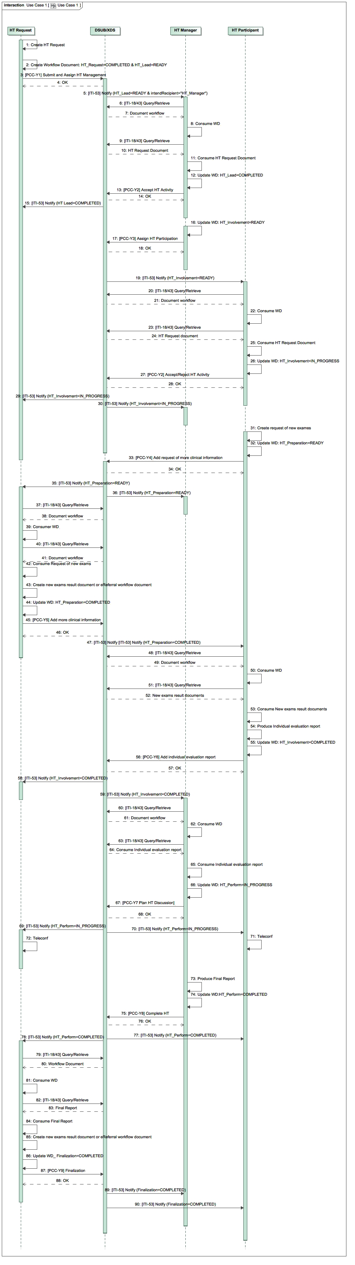



Figure X.4.2.1.2-1: XCHT-WD Sequence Diagram for use case 1

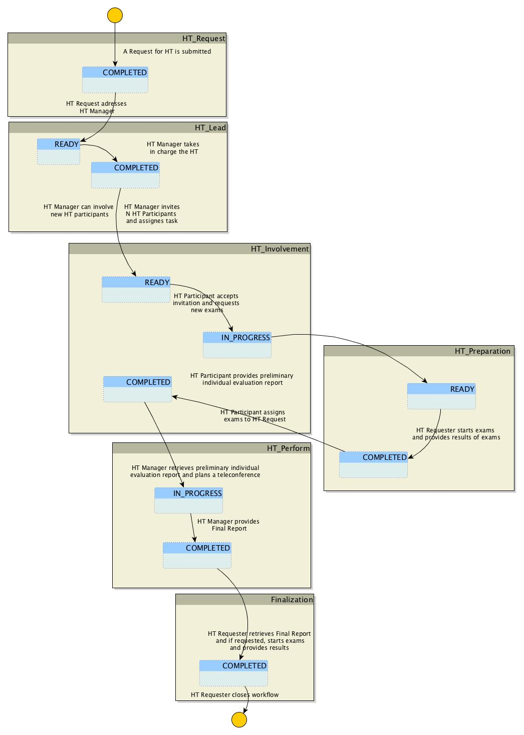

Figure X.4.2.1.2-2: XCHT-WD Process Flow for use case 1

#### X.4.2.2 Use Case #2: Complex Heart Team Coordination

The following use case illustrates the workflow management of a Cross-enterprise Cardiovascular Heart Team that is composed of other professionals besides the requester and manager of Heart Team. This use case describes the management of rejection the HT and the assignment to another manager. It describes also a reject of to be involved to HT as participant.

In this use case, the requester is a cardiologist, Dr. Smith, requests support from a cardiac surgeon, Dr. Johnson, to decide the best treatment path for the patient *with complex coronary disease* (PCI or CABG intervention) avoiding any unnecessary patient transfers to cardiac surgery or cathlab. Dr. Johnson rejects the assignment because he is unable to manage this HT case, due to complexities, and decides that HT is better suited for the job. Dr. Smith requests support from another cardiac surgeon, Dr. John, who works in another hospital. Dr. John accepts the request and invites interventional cardiologist, Dr. Brown, and a cardiothoracic anesthesiologist, Dr. Ralph, to HT but only Dr. Brown accepts the request to be involved. Consequently, the HT is composed of Dr. Smith, the cardiologist that is in charge of the patient, the cardiac surgeon, Dr. John, and the interventional cardiologist, Dr. Brown. During the process, Dr. Brown needs additional clinical report and asks to Dr. Smith to provide it. When all clinical information are available, all members of HT (except the requester) provide Individual Evaluation Reports, and on basis of these, Dr. John provide Final Report for Dr. Smith, without the use of videoconference. The decision is made to treat patient with PCI intervention, in the cathlab.

In this use case, Dr. Smith uses a system supported by HT Requester Actor, and Dr. Johnson and Dr. John uses system supported by HT Manager and HT Participant, and Dr. Ralph and Dr. Brown use a system supported by HT Participant. The workflow document manages this process, and it contains links to all documents shared in this use case (HT Request Document, Request to new exams, Clinical document or report or images, Individual Evaluation Report and Final Report).

**X.4.2.2.1 Complex Heart Team Coordination Use Case Description**

**A. Request Start-up of HT**

On Wednesday morning, Dr. Smith, an interventional cardiologist in a general hospital, visits a 67-year-old male patient, diagnosed with hypertension without a previous history of cardiac disease, who starts complaining of effort angina, CCS class III. The patient undergoes a cardiac echocardiogram to evaluate heart functionality. The systolic function of the left ventricle was normal, with an ejection fraction of 60%. Dr. Smith decides to evaluate the patient with a coronary angiography on Friday which reveals a critical (90%) stenosis at the ostium of the left anterior descending (LAD) and left circumflex (LCX) coronary arteries, and diffuse disease of the right coronary artery (RCA). SYNTAX score is 20. Class I recommendation in management of patients with complex coronary disease as issued in guidelines by American and European professional organizations require that patients with a multi-vessels stenosis and with SYNTAX score ≤22 be discussed in a HT.

Dr. Smith decides to request the involvement of the HT in order to take decision on the treatment of the patient. Dr. Smith selects the data to share with HT, and Dr. Smith’s secretary prepares the HT Request required to activate the HT, through his software. Through IT infrastructure (supported by XDS, DSUB, and XDW profiles) and on the basis of local policies, the HT Request is electronically available for a cardiac surgery. The HT Request links the following documents and images: Medical history, Drug therapy, Biochemical profile test blood, Euroscore II and Syntax score, ECG (Image), echocardiogram, Angiography and ventriculography (Cine-loops). Dr. Smith selects also who to address the management of Heart Team (Department of Dr. Johnson, a cardiac surgeon).

The new workflow document for this case is automatically created when the HT Request is created, and this document is shared with recipient through the same IT infrastructure. Subsequent activity will update this document. This document is a procedural document that cannot be seen by user of the software.

**B. Definition of Manager of HT**

The software of cardiac surgeon, Dr. Johnson, which is subscribed to receive notifications addressed to itself, receives a notification on availability of an HT Request for itself, using the IT infrastructure, in particular thank to DSUB Profile (ITI-53). The software of Dr. Johnson retrieves documents and images, and it allows to Dr. Johnson to study the clinical case. Dr. Johnson decides that he is not able to manage this HT case, due to complexities, and decides that HT is better suited for the job. He confirms his decision through his software, which notify this decision to Dr. Smith.

Dr. Smith decides another cardiac surgeon to address the management of Heart Team, Dr. John, and he inserts this decision in his software. Electronically, the availability of HT Request is notified to software of Dr. John, another cardiac surgeon who belongs to another department or hospital.

Dr. John sees the software notification and the documentation related to HT Request, and confirms electronically that he has taken charge of the management of the HT for this clinical case. The software of Dr. John automatically updates the workflow document, marking the taking charge of HT Request. Dr. Smith is electronically notified of Dr. John’s acceptance of the HT Request.

**C. Involvement of HT participants**

Dr John considers how to staff the HT and determines that the HT will consist of the following members, Dr. Brown, the interventional cardiologist that carried out the previous coronary angiography, Dr. Ralph, a cardiothoracic anesthesiologist that works with Dr. John, and Dr. Smith. Dr. John’s software electronically invites all members defined to be involved in HT.

Dr. Ralph electronically rejects the invitation because can’t commit to HT. Dr. John decides the HT can function without Dr. Ralph. Other involved professionals electronically confirms their participation, also providing other needed data. In fact, to decide the appropriate treatment for the patient, Dr. Brown requires that a new echocardiogram (Cine-loops) is needed. Electronically, the software of Dr. Brown confirms his participation, links a request for a new echocardiogram, and electronically notifies Dr. Smith.

**D. Filling additional requirements of the HT**

1. Dr. Smith performs a new echocardiogram (Cine-loops).
2. When the new echocardiogram results are electronically available, the software of Dr. Smith automatically updates the workflow document, indicating that results of new exams are now available. Consequently, all member of HT are electronically notified and their software can retrieve the documents through an IT infrastructure.

**E. Providing of a preliminary individual evaluation report**

On the basis of all clinical documents and images shared until now, Dr. John and Dr. Brown each create a preliminary individual report. The software of Dr. John and Dr. Brown updates automatically the workflow document, marking that their individual preliminary reports are now available. All member are notified on availability of these documents.

**F. HT Decision**

Dr. John analyzes the preliminary individual report prepared by Dr. Brown. Dr. Brown’s recommendation and his are the same, which is to perform a PCI intervention. Dr. John decides that it isn’t necessary to start a videoconference since the treatment recommendations are the same.

Dr. John creates a final report recommending a PCI through his software. Additional exams are not necessary. The software of Dr. John automatically updates the workflow document, indicating that a final report is now available. Proper notification is sent to the members of HT.

**G. Finalization of needed documents for intervention or treatment**

The software of Dr. Smith retrieves the final report and Dr. Smith, on basis of content of the report, electronically closes the process. The software of Dr. Smith automatically updates the workflow document for the last time, marking that the workflow is concluded, and all members are notified.

##### X.4.2.2.2 Complex Heart Team Coordination Process Flow

The following diagrams show sequence of transactions and sequence of tasks within the workflow which describes the typical process flow for the Common Workflow scenario. Please see Appendix C for other use case flow chart diagram.

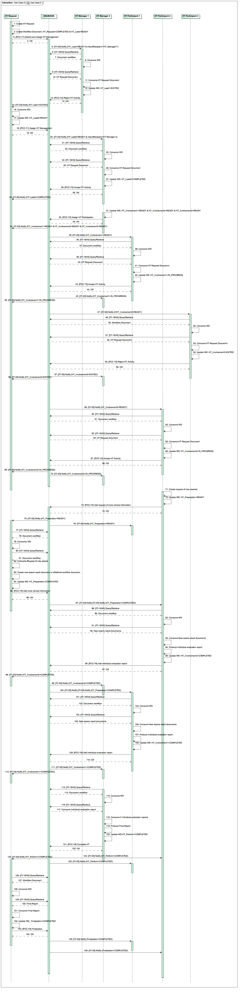

**

**

Figure X.4.2.2.2-1: XCHT-WD Sequence Diagram for Use Case 2

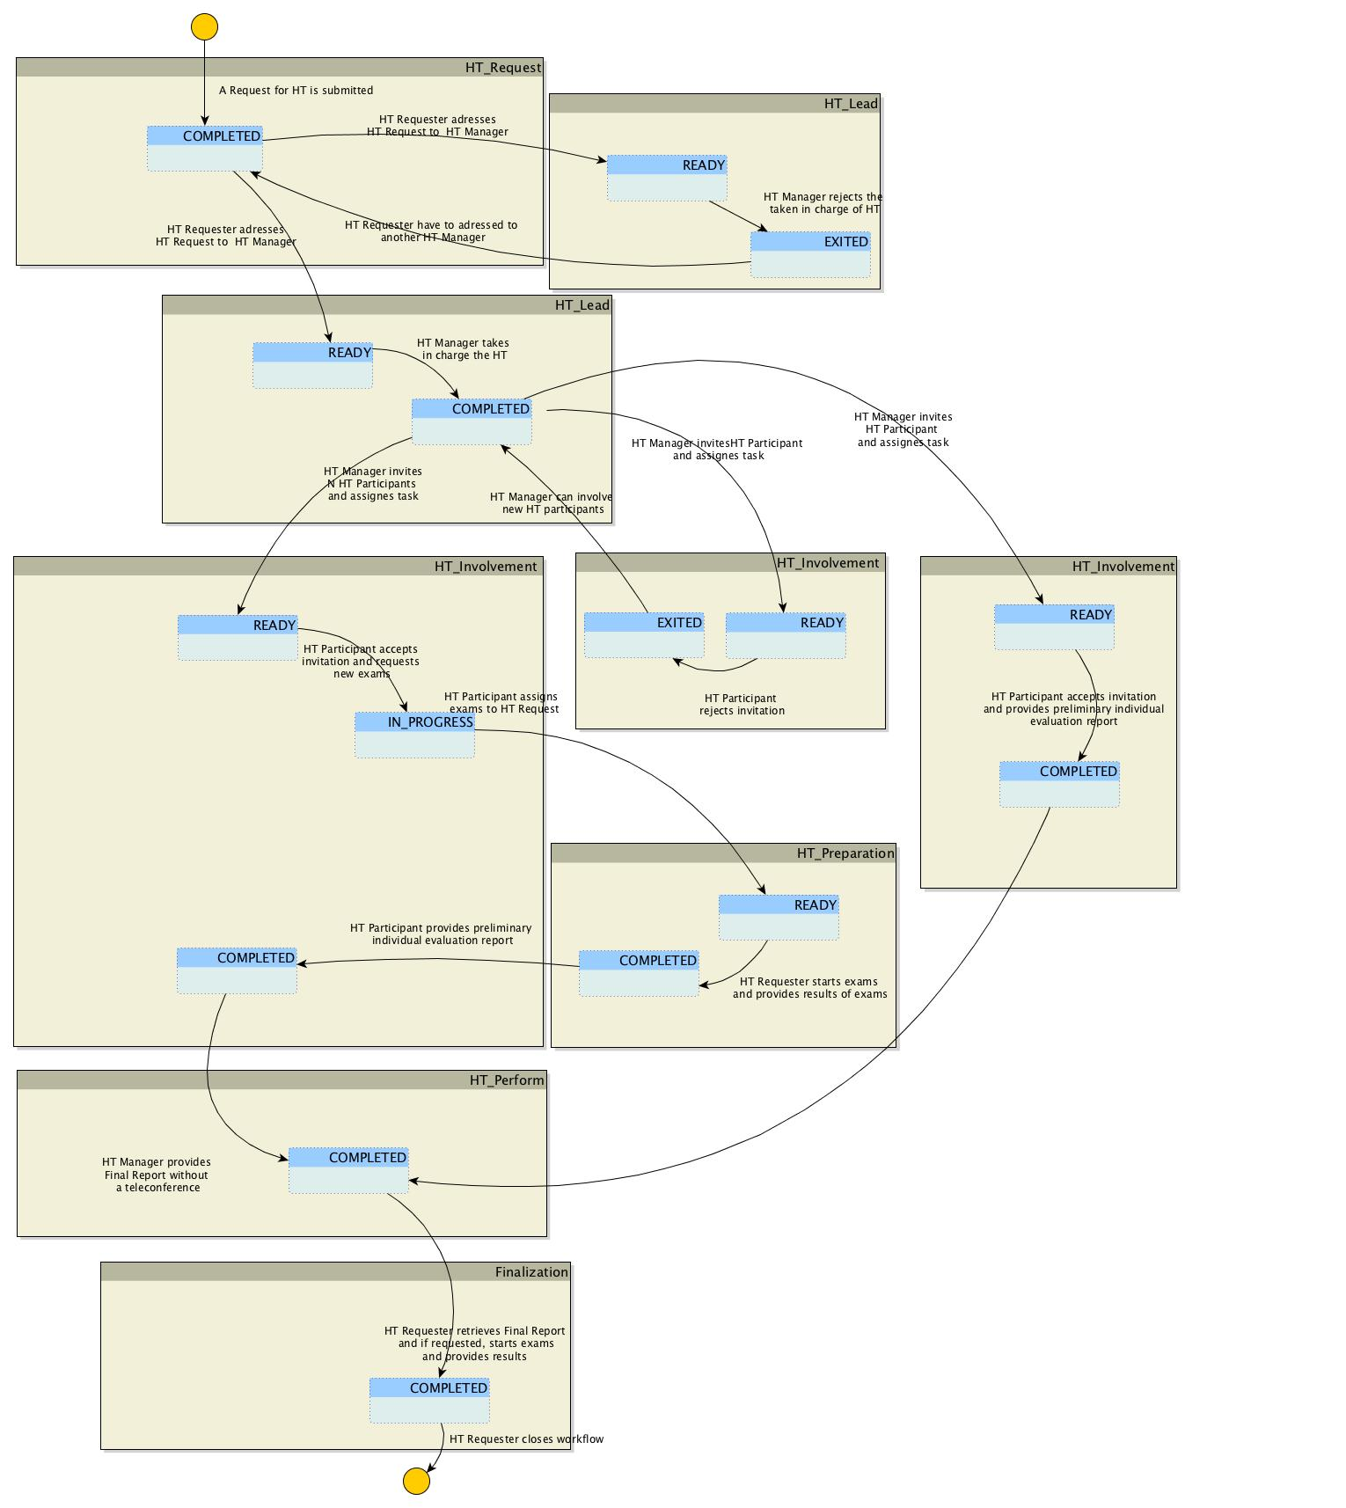Figure X.4.2.2.2-1: XCHT-WD Process Flow for Use Case 2

#### X.4.2.3 Exception #1: Heart Team Cancellation Scenario

The requester of support by HT wants to abort the process just created (case a) because the Request is no longer valid. This would occur if, the HT Request is incorrect or uncompleted or if the patient dies. Or, the manager of HT may want to abort the process (case b) because the case requires an emergency process or the patient dies.

**X.4.2.3.1 HT Cancellation Exception Description**

The HT Cancellation is the pathway scenario where a requesting facility has a need to cancel a request because the HT is no longer needed.

The HT Requester or HT Manager can want to abort the process. In the first case the HT Requester shall update the Workflow Document moving into status FAILED for the HT Request task and closing the workflow itself. In the second case, HT Manager shall update the Workflow Document moving into status FAILED for the HT lead or HT Perform task and closing the workflow itself.

This update notifies all the participants of the workflow. After the closure, a HT Workflow Document cannot be updated by any participant.

##### X.4.2.3.2 HT Cancellation Process Flow

The following diagram describes the typical process flow for the XCHT Workflow scenario when HT Requester fails the workflow (case a).

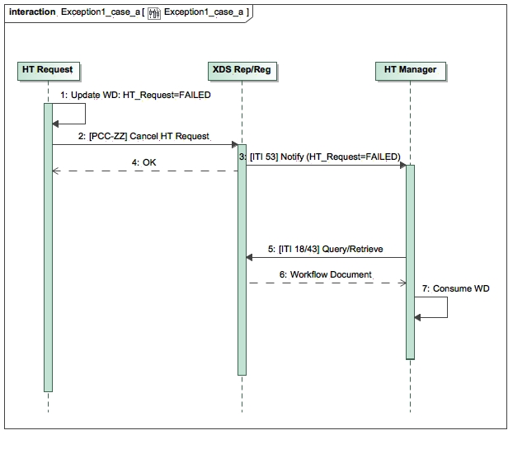

Figure X.4.2.3.2-1: XCHT-WD Sequence Diagram of actors for Exception 1 (case a)

The following diagram describes the typical process flow for the XCHT Workflow scenario when HT Manager fails the workflow (case b).

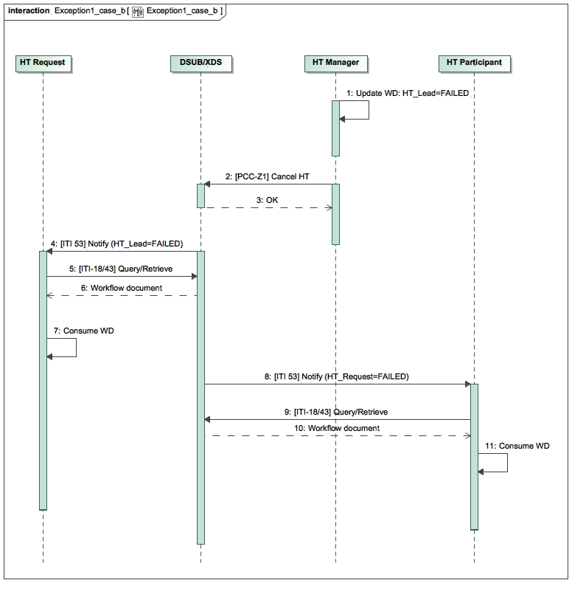

Figure X.4.2.3.2-2: XCHT-WD Sequence Diagram of actors for Exception 1 (case b)

#### X.4.2.4 Exception 2# Heart Team Assignment Cancellation

This use-case describe the scenario in which the requester of support by HT, for example Dr. Smith in use case 2, wants to revoke the assignment of HT request to invited manager of HT that has not already been claimed (case a) by Dr. Johnson in use case 2. Or, the manager of HT, Dr. John (in use case 2) wants to revoke the assignment of involvement in HT to an invited participant that has not already claimed (case b), such as Dr. Ralph in use case 2. These behaviors avoid blocking the process when HT Manager or HT Participant does not respond within a certain allotted time.

**X.4.2.4.1 HT Assignment Cancellation Exception description**

The HT Requester and HT Manager systems, are configured to revoke task assigned respectively to HT Manager and HT Participant systems that have not accomplish their activities within predefined working hours (E.g. the Community Hospital has network problems and after claiming the HT Manager could not respond). The HT Requester and HT Manager can revoke the assignment of the respectively HT Lead task and HT Involvement Task at any time before task completion. HT Requester and HT Manager actor can update respective HT Lead task and HT Involvement Task moving it into status EXITED.

The HT Requester actor could assign the management of HT to a new HT Manager actor if needed. The HT Manager actor could assign the management of HT to a new HT Participant actor if needed.

**X.4.2.4.2 HT Assignment Cancellation process-flow**

The following diagram describes the typical process flow for the XCHT Workflow scenario when HT Requester revoke HT Manager assignment (case a).

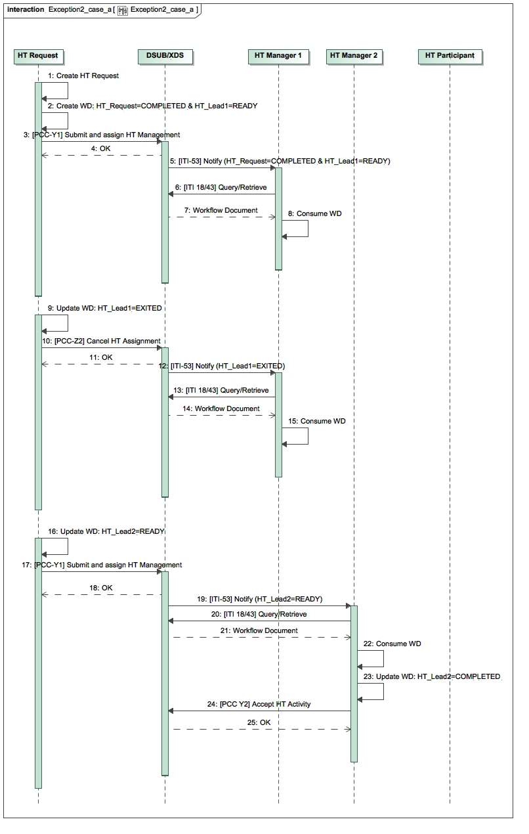

Figure X.4.2.4.2-1: XCHT-WD Sequence Diagram of actors for Exception 2 (case a)

The following diagram describes the typical process flow for the XCHT Workflow scenario when HT Manager revoke HT Participant assignment (case b).

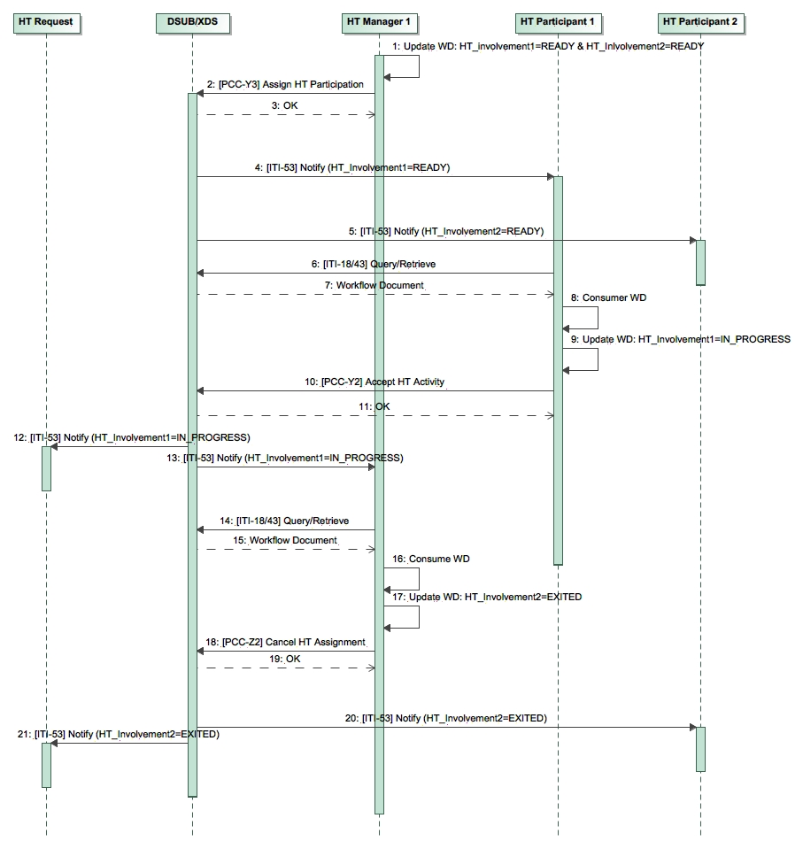

Figure X.4.2.4.2-2: XCHT-WD Sequence Diagram of actors for Exception 2 (case b)

## X.5 XCHT-WD Security Considerations

For this section please refer to the section ITI TF-1: 30.5 XDW Security Considerations

## X.6 XCHT-WD Cross Profile Considerations

In this section, some relationships of this profile are defined along with other profiles. These dependencies shall not be considered additional requirements for Actors involved in the Cross-Enterprise Cardiovascular Heart Team workflow.

Since the HT Manager and HT Participant could ask the HT Requester to execute new exams during the workflow, HT Requester can do it via eReferral Workflow document on basis of XBeR WD Profile and it can share this document with HT. For this reason, HT Requester should be supported by Referral Requester in order to start a separate workflow related to referral.

Appendices

1. Appendix A - Actor Summary Definitions

|  |  |
| --- | --- |
| **Actors** | **Description** |
| HT Requester | The actor is responsible for   * initiating the workflow of HT process for clinical support * assigning the management of HT to a HT Manager, * providing more clinical information, if requested, * completing the workflow by receiving the Final Report, and acknowledging the receiving of that report, providing also new clinical results |
| HT Manager | The actor is responsible for   * accepting/refusing the management of HT by HT Requester * staffing of HT * performing the HT, planning communication point, if requested, and creating Final Report |
| HT Participant | The actor is responsible for:   * accepting/refusing to participate to HT * providing request more clinical information, if needed * providing individual preliminary evaluation reports |

1. Appendix B - Transaction Summary Definitions

|  |  |
| --- | --- |
| **Transactions** | **Description** |
| [PCC-Y1] Submit and assign HT Management | HT Requester submits the workflow document and assigns the management of HT to HT Manager |
| [PCC-Y2] Accept/Reject HT Activity | HT Manager or HT Participant accepts or rejects to be involved to do activities expected for the actor. |
| [PCC-Y3] Assign HT Participation | HT Manager assigns activities expected for HT Participant |
| [PCC-Y4] Add Request of more clinical information | HT Participant requests that HT Requester provides more clinical information |
| [PCC-Y5] Add more clinical information | HT Requester provides more clinical information |
| [PCC-Y6] Add individual evaluation report | HT Participant provides an individual evaluation report |
| [PCC-Y7] Plan HT Discussion | HT Manager schedules the communication point |
| [PCC-Y8] Complete HT | HT Manager performs the HT request providing Final Report |
| [PCC-Y9] Finalization | HT Requester finalizes the Final Report providing new exams for preparation of operation for patient. |
| [PCC-Z1] Cancel HT | HT Requester or HT Manager forced workflow in failed status |
| [PCC-Z2] Cancel HT assignment | HT Requester or HT Manager revokes the assignment |

1. Appendix C – Adding use cases diagrams

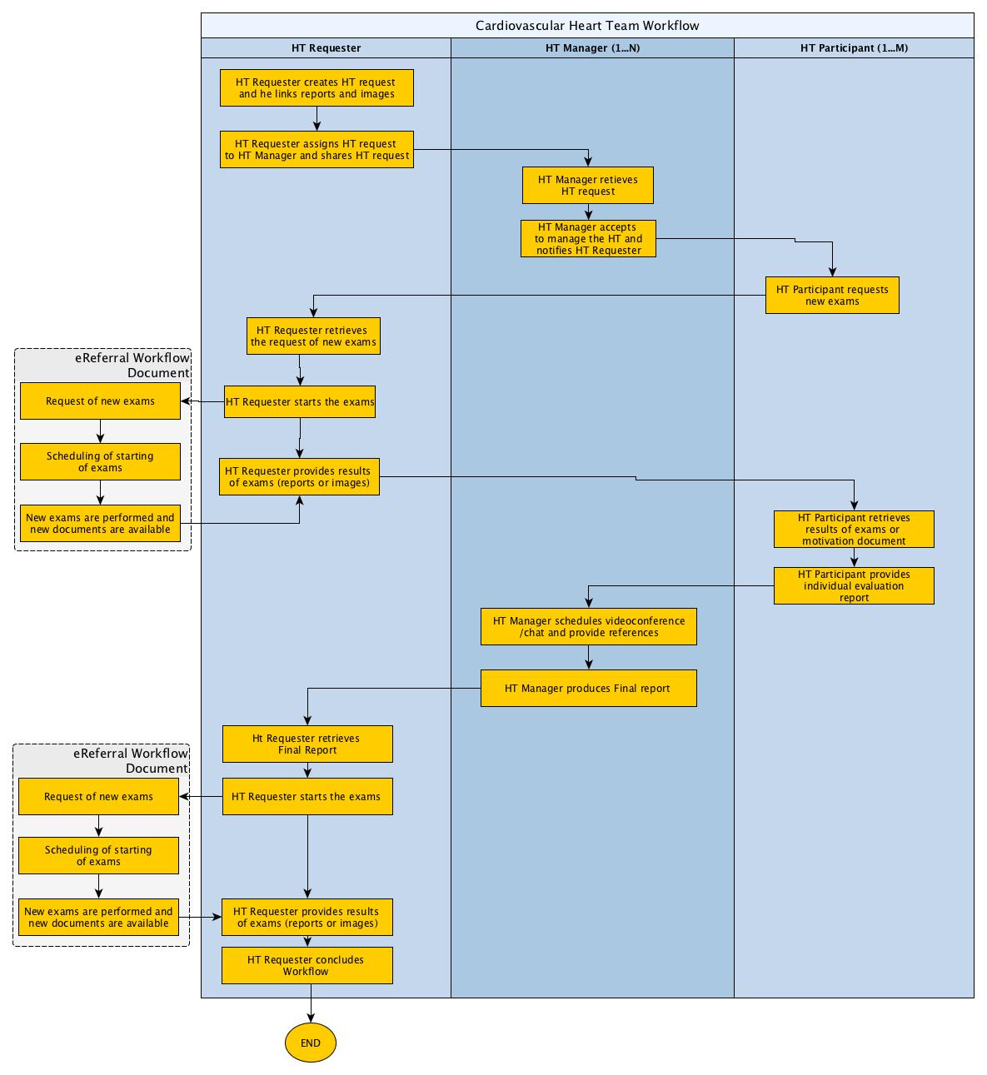

Figure Appendix C-1: XCHT-WD process flow of actors for use case 1 (section X.4.2.1): it illustrates the workflow of management of the Cross-enterprise Cardiovascular Heart Team for an HT composed only of requester and manager of HT without the involvement of other professionals. The use case is similar to a tele-consultation, when the requester and manager collaborate each other through many interaction points such as sharing of documents (reports, results of exams, videos and images) and/or video/teleconference.

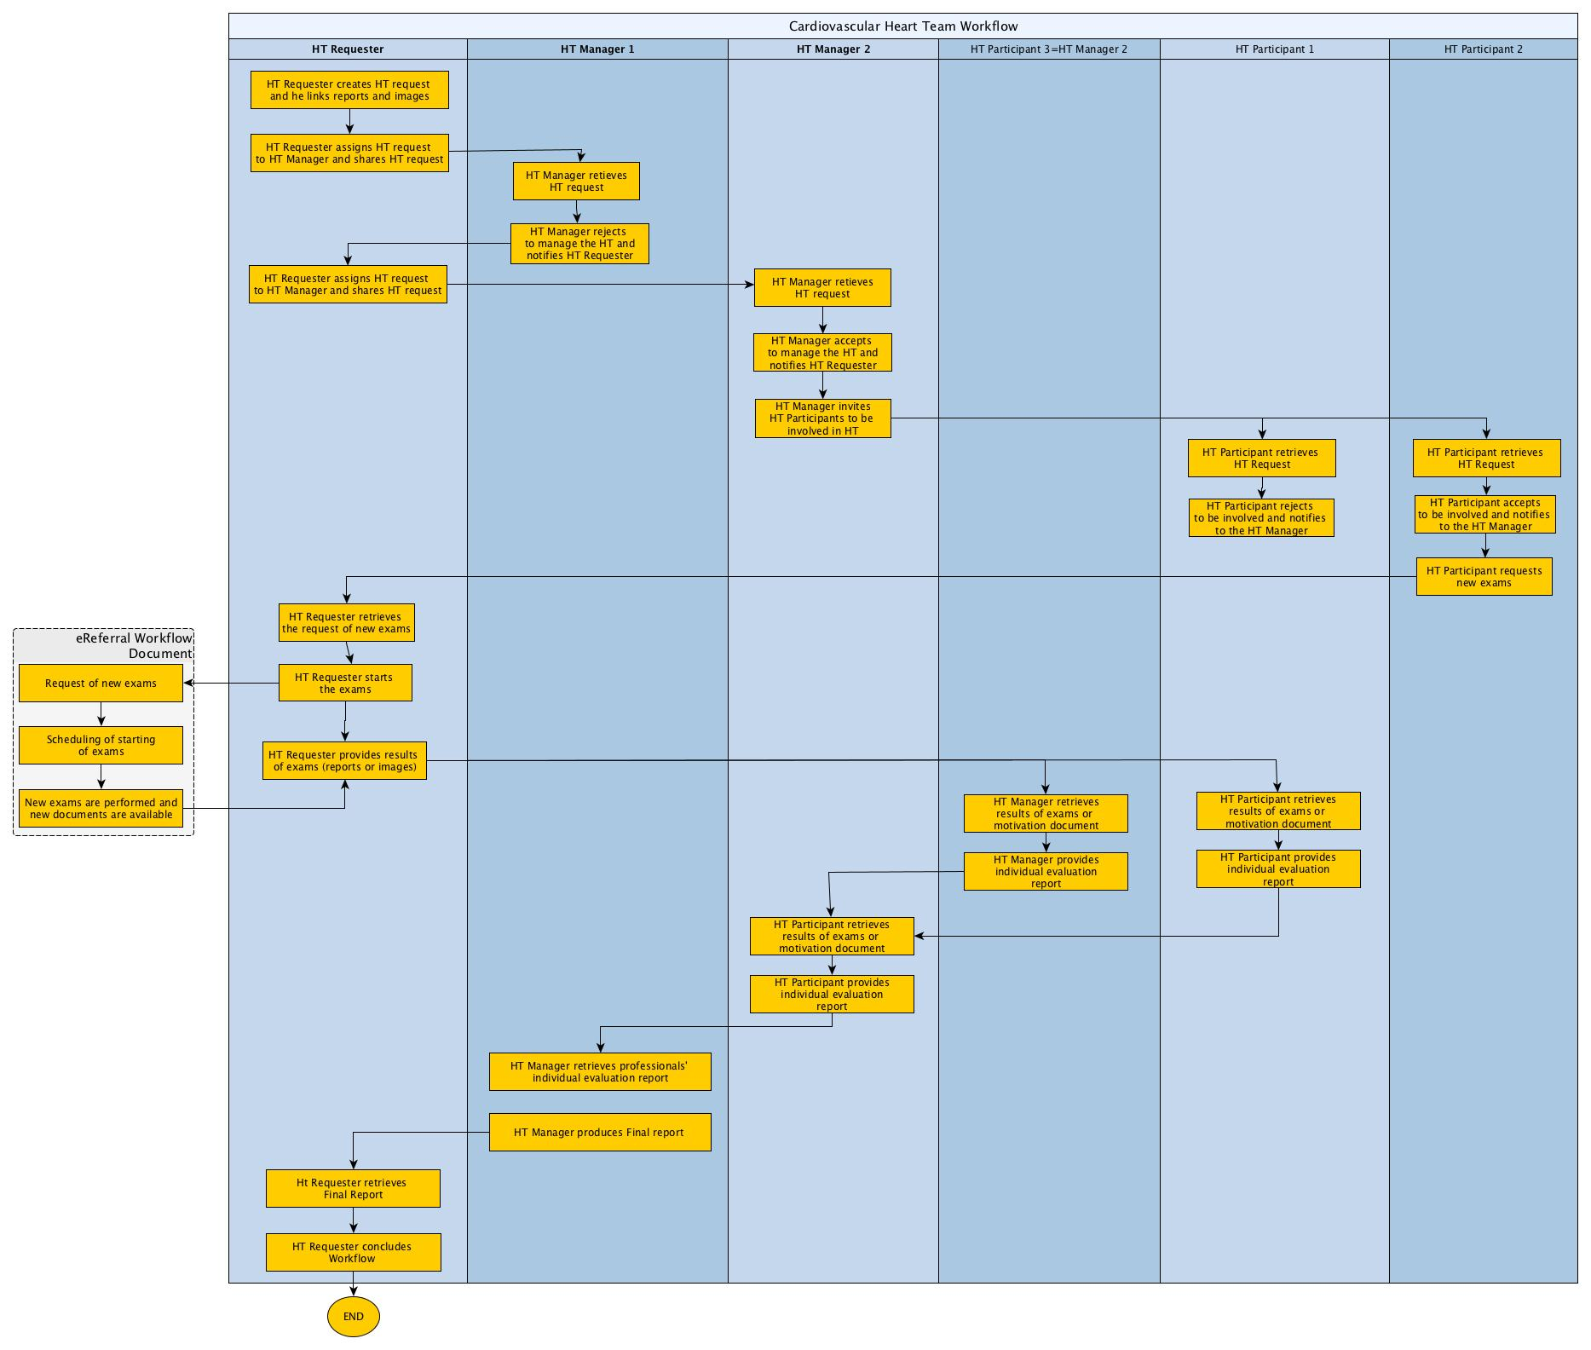**Figure Appendix C-2: XCHT-WD process flow of actors for use case 2 (section X.4.2.2):** It illustrates the workflow of management of a Cross-enterprise Cardiovascular Heart Team composed of other professionals besides the requester and manager of Heart Team. This use case describes also the reject of management of the HT and the assignment to another manager, and the reject of to be involved to HT as participant.

Glossary

Add the following terms to the IHE Technical Frameworks General Introduction Glossary:

<Any glossary additions associated with the profile draft go here. This section will be deleted prior to inclusion into the Technical Framework Final Text. >

Volume 2 – Transactions

## 3.Y1 Submit and assign HT Management [PCC-Y1]

### 3.Y1.1 Scope

The Submit and assign HT Management transaction starts a Heart Team process. It submits a new Workflow Document in order to provide the HT Request document to HT Manager and/or to assign HT management to HT Manager.

### 3.Y1.2 Actor Roles

HT Requester

XDS Document Repository

Figure 3.Y1.2-1: Use Case Diagram

Table 3.Y1.2-1: Actor Roles

|  |  |
| --- | --- |
| **Actor:** | HT Requester |
| **Role:** | Creates the Heart Team Workflow Document, Assigns the HT management to an HT Manager that can manage the Heart Team, and submits the Heart Team Workflow Documents with associated metadata to a Document Repository. |
| **Actor:** | XDS Document Repository |
| **Role:** | Receives, stores and eventually notifies the Workflow Document |

### 3.Y1.3 Referenced Standards

**XDS.b (Cross-Enterprise Document Sharing):**  For a list of the standards for the underlying Provide and Register Document Set-b [ITI-41] transaction, see ITI TF-2b: 3.41.3.

**XDW (Cross-Enterprise Document Workflow):** For requirements and standards related to the Heart Team Workflow Document, see ITI TF-1:20 and ITI TF-3:4.5.

### 3.Y1.4 Interaction Diagram

HT Requester

Actor A

Submit and assign HT Management

XDS Document Repository

Actor D

Provide And Register Document set-b Response

Message 2

#### 3.Y1.4.1 Submit and assign HT Management

<One or two sentence summary of what Message 1 accomplishes typically relating the message to the relevant standard. Avoid shall language in this upper level section. Do not duplicate the triggers, encoding, semantics, standards used, or expected actions. Those belong in the following sections.>

<Explicitly state if the multiplicity of an actor may be greater than one; i.e., if an actor (whether it is a client or server) can expect this message from a single source or multiple sources.>

This message initiates the Heart Team workflow by sharing the Heart Team Workflow Document with the Document Repository in order to provide the HT Request Document to HT Manager and to assign HT management to HT Manager. Alternatively, this message can only have to assign HT management to another HT Manager, if a previous assignment was been rejected.

##### 3.Y1.4.1.1 Trigger Events

<Description of the real world events that cause the sender (Actor A) to send Message 1 (e.g., an operator or an automated function determines that a new workitem is needed).>

The HT Requester sends this message when:

* It is ready to initiate the Heart Team process and has acquired and collected all the information needed, and HT Request is ready to be assigned. This means that the HT Requester shall be able to identify a HT Manager able to manage the HT, but rules for assignment are out of scope for this specification, and should be locally defined by domain policies.

OR

* A previous assignment to HT management is revoked by HT Requester or rejected by HT Manager and it has been assigned again. This means that the HT Requester shall be able to identify a HT Manager able to manage the HT, but rules for assignment are out of scope for this specification, and should be locally defined by domain policies.

The **pre-conditions** are encoded as:

1. The workflow document is open (**WorkflowDocument/workflowStatus**=”OPEN”) **and** the HT Request task is COMPLETED (WorkflowDocument/TaskList/XDWTask/taskData/taskDetails/status=”COMPLETED”and WorkflowDocument/TaskList/XDWTask/taskData/taskDetails/taskType=”HTRequest”) and each HT Lead task is “EXITED”(**WorkflowDocument/TaskList/XDWTask/taskData/taskDetails/status**=”EXITED” and **WorkflowDocument/TaskList/XDWTask/taskData/taskDetails/taskType**=”HTLead”)

##### The information needed are:

* Heart Team Request Document: the request for a HT to perform a Final Report for the clinical case.
* Images Manifest: a document identifying the key images set
* Images Report (Optional)
* Clinical Report (Optional)
* Videos (Optional)

##### 3.Y1.4.1.2 Message Semantics

<Detailed description of the meaning, structure and contents of the message, including any IHE specific clarifications of the message format, attributes, etc.>

<Start by describing the standard underlying the message and how the participating actors are mapped (e.g., “This message is a DICOM C-FIND Request. Actor A is the SCU. Actor D is the SCP.”).>

<Continue profiling the message by providing guidance or constraints on how the message parameters are populated, how the payload is encoded, how the message is structured and what the contents mean. These message semantics should both help the sender to construct the message and the receiver to interpret the message.>

This message is a Provide And Register Document Set-b Request message. This message shall comply with the message semantics defined for the Provide and Register Document Set-b Request message in ITI TF-2b:3.41.4.1.2. The HT Requester is the Document Source.

This section defines:

* The Heart Team Workflow Document Content submitted in the Provide and Register. See Section 3.Y1.4.1.2.1.
* The Heart Team Request Document Content submitted in the Provide and Register. See Section 3.Y1.4.1.2.2.
* The Document Sharing Metadata requirements for the Submission Set and Document Entry. See Section 3.Y1.4.1.2.3.

This specification does not require that all the documents referenced as input documents within the Workflow Document are included in the same submissionSet.

##### 3.Y1.4.1.2.1 Heart Team Workflow Document Content Requirements

The HT Requester initiates the workflow by creating a new Heart Team Workflow Document if any assignment hasn’t yet been done. The Heart Team Workflow Document is updated by the HT Requester if a previous assignment is revoked by HT Requester or rejected by HT Manager and it has been assigned again.

##### 3.Y1.4.1.2.1.1 Workflow Document Elements

The HT Requester shall create a new Heart Team Workflow Document according to the definition of an XDW Workflow Document in ITI TF-3: 5.4 with the following constraints:

* **<WorkflowStatus>** shall be set to “OPEN”.
* **<workflowDefinitionReference>** shall be set to “1.2.3.4.5.6.7.8.9.0”.
* for **<TaskList>** constraints see Section 3.Y1.4.1.2.1.1.1.

If this message is only to assign HT management to HT Manager, HT Requester shall update the Heart Team Workflow Document according to the definition of an XDW Workflow Document in ITI TF-3: 5.4 with the following constraint:

* For **<TaskList>** constraints see Section 3.Y1.4.1.2.1.1.1.

##### 3.Y1.4.1.2.1.1.1 Workflow Document taskList Element

This element shall be structured according to ITI TF-3:5.4.2.3 “XDW Workflow Document Elements from the OASIS Human Task,” with the additional constraints specified below.

The HT Requester shall put in the **<TaskList>** element:

* If Heart Team Workflow Document has been created and assignments aren’t yet done, a required **<XDWTask>** child element that represents the HT Request task. See Section 3.Y.4.1.2.1.1.1.1
* A required **<XDWTask>** child element that represents the HT Lead task. See Section 3.Y.4.1.2.1.1.1.2

Further requirements are defined in the next sections.

##### 3.Y1.4.1.2.1.1.1.1 XDW Task “HT Request”

The **<XDWTask>** sub element **<taskDetails>** describes the HT Request task details:

* the <**taskType>** child element shall have the value “HT Request”
* the <**status>** child element shall have thevalue “COMPLETED”.

The HT Requester actor **may** set the value of additional elements that characterize the nature and the execution of the HT Requested:

* **taskData/taskDetails/expirationTime**: this elements allows the HT Requester to specify a date/time by which the HT needs to be completed
* **taskData/taskDetails/notificationRecipients:**this elements identifies user/organization that needs to be notified. If this element has one or more values, the same user/organization shall be identified as SubmissionSet.intendedRecipient for the submission that will result in the publication of the Workflow Document itself.

The element **<XDWTask>** shall have a child element **taskData/input/part** for each input document referenced. The document referenced as input are listed below. Further details about attachment encoding within **taskData/input/part** are specified at ITI TF-3: Table 5.4.3-9 AttachmentInfo Element

* **part/@name** =”HTRequest”: (1..1) this is a required input that identifies the HT Request document. See Section 3.Y1 4.1.2.2
* **part/@name** =”ClinicalDocuments”: (0..N) this is an optional and repeatable input that identifies relevant Clinical Document.
* **part/@name**=”ImageManifest”: (0..N) this is an optional and repeatable input that identifies the Image Manifest of the relevant images.
* **part/@name=**=”ClinicalVideos”: (0..N) this is an optional and repeatable input that identifies the the relevant videos

The element **<XDWTask>** shall have only one child element **taskEventHistory/taskEvent** characterized by <**status>** = “COMLETED”.

##### 3.Y1.4.1.2.1.1.1.2 XDW Task “HT Lead”

The **<XDWTask>** sub element **<taskDetails>** describes the HT Lead task details:

* the <**taskType>** child element shall have the value “HTLead”
* the <**status>** child element shall have thevalue “READY”.

The HT Requester shall specify the identified HT Manager in the **<potentialOwner>** element:

* **taskData/taskDetails/potentialOwner:** this element allows to “reserve” the task for a HT Manager. The HT Manager can be a user. Only identified HT Manager can claim the task. This transaction does not define the criteria by which HT Requester select a specific HT Manager.

The HT Requester shall specify the HT Manager identified as a “notificationRecipient” for the task:

* **taskData/taskDetails/notificationRecipients:** this elements specifies user/organization that needs to be notified.

The HT Requester could set the value of additional elements that characterize the nature and the execution of the HT:

* **taskData/taskDetails/expirationTime**: this element specifies a date/time by which the HT Manager have to accept or reject.

##### 3.Y1.4.1.2.2 HT Request Content Requirements

The HT Request Document shall contain the reason why the clinical case is submitted to Heart Team. The document contains synthetic clinical information on the patient. This specification does not mandate any specific structure for this document.

##### 3.Y1.4.1.2.3 Document Sharing Metadata Requirements

Document metadata for this transaction shall comply with the requirements in ITI TF-3:4 “Metadata used in Document Sharing Profiles”.

This section specifies additional Document Sharing Metadata requirements for the both the Heart Team Workflow Document and for the Heart Team Request document.

The **DocumentEntry metadata of the Heart Team Workflow Document** shall meet the following constraints:

* The eventCodeList metadata attribute is used to document the current status of the workflow and the status of task(s) within the workflow. This enables queries or DSUB notifications about status based on the values in eventCodeList:
* A single entry of eventCodeList shall convey the actual status (OPEN) of the workflow: code = “urn:ihe:iti:xdw:2011:eventCode:open” codingScheme=” 1.3.6.1.4.1.19376.1.2.3”
* A single entry of the eventCodeList metadata shall convey the actual status of the HT Request task: code=”urn:ihe:pcc:xcht-wd:2015:eventCodeTaskStatus:HTRequestCompleted” codingScheme=”1.3.6.1.4.1.19376.1.2.1”
* A single entry of the eventCodeList metadata shall convey the status of the HT Lead task: code=”urn:ihe:pcc:xcht-wd:2015:eventCodeTaskStatus:HTLeadReady” codingScheme=”1.3.6.1.4.1.19376.1.2.1”
* The referenceIdList metadata shall provide the accession number in accordance with PCC TF-3: Table 4.68.4.1.2.3-1.
* The typeCode shall convey the following code: “XCHT-WD” codingScheme: 1.2.3.4.5.6.7.8.9.0

The **SubmissionSet metadata of the Heart Team Workflow Document** shall meet the following constraints:

* The intendedRecipient metadata contain the identifier of the organization, or the person intended to manage the HT. This metadata shall convey the same users/organizations identified within the Workflow Document in the **<notificationRecipients>**element of the HT Lead task

This transaction does not define document sharing metadata requirements for the HT Request document. The document may be included in the same Submission Set as the Heart Team Workflow Document in this transaction [PCC-Y1] or in a different Submisstion Set using a [ITI-41] Provide and Register Document Set-b transaction.

##### 3.Y1.4.1.3 Expected Actions

<Description of the actions expected to be taken as a result of sending or receiving this message.>

<Describe what the receiver is expected/required to do upon receiving this message. >

<Avoid re-iterating the transaction sequencing specified in the Profile Process Flows as expected actions internal to the transaction. Doing so prevents this transaction being re-used in other contexts.>

<Explicitly define any expected action based on the multiplicity of an actor(s), if applicable.>

The HT Requester actor shall process the Provide and Register Document Set-b Request message as described in section ITI TF-2b:3.41.4.1.3.

#### 3.Y1.4.2 Provide And Register Document set-b Response

<One or two sentence summary of what Message 2 accomplishes typically relating the message to the relevant standard. Avoid shall language in this upper level section. Do not duplicate the triggers, encoding, semantics, standards used, or expected actions. Those belong in the following sections.>

<Explicitly state if the multiplicity of an actor may be greater than one; i.e., if an actor (whether it is a client or server) can expect this message from a single source or multiple sources.>

<Repeat this section as necessary based on the number of messages in the interaction diagram.>

This specification does not add additional requirements for the Provide And Register Document Set-b Response message defined in ITI TF-2b:3.41.4.2.

##### 3.Y1.4.2.1 Trigger Events

<Description of the real world events that cause the sender (Actor A) to send Message 1(e.g., an operator or an automated function determines that a new workitem is needed).>

See section ITI TF-2b:3.41.4.2.1

##### 3.Y1.4.2.2 Message Semantics

<Detailed description of the meaning, structure and contents of the message, including any IHE specific clarifications of the message format, attributes, etc.>

<Start by describing the standard underlying the message and how the participating actors are mapped (e.g., “This message is a DICOM C-FIND Request. Actor A is the SCU. Actor D is the SCP.”).>

<Continue profiling the message by providing guidance or constraints on how the message parameters are populated, how the payload is encoded, how the message is structured and what the contents mean. These message semantics should both help the sender to construct the message and the receiver to interpret the message.>

See section ITI TF-2b:3.41.4.2.2

##### 3.Y1.4.2.3 Expected Actions

<Description of the actions expected to be taken as a result of sending or receiving this message.>

<Describe what the receiver is expected/required to do upon receiving this message. >

<Avoid re-iterating the transaction sequencing specified in the Profile Process Flows as expected actions internal to the transaction. Doing so prevents this transaction being re-used in other contexts.>

<Explicitly define any expected action based on the multiplicity of an actor(s), if applicable.>

See section ITI TF-2b:3.41.4.2.3.

In addition to the Expected Actions defined for the Provide And Register Document Set-b Response message, when the Document Repository sends a Response of Success (See ITI TF-3: 4.2.4.2)to the HT Requester actor, the HT Requester shall save the workflowInstanceId associated with the workflow for subsequents subscriptions or queries.

If an error is generated by the Document Repository that error should be managed by the HT Requester in accordance to local defined behaviors, and in accordance to XDW actor behaviors (race condition) defined in section ITI TF-3: 5.4.5.1

### 3.Y1.5 Security Considerations

<Description of the transaction specific security consideration; such as use of security profiles.>

#### See section ITI TF-2b:3.41.5.

#### 3.Y1.5.1 Security Audit Considerations

<This section should identify any specific ATNA security audit event that is associated with this transaction and requirements on the encoding of that audit event. >

#### See section ITI TF-2b:3.41.5.1.

## 3.Y2 Accept/Reject HT Activity PCC-Y2

### 3.Y2.1 Scope

This transaction allows a HT Manager or HT participant to accept or reject the assignment respectively to manage the Heart Team or to be involved in the Heart Team.

### 3.Y2.2 Actor Roles

HT Manager or HT Participant

Actor ABC

XDS Document Repository

Figure 3.Y2.2-1: Use Case Diagram

Table 3.Y2.2-1: Actor Roles

|  |  |
| --- | --- |
| **Actor:** | Sender: HT Manager or HT Participant |
| **Role:** | Accepts or rejects the assignment to manage the Heart Team. |
| **Actor:** | XDS Document Repository |
| **Role:** | Receives and stores the updated Workflow Document |

### 3.Y2.3 Referenced Standards

**XDS.b (Cross-Enterprise Document Sharing):**  For a list of the standards for the underlying Provide and Register Document Set-b [ITI-41] transaction, see ITI TF-2b: 3.41.3.

**XDW (Cross-Enterprise Document Workflow):** For requirements and standards related to the Heart Team Workflow Document, see ITI TF-1:20 and ITI TF-3:4.5.

### 3.Y2.4 Interaction Diagram

HT Manager or HT Participant

Actor A

Accept/Reject HT Activity

XDS Document Repository

Actor D

Provide And Register Document set-b Response

Message 2

#### 3.Y2.4.1 Accept/Reject HT Activity

This message accept/rejects the assignment to manage the Heart Team requested, through PCC-Y1 or the assignment to be involved in the Heart Team, requested through PCC-Y3.

##### 3.Y2.4.1.1 Trigger Events

The HT Manager or HT Participant sends this message when it learns that respectively a HT Lead or HT Involvement task has been assigned to itself. The mechanism to learn this is not defined by this transaction.

If the sender is the HT Manager, the **pre-conditions** are encoded as:

the HT Lead task is assigned to the HT Manager if the workflow document is open (**WorkflowDocument/workflowStatus**=”OPEN”) and “HT Lead” Task is READY and assigned to HT Manager (**WorkflowDocument/TaskList/XDWTask/taskData/taskDetails/status**=”READY” and **WorkflowDocument/TaskList/XDWTask/taskData/taskDetails/taskType**=”HTLead” and **WorkflowDocument/TaskList/XDWTask/taskData/taskDetails/potentialOwners**=HT Manager)

If the sender is the HT Participant, the **pre-conditions** are encoded as:

the HT Involvement task is assigned to the HT Participant if the workflow document is open (**WorkflowDocument/workflowStatus**=”OPEN”) and “HT Involvement” Task is READY and assigned to HT Participant (**WorkflowDocument/TaskList/XDWTask/taskData/taskDetails/status**=”READY” and **WorkflowDocument/TaskList/XDWTask/taskData/taskDetails/taskType**=”HTInvolvement” and **WorkflowDocument/TaskList/XDWTask/taskData/taskDetails/potentialOwners**=HT Participant).

Note: this transaction does not define a method for identifying HT Manager or HT Paticipant.

##### 3.Y2.4.1.2 Message Semantics

This message is a Provide and Register Document Set-b Request message. This message shall comply with the message semantics defined for the Provide and Register Document Set-b Request message in ITI TF-2b:3.41.4.1.2. The HT Manager or HT Participant is the Document Source.

This section also defines:

* the Heart Team Workflow Document Content submitted in the Provide and Register. See Section 3.Y2.4.1.2.1.
* The Document Sharing Metadata requirements for the Submission Set and Document Entry. See Section 3.Y2.4.1.2.3.

##### 3.Y2.4.1.2.1 Heart Team Workflow Document Content Requirements

The Heart Team Workflow Document is updated by the HT Manager or HT Participant.

##### 3.Y2.4.1.2.1.1 Workflow Document Elements

The HT Manager or HT Participant shall update the Heart Team Workflow Document according to the definition of an XDW Workflow Document in ITI TF-3: 5.4

This transaction does not require the creation of new tasks within the Workflow Document; however, it requires the HT Manager or HT Participant to add a new **taskEvent** respectively in the HT Lead task or in HT Involvement. See respectively Section 3.Y2.4.1.2.1.1.1 or 3.Y2.4.1.2.1.1.2

##### 3.Y2.4.1.2.1.1.1 XDWTask “HT Lead”

If the HT Manager is accepting the assignment to manage Heart Team, a new **<taskEvent>** (characterized by: status=COMPLETED, eventType=”start”) shall be added to the **<taskEventHistory>** element.

If the HT Manager is rejecting the assignment to manage Heart Team, a new **<taskEvent>** (characterized by: status=EXITED, eventType=”skip”) shall be added to the **<taskEventHistory>** element.

The HT Manager shall populate **taskData/comments** child element of the updated task with reasons for rejection.

##### 3.Y2.4.1.2.1.1.2 XDWTask “HT Involvement”

If the HT Participant is accepting the assignment to manage Heart Team, a new **<taskEvent>** (characterized by: status=IN_PROGRESS, eventType=”start”) shall be added to the **<taskEventHistory>** element.

If the HT Participant is rejecting the assignment to manage Heart Team, a new **<taskEvent>** (characterized by: status=EXITED, eventType=”skip”) shall be added to the **<taskEventHistory>** element.

The HT Participant shall populate **taskData/comments** child element of the updated task with reasons for rejection.

##### 3.Y2.4.1.2.2 Document Sharing Metadata requirements

Document metadata for this transaction shall comply with the requirements in ITI TF-3:4 “Metadata used in Document Sharing Profiles”.

This section specifies additional Document Sharing Metadata requirements for the Heart Team Workflow Document.

The **DocumentEntry metadata of the Heart Team Workflow Document** shall meet the following constraints:

* The eventCodeList metadata attribute is used to document the current status of the workflow and the status of task(s) within the workflow. This enables queries or DSUB notifications about status based on the values in eventCodeList:
* A single entry of eventCodeList metadata shall convey the current status (OPEN) of the workflow: code = “urn:ihe:iti:xdw:2011:eventCode:open” codingScheme=” 1.3.6.1.4.1.19376.1.2.3”
* If sender is an HT Manager, a single entry of the eventCodeList metadata shall convey the current status of the HT Lead task. The value shall be one of:
  + code=”urn:ihe:pcc:xcht-wd:2015:eventCodeTaskStatus:HTLeadExited” codingScheme=”1.3.6.1.4.1.19376.1.2.1”
  + code=”urn:ihe:pcc:xcht-wd:2015:eventCodeTaskStatus:HTLeadCompleted” codingScheme=”1.3.6.1.4.1.19376.1.2.1”

OR

If sender is an HT Participant, a single entry of the eventCodeList metadata shall convey the current status of the HT Involvement task. The value shall be one of:

* + code=”urn:ihe:pcc:xcht-wd:2015:eventCodeTaskStatus:HTInvolvementExited” codingScheme=”1.3.6.1.4.1.19376.1.2.1”
  + code=”urn:ihe:pcc:xcht-wd:2015:eventCodeTaskStatus:HTInvolvementInprogress” codingScheme=”1.3.6.1.4.1.19376.1.2.1”

##### 3.Y2.4.1.3 Expected Actions

The Document Repository actor shall process the Provide and Register Document Set-b Request message as described in ITI TF-2b:3.41.4.1.3.

#### 3.Y2.4.2 Provide and Register Document set-b Response

This specification does not add additional requirements for the Provide and Register Document Set-b Response message defined in ITI TF-2b:3.41.4.2.

##### 3.Y2.4.2.1 Trigger Events

See ITI TF-2b:3.41.4.2.1

##### 3.Y2.4.2.2 Message Semantics

See ITI TF-2b:3.41.4.2.2

##### 3.Y2.4.2.3 Expected Actions

See section ITI TF-2b:3.41.4.2.3.

In addition to the Expected Actions defined for the Provide And Register Document Set-b Response message, when the Document Repository sends a Response of Success (See ITI TF-3: 4.2.4.2)to the HT Manager or HT Participant actor, the HT Requester shall save the workflowInstanceId associated with the workflow for subsequents subscriptions or queries.

If an error is generated by the Document Repository that error should be managed by the HT Manager or HT Participant in accordance to local defined behaviors, and in accordance to XDW actor behaviors (race condition) defined in section ITI TF-3: 5.4.5.1

### 3.Y2.5 Security Considerations

#### See ITI TF-2b:3.41.5.

#### 3.Y2.5.1 Security Audit Considerations

#### See ITI TF-2b:3.41.5.1.

## 3.Y3 Assign HT Participation [PCC-Y3]

### 3.Y3.1 Scope

The Assign HT Participation transaction updates Workflow Document in order to assign HT participation to each HT Participants. The identification of what group of HT Participants to be involved in Heart Team is out of scope for this specification and should be locally defined by domain policies.

### 3.Y3.2 Actor Roles

HT Manager

XDS Document Repository

Figure 3.Y.2-1: Use Case Diagram

Table 3.Y.2-1: Actor Roles

|  |  |
| --- | --- |
| **Actor:** | HT Manager |
| **Role:** | Assigns the HT participation to HT Participants that can provide advices to the Heart Team, updates Heart Team Workflow Documents and submits the updated Heart Team Workflow Documents to a Document Repository. |
| **Actor:** | XDS Document Repository |
| **Role:** | Receives, stores and eventually notifies the updated Workflow Document |

### 3.Y3.3 Referenced Standards

**XDS.b (Cross-Enterprise Document Sharing):**  For a list of the standards for the underlying Provide and Register Document Set-b [ITI-41] transaction, see ITI TF-2b: 3.41.3.

**XDW (Cross-Enterprise Document Workflow):** For requirements and standards related to the Heart Team Workflow Document, see ITI TF-1:20 and ITI TF-3:4.5.

### 3.Y3.4 Interaction Diagram

HT Manager

Actor A

Assign HT Participation

XDS Document Repository

Actor D

Provide And Register Document set-b Response

Message 2

#### 3.Y3.4.1 Assign HT Participation

This message assigns HT participation to each HT Participant that has to be involved in Heart Team.

##### 3.Y3.4.1.1 Trigger Events

The HT Manager sends this message when it has accepted to manage the HT and is ready to be able to identify HT Participants able to be involved in the Heart Team, but rules for assignment are out of scope for this specification, and should be locally defined by domain policies.

The **pre-conditions** are encoded as:

1. The workflow document is active (**WorkflowDocument/workflowStatus**=”OPEN”)and one HT Lead task is “COMPLETED”(**WorkflowDocument/TaskList/XDWTask/taskData/taskDetails/status**=”COMPLETED” and **WorkflowDocument/TaskList/XDWTask/taskData/taskDetails/taskType**=”HTLead”)

##### 3.Y3.4.1.2 Message Semantics

This message is a Provide And Register Document Set-b Request message. This message shall comply with the message semantics defined for the Provide and Register Document Set-b Request message in ITI TF-2b:3.41.4.1.2. The HT Requester is the Document Source.

This section defines:

* the Heart Team Workflow Document Content submitted in the Provide and Register. See Section 3.Y3.4.1.2.1.
* The Document Sharing Metadata requirements for the Submission Set and Document Entry. See Section 3.Y3.4.1.2.3.

##### 3.Y3.4.1.2.1 Heart Team Workflow Document Content Requirements

The Heart Team Workflow Document is updated by the HT Manager.

##### 3.Y3.4.1.2.1.1 Workflow Document Elements

The HT Manager shall update the Heart Team Workflow Document according to the definition of an XDW Workflow Document in ITI TF-3: 5.4 with the following constraints:

* for **<TaskList>** constraints see Section 3.Y3.4.1.2.1.1.1

##### 3.Y3.4.1.2.1.1.1 Workflow Document taskList Element

This element shall be structured according to ITI TF-3:5.4.2.3 “XDW Workflow Document Elements from the OASIS Human Task,” with the additional constraints specified below.

The HT Manager shall put in the **<TaskList>** element:

* One or more **<XDWTask>** child elements that represents the HT Involvement tasks, one **<XDWTask>** for each HT Participant that has to be involved in Heart Team. See Section 3.Y3.4.1.2.1.1.1.1

Further requirements are defined in the next sections.

##### 3.Y3.4.1.2.1.1.1.1 XDW Task “HT Invitation”

The **<XDWTask>** sub element **<taskDetails>** describes the HT Involvement task details:

* the <**taskType>** child element shall have the value “HTInvitation”
* the <**status>** child element shall have thevalue “READY”.

The HT Manager shall specify the identified HT Participant in the **<potentialOwner>** element:

* **taskData/taskDetails/potentialOwner:** this element allows to “reserve” the task for a HT Participant. The HT Participant can be a user. Only identified HT Participant can claim the task. This transaction does not define how to identify a HT Participant.

The HT Manager shall specify the HT Participant identified as a “notificationRecipient” for the task:

* **taskData/taskDetails/notificationRecipients:** this elements specifies user/organization that needs to be notified.

The HT Manager could set the value of additional elements that characterize the nature and the execution of the HT:

* **taskData/taskDetails/expirationTime**: this element specifies a date/time by which the accept or rejection needs to be completed

##### 3.Y3.4.1.2.2 Document Sharing Metadata Requirements

Document metadata for this transaction shall comply with the requirements in ITI TF-3:4 “Metadata used in Document Sharing Profiles”.

This section specifies additional Document Sharing Metadata requirements for the Heart Team Workflow Document.

The **DocumentEntry metadata of the Heart Team Workflow Document** shall meet the following constraints:

* The eventCodeList metadata attribute is used to document the current status of the workflow and the status of task(s) within the workflow. This enables queries or DSUB notifications about status based on the values in eventCodeList:
* A single entry of eventCodeList shall convey the actual status (OPEN) of the workflow: code = “urn:ihe:iti:xdw:2011:eventCode:open” codingScheme=” 1.3.6.1.4.1.19376.1.2.3”
* A single entry of the eventCodeList metadata for each HT Invitation shall convey the status of the HT Invitation task: code=”urn:ihe:pcc:xcht-wd:2015:eventCodeTaskStatus:HTInvitationReady” codingScheme=”1.3.6.1.4.1.19376.1.2.1”

The **SubmissionSet metadata of the Heart Team Workflow Document** shall meet the following constraints:

* The intendedRecipient metadata contain the identifier of the organization, or the person intended to be involved in the Heart Team. This metadata shall convey the same users/organizations identified within the Workflow Document in the **<notificationRecipients>**element of the HT Involvement task.

##### 3.Y3.4.1.3 Expected Actions

The Document Repository actor shall process the Provide and Register Document Set-b Request message as described in section ITI TF-2b:3.41.4.1.3.

#### 3.Y3.4.2 Provide And Register Document set-b Response

This specification does not add additional requirements for the Provide And Register Document Set-b Response message defined in ITI TF-2b:3.41.4.2.

##### 3.Y3.4.2.1 Trigger Events

See section ITI TF-2b:3.41.4.2.1

##### 3.Y3.4.2.2 Message Semantics

See section ITI TF-2b:3.41.4.2.2

##### 3.Y3.4.2.3 Expected Actions

See section ITI TF-2b:3.41.4.2.3.

If an error is generated by the Document Repository that error should be managed by the HT Manager in accordance to local defined behaviors, and in accordance to XDW actor behaviors (race condition) defined in section ITI TF-3: 5.4.5.1

### 3.Y3.5 Security Considerations

#### See section ITI TF-2b:3.41.5.

#### 3.Y3.5.1 Security Audit Considerations

#### See section ITI TF-2b:3.41.5.1.

## 3.Y4 Add request of more clinical information [PCC-Y4]

### 3.Y4.1 Scope

The Add Request of more clinical information transaction updates and submits an updated Workflow Document, in order to allow each HT Participant to request that HT Request provides more clinical information.

### 3.Y4.2 Actor Roles

HT Participant

XDS Document Repository

Figure 3.Y4.2-1: Use Case Diagram

Table 3.Y4.2-1: Actor Roles

|  |  |
| --- | --- |
| **Actor:** | HT Participant |
| **Role:** | Requests that HT Requester provides more clinical information, updates and submits updates the Heart Team Workflow Documents with associated metadata to a Document Repository. |
| **Actor:** | XDS Document Repository |
| **Role:** | Receives, stores and eventually notifies the Workflow Document |

### 3.Y4.3 Referenced Standards

**XDS.b (Cross-Enterprise Document Sharing):**  For a list of the standards for the underlying Provide and Register Document Set-b [ITI-41] transaction, see ITI TF-2b: 3.41.3.

**XDW (Cross-Enterprise Document Workflow):** For requirements and standards related to the Heart Team Workflow Document, see ITI TF-1:20 and ITI TF-3:4.5.

### 3.Y4.4 Interaction Diagram

HT Participant

Actor A

Add Request of more clinical information

XDS Document Repository

Actor D

Provide And Register Document set-b Response

Message 2

#### 3.Y4.4.1 Add Request of more clinical information

This message requests that HT Requester provides more clinical information to Heart Team.

##### 3.Y4.4.1.1 Trigger Events

The HT Participant sends this message when it has accepted to be involved in the HT and is ready to request that HT Requester provides more clinical information to Heart Team.

The **pre-conditions** are encoded as:

1. The workflow document is open (**WorkflowDocument/workflowStatus**=”OPEN”) **and t**he HT Involvement task to which HT participant is owner is “IN PROGRESS”(**WorkflowDocument/TaskList/XDWTask/taskData/taskDetails/status**=”IN PROGRESS” and **WorkflowDocument/TaskList/XDWTask/taskData/taskDetails/taskType**=”HTInvolvment”)

##### The information needed is:

* Request of more information document: the request for HT Requester to provide more clinical information (reports, images, etc).

##### 3.Y4.4.1.2 Message Semantics

This message is a Provide And Register Document Set-b Request message. This message shall comply with the message semantics defined for the Provide and Register Document Set-b Request message in ITI TF-2b:3.41.4.1.2. The HT Participant is the Document Source

This section defines:

* the Heart Team Workflow Document Content submitted in the Provide and Register. See Section 3.Y4.4.1.2.1.
* The Heart Team Request of more clinical information content submitted in the Provide and Register. See Section 3.Y4.4.1.2.2..
* The Document Sharing Metadata requirements for the Submission Set and Document Entry. See Section 3.Y4.4.1.2.3.

##### 3.Y4.4.1.2.1 Heart Team Workflow Document Content Requirements

The Heart Team Workflow Document is updated by the HT Participant.

##### 3.Y4.4.1.2.1.1 Workflow Document Elements

The HT Participant shall update the Heart Team Workflow Document according to the definition of an XDW Workflow Document in ITI TF-3: 5.4 with the following constraints:

* for **<TaskList>**constraints see Section 3.Y4.4.1.2.1.1.1

##### 3.Y4.4.1.2.1.1.1 Workflow Document taskList Element

This element shall be structured according to ITI TF-3:5.4.2.3 “XDW Workflow Document Elements from the OASIS Human Task,” with the additional constraints specified below.

The HT Participant shall put in the **<TaskList>** element:

* One or more **<XDWTask>** child element that represents the HT Preparation tasks, one **<XDWTask>** for each HT Participant that has to be involved in Heart Team and for each request of more information. See Section 3.Y4.4.1.2.1.1.1.1

Further requirements are defined in the next sections.

##### 3.Y4.4.1.2.1.1.1.1 XDW Task “HT Preparation”

The **<XDWTask>** sub element **<taskDetails>** describes the HT Preparation task details:

* the <**taskType>** child element shall have the value “HT Preparation”
* the <**status>** child element shall have thevalue “READY”.

The HT Participant shall specify the HT Requester in the **<potentialOwner>** element:

* **taskData/taskDetails/potentialOwner:** this element allows to “reserve” the task for a HT Requester. Only identified HT Requester can claim the task.

The HT Participant shall specify the HT Requester identified as a “notificationRecipient” for the task:

* **taskData/taskDetails/notificationRecipients:** this elements specifies user/organization that needs to be notified.

The HT Participant **may** set the value of additional elements that characterize the nature and the execution of the activity requested:

* **taskData/taskDetails/expirationTime**: this elements allows the HT Participant to specify a date/time by which the task needs to be completed

The element **<XDWTask>** shall have a child element **taskData/input/part** for each input document referenced. The document referenced as input are listed below. Further details about attachment encoding within **taskData/input/part** are specified at ITI TF-3: Table 5.4.3-9 AttachmentInfo Element

* **part/@name** =”HTRequestMoreInformation”: (1..1) this is a required input that identifies the Request of more information document**.**  See Section 3.Y4 4.1.2.2.

##### 3.Y4.4.1.2.2 Request of more information document Content Requirements

The Request of more information document shall contain the list of information the participants need before the discussion of Heart Team. This specification does not mandate any specific structure for this document.

##### 3.Y4.4.1.2.3 Document Sharing Metadata Requirements

Document metadata for this transaction shall comply with the requirements in ITI TF-3:4 “Metadata used in Document Sharing Profiles”.

This section specifies additional Document Sharing Metadata requirements for the both the Heart Team Workflow Document and for the Request of more information document.

The **DocumentEntry metadata of the Heart Team Workflow Document** shall meet the following constraints:

* The eventCodeList metadata attribute is used to document the current status of the workflow and the status of task(s) within the workflow. This enables queries or DSUB notifications about status based on the values in eventCodeList:
* A single entry of eventCodeList shall convey the actual status (OPEN) of the workflow: code = “urn:ihe:iti:xdw:2011:eventCode:open” codingScheme=” 1.3.6.1.4.1.19376.1.2.3”
* A single entry of the eventCodeList metadata for each HT Preparation task shall convey the status of the HT Preparation task: code=”urn:ihe:rad:xcht-wd:2015:eventCodeTaskStatus:HTPreparationReady” codingScheme=”1.3.6.1.4.1.19376.1.2.1”

The **SubmissionSet metadata of the Heart Team Workflow Document** shall meet the following constraints:

* The intendedRecipient metadata contain the identifier of the organization, or the person intended to provide more clinical infomration. This metadata shall convey the same users/organizations identified within the Workflow Document in the **<notificationRecipients>**element of the HT Preparation task

This transaction does not define document sharing metadata requirements for the Request of more information document. The document may be included in the same Submission Set as the Heart Team Workflow Document in this transaction ([PCC-Y4]) or in a different Submission Set using a [ITI-41] Provide and Register Document Set-b transaction.

##### 3.Y4.4.1.3 Expected Actions

The Document Repository actor shall process the Provide and Register Document Set-b Request message as described in section ITI TF-2b:3.41.4.1.3.

#### 3.Y4.4.2 Provide And Register Document set-b Response

This specification does not add additional requirements for the Provide And Register Document Set-b Response message defined in ITI TF-2b:3.41.4.2.

##### 3.Y4.4.2.1 Trigger Events

See section ITI TF-2b:3.41.4.2.1

##### 3.Y4.4.2.2 Message Semantics

See section ITI TF-2b:3.41.4.2.2

##### 3.Y4.4.2.3 Expected Actions

See section ITI TF-2b:3.41.4.2.3.

If an error is generated by the Document Repository that error should be managed by the HT Participant in accordance to local defined behaviors, and in accordance to XDW actor behaviors (race condition) defined in section ITI TF-3: 5.4.5.1

### 3.Y4.5 Security Considerations

#### See section ITI TF-2b:3.41.5.

#### 3.Y4.5.1 Security Audit Considerations

#### See section ITI TF-2b:3.41.5.1.

## 3.Y5 Add more clinical information [PCC-Y5]

### 3.Y5.1 Scope

The Add more clinical information transaction updates and submits an updated Workflow Document, in order to provides clinical information requested by one or more PCC-Y4 transaction.

### 3.Y5.2 Actor Roles

HT Requester

XDS Document Repository

Figure 3.Y4.2-1: Use Case Diagram

Table 3.Y4.2-1: Actor Roles

|  |  |
| --- | --- |
| **Actor:** | HT Requester |
| **Role:** | Provides more clinical information requested by HT Participants, updates and submits updates the Heart Team Workflow Documents with associated metadata to a Document Repository. |
| **Actor:** | XDS Document Repository |
| **Role:** | Receives, stores and eventually notifies the Workflow Document |

### 3.Y5.3 Referenced Standards

**XDS.b (Cross-Enterprise Document Sharing):**  For a list of the standards for the underlying Provide and Register Document Set-b [ITI-41] transaction, see ITI TF-2b: 3.41.3.

**XDW (Cross-Enterprise Document Workflow):** For requirements and standards related to the Heart Team Workflow Document, see ITI TF-1:20 and ITI TF-3:4.5.

### 3.Y5.4 Interaction Diagram

HT Requester

Actor A

Add more clinical information

XDS Document Repository

Actor D

Provide And Register Document set-b Response

Message 2

#### 3.Y5.4.1 Add more clinical information

This message provides more clinical information to Heart Team.This messageprovides clinical information requested by one or more PCC-Y4 transactions by each HT Participant. This mean that it concludes HT Preparation tasks generated by HT Participants for HT Requester.

##### 3.Y5.4.1.1 Trigger Events

The HT Requester sends this message when is ready to response to request of information *by* Heart Team.

The **pre-conditions** are encoded as:

1. The workflow document is open (**WorkflowDocument/workflowStatus**=”OPEN”) **and t**he HT Preparation task is “READY”(**WorkflowDocument/TaskList/XDWTask/taskData/taskDetails/status**=”READY” and **WorkflowDocument/TaskList/XDWTask/taskData/taskDetails/taskType**=”HTPreparation”)

##### The information needed are one or more of these:

* Basic ePrescription Workflow Document
* Images Manifest: a document identifying the key images set
* Images Report
* Clinical Report
* Clinical Videos

##### 3.Y5.4.1.2 Message Semantics

This message is a Provide And Register Document Set-b Request message. This message shall comply with the message semantics defined for the Provide and Register Document Set-b Request message in ITI TF-2b:3.41.4.1.2. The HT Requester is the Document Source.

This section defines:

* the Heart Team Workflow Document Content submitted in the Provide and Register. See Section 3.Y4.4.1.2.1.
* The Document Sharing Metadata requirements for the Submission Set and Document Entry. See Section 3.Y4.4.1.2.3.

This specification does not require that all the documents referenced as input documents within the Workflow Document are included in the same submissionSet.

##### 3.Y5.4.1.2.1 Heart Team Workflow Document Content Requirements

The Heart Team Workflow Document is updated by the HT Requester.

##### 3.Y5.4.1.2.1.1 Workflow Document Elements

The HT Requester shall update the Heart Team Workflow Document according to the definition of an XDW Workflow Document in ITI TF-3: 5.4.

This transaction does not require the creation of new tasks within the Workflow Document; however, it requires the HT Requester to add a new **taskEvent** in each HT Preparation task. See Section 3.VV.4.1.2.1.1.1.

##### 3.Y5.4.1.2.1.1.1.1 XDW Task “HT Preparation”

If the HT Requester is ready to provide requested information to Heart Team, a new **<taskEvent>** (characterized by: status=COMPLETED, eventType=”start”) shall be added to the **<taskEventHistory>** element.

The element **<XDWTask>** shall have a child element **taskData/output/part** for each output document referenced. The document referenced as output are listed below. At least one document have to be presence. Further details about attachment encoding within **taskData/output/part** are specified at ITI TF-3: Table 5.4.3-9 AttachmentInfo Element

* **part/@name** =”xbepWorkflowDocument”: (0..N) this is an optional and repeatable output that identifies other Basic ePrescription Workflows.
* **part/@name** =”ClinicalDocuments”: (0..N) this is an optional and repeatable output that identifies relevant Clinical Document.
* **part/@name**=”ImageManifest”: (0..N) this is an optional and repeatable output that identifies the Image Manifest of the relevant images.
* **part/@name=**=”ClinicalVideo”: (0..N) this is an optional and repeatable output that identifies the the relevant videos

If the HT Requester cannot provide requested information in HT Preparation task, a new **<taskEvent>** (characterized by: status= EXITED, eventType=”start”) shall be added to the **<taskEventHistory>** element.

The HT Request shall populate **taskData/comments** child element of the updated task with reasons for which cannot provide information.

##### 3.Y5.4.1.2.2 Document Sharing Metadata Requirements

Document metadata for this transaction shall comply with the requirements in ITI TF-3:4 “Metadata used in Document Sharing Profiles”.

This section specifies additional Document Sharing Metadata requirements for the Heart Team Workflow Document.

The **DocumentEntry metadata of the Heart Team Workflow Document** shall meet the following constraints:

* The eventCodeList metadata attribute is used to document the current status of the workflow and the status of task(s) within the workflow. This enables queries or DSUB notifications about status based on the values in eventCodeList:
* A single entry of eventCodeList shall convey the actual status (OPEN) of the workflow: code = “urn:ihe:iti:xdw:2011:eventCode:open” codingScheme=” 1.3.6.1.4.1.19376.1.2.3”
* A single entry of the eventCodeList metadata for each HT Preparation task shall convey the status of the HT Preparation task: code=”urn:ihe:rad:xcht-wd:2015:eventCodeTaskStatus:HTPreparationCompleted” codingScheme=”1.3.6.1.4.1.19376.1.2.1”

OR

* A single entry of the eventCodeList metadata for each HT Preparation task shall convey the status of the HT Preparation task: code=”urn:ihe:rad:xcht-wd:2015:eventCodeTaskStatus:HTPreparationExited” codingScheme=”1.3.6.1.4.1.19376.1.2.1”

##### 3.Y5.4.1.3 Expected Actions

The Document Repository actor shall process the Provide and Register Document Set-b Request message as described in section ITI TF-2b:3.41.4.1.3.

#### 3.Y5.4.2 Provide And Register Document set-b Response

This specification does not add additional requirements for the Provide And Register Document Set-b Response message defined in ITI TF-2b:3.41.4.2.

##### 3.Y5.4.2.1 Trigger Events

See section ITI TF-2b:3.41.4.2.1

##### 3.Y5.4.2.2 Message Semantics

See section ITI TF-2b:3.41.4.2.2

##### 3.Y5.4.2.3 Expected Actions

See section ITI TF-2b:3.41.4.2.3.

If an error is generated by the Document Repository that error should be managed by the HT Requester in accordance to local defined behaviors, and in accordance to XDW actor behaviors (race condition) defined in section ITI TF-3: 5.4.5.1

### 3.Y5.5 Security Considerations

#### See section ITI TF-2b:3.41.5.

#### 3.Y5.5.1 Security Audit Considerations

#### See section ITI TF-2b:3.41.5.1.

## 3.Y6 Add Individual evaluation report [PCC-Y6]

### 3.Y6.1 Scope

The Add Individual evaluation report transaction updates and submits an updated Workflow Document, in order to HT Participant provides Individual evaluation report to support the Heart Team.

### 3.Y6.2 Actor Roles

HT Participant

XDS Document Repository

Figure 3.Y6.2-1: Use Case Diagram

Table 3.Y6.2-1: Actor Roles

|  |  |
| --- | --- |
| **Actor:** | HT Participant |
| **Role:** | Provides Individual evaluation report, updates and submits updates the Heart Team Workflow Documents with associated metadata to a Document Repository. |
| **Actor:** | XDS Document Repository |
| **Role:** | Receives, stores and eventually notifies the Workflow Document |

### 3.Y6.3 Referenced Standards

**XDS.b (Cross-Enterprise Document Sharing):**  For a list of the standards for the underlying Provide and Register Document Set-b [ITI-41] transaction, see ITI TF-2b: 3.41.3.

**XDW (Cross-Enterprise Document Workflow):** For requirements and standards related to the Heart Team Workflow Document, see ITI TF-1:20 and ITI TF-3:4.5.

### 3.Y6.4 Interaction Diagram

HT Participant

Actor A

Add Individual Evaluation Report

XDS Document Repository

Actor D

Provide And Register Document set-b Response

Message 2

#### 3.Y6.4.1 Add Individual evaluation report

This message provides Individual Evaluation Report to Heart Team.

##### 3.Y6.4.1.1 Trigger Events

The HT Participant sends this message when received all information by HT Requester, if needed, and is ready to provide Individual Evaluation Report to Heart Team.

The **pre-conditions** are encoded as:

The workflow document is open (**WorkflowDocument/workflowStatus**=”OPEN”) **and**

1. If the HT Participant hasn’t created any HT Preparation tasks,  **t**he HT Involvement task is “IN PROGRESS”(**WorkflowDocument/TaskList/XDWTask/taskData/taskDetails/status**=”IN PROGRESS” and **WorkflowDocument/TaskList/XDWTask/taskData/taskDetails/taskType**=”HTInvolvement”)

OR

1. If the HT Participant has created HT Preparation tasks, **t**he HT Preparation task is “COMPLETED”or “EXITED”(**WorkflowDocument/TaskList/XDWTask/taskData/taskDetails/status**=”COMPLETED” or “EXITED ”and **WorkflowDocument/TaskList/XDWTask/taskData/taskDetails/taskType**=”HTPreparation”)

##### The Document needed is Individual evaluation report.

##### 3.Y6.4.1.2 Message Semantics

This message is a Provide And Register Document Set-b Request message. This message shall comply with the message semantics defined for the Provide and Register Document Set-b Request message in ITI TF-2b:3.41.4.1.2. The HT Participant is the Document Source.

This section defines:

* the Heart Team Workflow Document Content submitted in the Provide and Register. See Section 3.Y6.4.1.2.1.
* The Individual Evaluation Report Document submitted in the Provide and Register. See Section 3.Y6.4.1.2.2..
* The Document Sharing Metadata requirements for the Submission Set and Document Entry. See Section 3.Y6.4.1.2.3.

##### 3.Y6.4.1.2.1 Heart Team Workflow Document Content Requirements

The Heart Team Workflow Document is updated by the HT Participant.

##### 3.Y6.4.1.2.1.1 Workflow Document Elements

The HT Participant shall update the Heart Team Workflow Document according to the definition of an XDW Workflow Document in ITI TF-3: 5.4.

This transaction does not require the creation of new tasks within the Workflow Document; however, it requires the HT Participant to add a new **taskEvent** in the HT Involvement task. See Section 3.Y6.4.1.2.1.1.1.

##### 3.Y6.4.1.2.1.1.1.1 XDW Task “HT Involvement”

A new **<taskEvent>** (characterized by: status=COMPLETED, eventType=”start”) shall be added to the **<taskEventHistory>** element.

The HT Participant shall update the element **<XDWTask>** to have a child element **taskData/output/part** where:

* **part/@name** =”IndividualEvaluationReport”: (1..1) this is an output that describe what HT Participant thinks on this clinical case and how professional thinks patient has to be trated.

##### 3.Y6.4.1.2.2 Individual Evaluation Report Content Requirements

The Individual Evaluation Report Document shall contain what HT Participant thinks on this clinical case and how professional thinks patient has to be treated, on basis of information provided by HT Requester. This specification does not mandate any specific structure for this document.

##### 3.Y6.4.1.2.3 Document Sharing Metadata Requirements

Document metadata for this transaction shall comply with the requirements in ITI TF-3:4 “Metadata used in Document Sharing Profiles”.

This section specifies additional Document Sharing Metadata requirements for the Heart Team Workflow Document.

The **DocumentEntry metadata of the Heart Team Workflow Document** shall meet the following constraints:

* The eventCodeList metadata attribute is used to document the current status of the workflow and the status of task(s) within the workflow. This enables queries or DSUB notifications about status based on the values in eventCodeList:
* A single entry of eventCodeList shall convey the actual status (OPEN) of the workflow: code = “urn:ihe:iti:xdw:2011:eventCode:open” codingScheme=” 1.3.6.1.4.1.19376.1.2.3”
* A single eventCodeList metadata shall convey the status of the HT Preparation task: code=”urn:ihe:rad:xcht-wd:2015:eventCodeTaskStatus:HTInvolvementCompleted” codingScheme=”1.3.6.1.4.1.19376.1.2.1”

This transaction does not define document sharing metadata requirements for the Individual Evaluation Report document. The document may be included in the same Submission Set as the Heart Team Workflow Document in this transaction ([PCC-Y6] Add Individual Evaluation Report) or in a different Submisstion Set using a [ITI-41] Provide and Register Document Set-b transaction.

##### 3.Y6.4.1.3 Expected Actions

The Document Repository actor shall process the Provide and Register Document Set-b Request message as described in section ITI TF-2b:3.41.4.1.3.

#### 3.Y6.4.2 Provide And Register Document set-b Response

This specification does not add additional requirements for the Provide And Register Document Set-b Response message defined in ITI TF-2b:3.41.4.2.

##### 3.Y6.4.2.1 Trigger Events

See section ITI TF-2b:3.41.4.2.1

##### 3.Y6.4.2.2 Message Semantics

See section ITI TF-2b:3.41.4.2.2

##### 3.Y6.4.2.3 Expected Actions

See section ITI TF-2b:3.41.4.2.3.

If an error is generated by the Document Repository that error should be managed by the HT Participant in accordance to local defined behaviors, and in accordance to XDW actor behaviors (race condition) defined in section ITI TF-3: 5.4.5.1

### 3.Y6.5 Security Considerations

#### See section ITI TF-2b:3.41.5.

#### 3.Y6.5.1 Security Audit Considerations

#### See section ITI TF-2b:3.41.5.1.

## 3.Y7 Plan HT Dicussion [PCC-Y7]

*<The “Y” in the heading should be the same as the # in the [Domain Acronym -#] title>*

### 3.Y7.1 Scope

The Plan HT Discussion transaction updates Workflow Document in order to schedules the communication point among members of Heart Team.

### 3.Y7.2 Actor Roles

<Optional: if desired, in addition to the table, add a diagram as shown below to illustrate the actors included in this transaction, or delete the diagram altogether.>

HT Manager

Actor ABC

XDS Document Repository

Figure 3.Y.7-1: Use Case Diagram

Table 3.Y.7-1: Actor Roles

|  |  |
| --- | --- |
| **Actor:** | HT Manager |
| **Role:** | Schedules the communication point *among members of Heart Team*, updates Heart Team Workflow Documents and submits the updated Heart Team Workflow Documents to a Document Repository. |
| **Actor:** | XDS Document Repository |
| **Role:** | Receives, stores and eventually notifies the updated Workflow Document |

### 3.Y7.3 Referenced Standards

**XDS.b (Cross-Enterprise Document Sharing):**  For a list of the standards for the underlying Provide and Register Document Set-b [ITI-41] transaction, see ITI TF-2b: 3.41.3.

**XDW (Cross-Enterprise Document Workflow):** For requirements and standards related to the Heart Team Workflow Document, see ITI TF-1:20 and ITI TF-3:4.5.

### 3.Y7.4 Interaction Diagram

HT Manager

Actor A

Plan HT Discussion

XDS Document Repository

Actor D

Provide And Register Document set-b Response

Message 2

#### 3.Y7.4.1 Plan HT Discussion

This message schedules the communication point among members of Heart Team.

##### 3.Y7.4.1.1 Trigger Events

The HT Manager sends this message when all HT Participants are been involved in Heart Team, and eventually they received needed information and they provided invidual evaluation report, and HT Manager is ready to be able to *schedule the communication point among members of Heart Team*.

The **pre-conditions** are encoded as:

1. The workflow document is active (**WorkflowDocument/workflowStatus**=”OPEN”) **and** all HT Involvement task is “COMPLETED”or “EXITED” (**WorkflowDocument/TaskList/XDWTask/taskData/taskDetails/status**=”COMPLETED” or “EXITED” and **WorkflowDocument/TaskList/XDWTask/taskData/taskDetails/taskType**=”HTInvolvement”)

##### 3.Y7.4.1.2 Message Semantics

This message is a Provide And Register Document Set-b Request message. This message shall comply with the message semantics defined for the Provide and Register Document Set-b Request message in ITI TF-2b:3.41.4.1.2. The HT Manager is the Document Source.

This section defines:

* the Heart Team Workflow Document Content submitted in the Provide and Register. See Section 3.Y7.4.1.2.1.
* The Document Sharing Metadata requirements for the Submission Set and Document Entry. See Section 3.Y7.4.1.2.3.

##### 3.Y7.4.1.2.1 Heart Team Workflow Document Content Requirements

The Heart Team Workflow Document is updated by the HT Manager.

##### 3.Y7.4.1.2.1.1 Workflow Document Elements

The HT Manager shall update the Heart Team Workflow Document according to the definition of an XDW Workflow Document in ITI TF-3: 5.4 with the following constraints:

* for **<TaskList>** constraints see Section 3.Y3.4.1.2.1.1.1

##### 3.Y7.4.1.2.1.1.1 Workflow Document taskList Element

This element shall be structured according to ITI TF-3:5.4.2.3 “XDW Workflow Document Elements from the OASIS Human Task,” with the additional constraints specified below.

The HT Manager shall put in the **<TaskList>** element:

* A **<XDWTask>** child element that represents the HT Perform task. See Section 3.Y7.4.1.2.1.1.1.1

Further requirements are defined in the next sections.

##### 3.Y7.4.1.2.1.1.1.1 XDW Task “HT Perform”

The **<XDWTask>** sub element **<taskDetails>** describes the HT Plan HT Discussion task details:

* the <**taskType>** child element shall have the value “HTPreform”
* the <**status>** child element shall have thevalue “IN PROGRESS”.

The HT Manager could set the value of additional elements that characterize the nature and the execution of the HT:

* **taskData/taskDetails/expirationTime**: this element specifies a date/time by which the Final Report needs to be completed.

The HT Manager shall update the element **<XDWTask>** to have a child element **taskData/output/part** where:

* **part/@name** =”ConnectionPointInformation”: (0..N) this is an output that contain the link that allow to access to videoconference room, for example.

##### 3.Y7.4.1.2.2 Document Sharing Metadata Requirements

Document metadata for this transaction shall comply with the requirements in ITI TF-3:4 “Metadata used in Document Sharing Profiles”.

This section specifies additional Document Sharing Metadata requirements for the Heart Team Workflow Document.

The **DocumentEntry metadata of the Heart Team Workflow Document** shall meet the following constraints:

* The eventCodeList metadata attribute is used to document the current status of the workflow and the status of task(s) within the workflow. This enables queries or DSUB notifications about status based on the values in eventCodeList:
* A single entry of eventCodeList shall convey the actual status (OPEN) of the workflow: code = “urn:ihe:iti:xdw:2011:eventCode:open” codingScheme=” 1.3.6.1.4.1.19376.1.2.3”
* A single entry of the eventCodeList metadata shall convey the status of the HT Invitation task: code=”urn:ihe:pcc:xcht-wd:2015:eventCodeTaskStatus:HTPerformInProgress” codingScheme=”1.3.6.1.4.1.19376.1.2.1”

##### 3.Y7.4.1.3 Expected Actions

The Document Repository actor shall process the Provide and Register Document Set-b Request message as described in section ITI TF-2b:3.41.4.1.3.

#### 3.Y7.4.2 Provide And Register Document set-b Response

This specification does not add additional requirements for the Provide And Register Document Set-b Response message defined in ITI TF-2b:3.41.4.2.

##### 3.Y7.4.2.1 Trigger Events

See section ITI TF-2b:3.41.4.2.1

##### 3.Y7.4.2.2 Message Semantics

See section ITI TF-2b:3.41.4.2.2

##### 3.Y7.4.2.3 Expected Actions

See section ITI TF-2b:3.41.4.2.3.

If an error is generated by the Document Repository that error should be managed by the HT Manager in accordance to local defined behaviors, and in accordance to XDW actor behaviors (race condition) defined in section ITI TF-3: 5.4.5.1

### 3.Y7.5 Security Considerations

#### See section ITI TF-2b:3.41.5.

#### 3.Y7.5.1 Security Audit Considerations

#### See section ITI TF-2b:3.41.5.1.

## 3.Y8 Complete Heart Team [PCC-Y8]

### 3.Y6.1 Scope

The Complete Heart Team transaction updates and submits an updated Workflow Document, in order to HT Manager provides Final Report, in response to HT Request.

### 3.Y8.2 Actor Roles

HT Manager

XDS Document Repository

Figure 3.Y8.2-1: Use Case Diagram

Table 3.Y8.2-1: Actor Roles

|  |  |
| --- | --- |
| **Actor:** | HT Participant |
| **Role:** | Provides Final Report, updates and submits updates the Heart Team Workflow Documents with associated metadata to a Document Repository. |
| **Actor:** | XDS Document Repository |
| **Role:** | Receives, stores and eventually notifies the Workflow Document |

### 3.Y6.3 Referenced Standards

**XDS.b (Cross-Enterprise Document Sharing):**  For a list of the standards for the underlying Provide and Register Document Set-b [ITI-41] transaction, see ITI TF-2b: 3.41.3.

**XDW (Cross-Enterprise Document Workflow):** For requirements and standards related to the Heart Team Workflow Document, see ITI TF-1:20 and ITI TF-3:4.5.

### 3.Y6.4 Interaction Diagram

HT Manager

Add Individual Evaluation Report

XDS Document Repository

Actor D

Provide And Register Document set-b Response

Message 2

#### 3.Y8.4.1 Complete Heart Team

This message provides Final Report to HT Requester and marks task as completed.

##### 3.Y8.4.1.1 Trigger Events

The HT Manager sends this message when it completes the HT Perform task and is ready to provide Final Report to Heart Team, on basis of HT Request Document, and if needed, Individual evaluation reports and the discussion in communication point.

The **pre-conditions** are encoded as:

The workflow document is open (**WorkflowDocument/workflowStatus**=”OPEN”)and

1. If HT Manager requires a communication point, **t**he HT Perform task is “IN PROGRESS”(**WorkflowDocument/TaskList/XDWTask/taskData/taskDetails/status**=”IN PROGRESS” and **WorkflowDocument/TaskList/XDWTask/taskData/taskDetails/taskType**=”HTPerform”).

OR

1. If HT Manager doesn’t require a communication point, **all** HT Involvement tasks are “COMPLETED” or “EXITED”(**WorkflowDocument/TaskList/XDWTask/taskData/taskDetails/status**=“COMPLETED” or “EXITED”and **WorkflowDocument/TaskList/XDWTask/taskData/taskDetails/taskType**=”HTInvolvement”).

##### The Document needed is Final Report.

##### 3.Y8.4.1.2 Message Semantics

This message is a Provide And Register Document Set-b Request message. This message shall comply with the message semantics defined for the Provide and Register Document Set-b Request message in ITI TF-2b:3.41.4.1.2. The HT Manager is the Document Source.

This section defines:

* the Heart Team Workflow Document Content submitted in the Provide and Register. See Section 3.Y8.4.1.2.1.
* The Final Report Document Content submitted in the Provide and Register. See Section 3.Y8.4.1.2.2..
* The Document Sharing Metadata requirements for the Submission Set and Document Entry. See Section 3.Y8.4.1.2.3.

##### 3.Y8.4.1.2.1 Heart Team Workflow Document Content Requirements

The Heart Team Workflow Document is updated by the HT Manager.

##### 3.Y8.4.1.2.1.1 Workflow Document Elements

The HT Manager shall update the Heart Team Workflow Document according to the definition of an XDW Workflow Document in ITI TF-3: 5.4.

This transaction does not require the creation of new tasks within the Workflow Document; however, it requires the HT Manager to add a new **taskEvent** in the HT Performtask. See Section 3.Y8.4.1.2.1.1.1.

##### 3.Y8.4.1.2.1.1.1.1 XDW Task “HT Perfotm”

A new **<taskEvent>** (characterized by: status=COMPLETED, eventType=”start”) shall be added to the **<taskEventHistory>** element.

The HT Participant shall update the element **<XDWTask>** to have a child element **taskData/output/part** where:

* **part/@name** =”FinalReport”: (1..1) this is an output that describe the final decision taken by Heart Team on clinical case.

##### 3.Y8.4.1.2.2 Final Report Content Requirements

The Final Report Document shall contain the final decision taken by Heart Team on clinical case.. This specification does not mandate any specific structure for this document.

##### 3.Y8.4.1.2.3 Document Sharing Metadata Requirements

Document metadata for this transaction shall comply with the requirements in ITI TF-3:4 “Metadata used in Document Sharing Profiles”.

This section specifies additional Document Sharing Metadata requirements for the Heart Team Workflow Document.

The **DocumentEntry metadata of the Heart Team Workflow Document** shall meet the following constraints:

* The eventCodeList metadata attribute is used to document the current status of the workflow and the status of task(s) within the workflow. This enables queries or DSUB notifications about status based on the values in eventCodeList:
* A single entry of eventCodeList shall convey the actual status (OPEN) of the workflow: code = “urn:ihe:iti:xdw:2011:eventCode:open” codingScheme=” 1.3.6.1.4.1.19376.1.2.3”
* A single eventCodeList metadata shall convey the status of the HT Preparation task: code=”urn:ihe:rad:xcht-wd:2015:eventCodeTaskStatus:HTPerformCompleted” codingScheme=”1.3.6.1.4.1.19376.1.2.1”

This transaction does not define document sharing metadata requirements for the Final Report document. The document may be included in the same Submission Set as the Heart Team Workflow Document in this transaction ([PCC-Y8]) or in a different Submission Set using a [ITI-41] Provide and Register Document Set-b transaction.

##### 3.Y8.4.1.3 Expected Actions

The Document Repository actor shall process the Provide and Register Document Set-b Request message as described in section ITI TF-2b:3.41.4.1.3.

#### 3.Y8.4.2 Provide And Register Document set-b Response

This specification does not add additional requirements for the Provide And Register Document Set-b Response message defined in ITI TF-2b:3.41.4.2.

##### 3.Y8.4.2.1 Trigger Events

See section ITI TF-2b:3.41.4.2.1

##### 3.Y8.4.2.2 Message Semantics

See section ITI TF-2b:3.41.4.2.2

##### 3.Y8.4.2.3 Expected Actions

See section ITI TF-2b:3.41.4.2.3.

If an error is generated by the Document Repository that error should be managed by the HT Manager in accordance to local defined behaviors, and in accordance to XDW actor behaviors (race condition) defined in section ITI TF-3: 5.4.5.1

### 3.Y8.5 Security Considerations

#### See section ITI TF-2b:3.41.5.

#### 3.Y8.5.1 Security Audit Considerations

#### See section ITI TF-2b:3.41.5.1.

## 3.Y9 Finalization [PCC-Y9]

### 3.Y5.1 Scope

The Finalization transaction updates and submits an updated Workflow Document, in order to HT Request finalizes the Final Report providing new exams for preparation of operation for patient, requested in Final Report.

### 3.Y5.9 Actor Roles

HT Requester

XDS Document Repository

Figure 3.Y4.2-1: Use Case Diagram

Table 3.Y4.2-1: Actor Roles

|  |  |
| --- | --- |
| **Actor:** | HT Requester |
| **Role:** | Provides more clinical information requested in Final Report, updates and submits updates the Heart Team Workflow Documents with associated metadata to a Document Repository. |
| **Actor:** | XDS Document Repository |
| **Role:** | Receives, stores and eventually notifies the Workflow Document |

### 3.Y9.3 Referenced Standards

**XDS.b (Cross-Enterprise Document Sharing):**  For a list of the standards for the underlying Provide and Register Document Set-b [ITI-41] transaction, see ITI TF-2b: 3.41.3.

**XDW (Cross-Enterprise Document Workflow):** For requirements and standards related to the Heart Team Workflow Document, see ITI TF-1:20 and ITI TF-3:4.5.

### 3.Y9.4 Interaction Diagram

HT Requester

Actor A

Finalization

XDS Document Repository

Actor D

Provide And Register Document set-b Response

Message 2

#### 3.Y9.4.1 Finalization

This message provides more clinical information to Heart Team.

##### 3.Y9.4.1.1 Trigger Events

The HT Requester sends this message when Final Report is available, and HT Requester is ready to provide requested information *to* Heart Team because it has acquired and collected all the information needed.

The **pre-conditions** are encoded as:

1. The workflow document is open (**WorkflowDocument/workflowStatus**=”OPEN”) **and t**he HT Perform task is “COMPLETED”(**WorkflowDocument/TaskList/XDWTask/taskData/taskDetails/status**=”COMPLETED” and **WorkflowDocument/TaskList/XDWTask/taskData/taskDetails/taskType**=”HTPerform”)

##### The information needed are one or more of these:

* Basic ePrescription Workflow Document
* Images Manifest: a document identifying the key images set
* Images Report
* Clinical Report
* Videos

##### 3.Y9.4.1.2 Message Semantics

This message is a Provide And Register Document Set-b Request message. This message shall comply with the message semantics defined for the Provide and Register Document Set-b Request message in ITI TF-2b:3.41.4.1.2. The HT Requester is the Document Source.

This section defines:

* the Heart Team Workflow Document Content submitted in the Provide and Register. See Section 3.Y9.4.1.2.1.
* The Document Sharing Metadata requirements for the Submission Set and Document Entry. See Section 3.Y9.4.1.2.3.

##### 3.Y9.4.1.2.1 Heart Team Workflow Document Content Requirements

The Heart Team Workflow Document is updated by the HT Requester.

##### 3.Y9.4.1.2.1.1 Workflow Document Elements

The HT Requester shall update the Heart Team Workflow Document according to the definition of an XDW Workflow Document in ITI TF-3: 5.4.

The HT Requester shall update the Heart Team Workflow Document according to the definition of an XDW Workflow Document in ITI TF-3: 5.4 with the following constraints:

* for **<TaskList>** constraints see Section 3.Y9.4.1.2.1.1.1
* The **<workflowStatus>** shall be set to “CLOSED”.

##### 3.Y9.4.1.2.1.1.1 Workflow Document taskList Element

This element shall be structured according to ITI TF-3:5.4.2.3 “XDW Workflow Document Elements from the OASIS Human Task,” with the additional constraints specified below.

The HT Requester shall put in the **<TaskList>** element:

* A **<XDWTask>** child element that represents the Finalization task. See Section 3.Y4.4.1.2.1.1.1.1

Further requirements are defined in the next sections.

##### 3.Y9.4.1.2.1.1.1.1 XDW Task “Finalization”

The **<XDWTask>** sub element **<taskDetails>** describes the Finalization task details:

* the <**taskType>** child element shall have the value “Finalization”
* the <**status>** child element shall have thevalue “COMPLETED” if the HT Requester is ready to provide requested information to Heart Team or “EXITED” if the HT Requester cannot provide requested information.

If the HT Requester is ready to provide requested information to Heart Team, the element **<XDWTask>** shall have a child element **taskData/output/part** for each output document referenced. The document referenced as output are listed below. At least one document have to be presence. Further details about attachment encoding within **taskData/output/part** are specified at ITI TF-3: Table 5.4.3-9 AttachmentInfo Element

* **part/@name** =”xbepWorkflowDocument”: (0..N) this is an optional and repeatable output that identifies other Basic ePrescription Workflows.
* **part/@name** =”ClinicalDocuments”: (0..N) this is an optional and repeatable output that identifies relevant Clinical Document.
* **part/@name**=”ImageManifest”: (0..N) this is an optional and repeatable output that identifies the Image Manifest of the relevant images.
* **part/@name=**=”ClinicalVideo”: (0..N) this is an optional and repeatable output that identifies the the relevant videos

If the HT Requester cannot provide requested information, the HT Request shall populate **taskData/comments** child element of the updated task with reasons for which cannot provide information.

##### 3.Y9.4.1.2.2 Document Sharing Metadata Requirements

Document metadata for this transaction shall comply with the requirements in ITI TF-3:4 “Metadata used in Document Sharing Profiles”.

This section specifies additional Document Sharing Metadata requirements for the Heart Team Workflow Document.

The **DocumentEntry metadata of the Heart Team Workflow Document** shall meet the following constraints:

* The eventCodeList metadata attribute is used to document the current status of the workflow and the status of task(s) within the workflow. This enables queries or DSUB notifications about status based on the values in eventCodeList:
* A single entry of eventCodeList metadata shall convey the status (CLOSED) of the workflow: code = “urn:ihe:iti:xdw:2011:eventCode:closed” codingScheme=” 1.3.6.1.4.1.19376.1.2.3”
* A single entry of the eventCodeList metadata shall convey the status of the HT Preparation task: code=”urn:ihe:rad:xcht-wd:2015:eventCodeTaskStatus:FinalizationCompleted” codingScheme=”1.3.6.1.4.1.19376.1.2.1”

##### 3.Y9.4.1.3 Expected Actions

The Document Repository actor shall process the Provide and Register Document Set-b Request message as described in section ITI TF-2b:3.41.4.1.3.

#### 3.Y9.4.2 Provide And Register Document set-b Response

This specification does not add additional requirements for the Provide And Register Document Set-b Response message defined in ITI TF-2b:3.41.4.2.

##### 3.Y9.4.2.1 Trigger Events

See section ITI TF-2b:3.41.4.2.1

##### 3.Y9.4.2.2 Message Semantics

See section ITI TF-2b:3.41.4.2.2

##### 3.Y9.4.2.3 Expected Actions

See section ITI TF-2b:3.41.4.2.3.

If an error is generated by the Document Repository that error should be managed by the HT Requester in accordance to local defined behaviors, and in accordance to XDW actor behaviors (race condition) defined in section ITI TF-3: 5.4.5.1

### 3.Y9.5 Security Considerations

#### See section ITI TF-2b:3.41.5.

#### 3.Y9.5.1 Security Audit Considerations

#### See section ITI TF-2b:3.41.5.1.

## 3.Z1 Cancellation HT [PCC-Z1]

### 3.Z1.1 Scope

This transaction cancels an ongoing Heart Team process.

### 3.Z1.2 Actor Roles

Sender

XDS Document Repository

Figure 3.Z1.2-1: Use Case Diagram

Table 3.Z1.2-1: Actor Roles

|  |  |
| --- | --- |
| **Actor:** | Sender: HT Requester or HT Manager |
| **Role:** | Ends the Heart Team workflow with a Failure condition |
| **Actor:** | XDS Document Repository |
| **Role:** | Receives, stores and eventually notifies the Workflow Document |

### 3.Z1.3 Referenced Standards

**XDS.b (Cross-Enterprise Document Sharing):**  For a list of the standards for the underlying Provide and Register Document Set-b [ITI-41] transaction, see ITI TF-2b: 3.41.3.

**XDW (Cross-Enterprise Document Workflow):** For requirements and standards related to the Heart Team Workflow Document, see ITI TF-1:20 and ITI TF-3:4.5.

### 3.Z1.4 Interaction Diagram

Sender

Cancellation HT

XDS Document Repository

Actor D

Provide And Register Document set-b Response

Message 2

#### 3.Z1.4.1 Cancellation Heart Team

This message cancels an Heart Team workflow.

##### 3.Z1.4.1.1 Trigger Events

The HT Requester or HT Manager wants to cancel a Heart Team workflow.

The **pre-conditions** for the HT Requester are encoded as:   
  
The workflow document is open (**WorkflowDocument/workflowStatus**=”OPEN”) and **t**he HT Request task is “COMPLETED”(**WorkflowDocument/TaskList/XDWTask/taskData/taskDetails/status**=”COMPLETED” and **WorkflowDocument/TaskList/XDWTask/taskData/taskDetails/taskType**=”HTRequest”) and one of the following:

1. the HT Lead task has been assigned but not accept or reject yet (**WorkflowDocument/TaskList/XDWTask/taskData/taskDetails/taskType**=”HTLead” and **WorkflowDocument/TaskList/XDWTask/taskData/taskDetails/status**=”READY”)

OR

1. all the HT Managers have rejected the assigned activity (**WorkflowDocument/TaskList/XDWTask/taskData/taskDetails/taskType**=”HTLead” and **WorkflowDocument/TaskList/XDWTask/taskData/taskDetails/status**=”EXITED”)

The **pre-conditions** for the HT Manager are encoded as:   
  
The workflow document is open (**WorkflowDocument/workflowStatus**=”OPEN”) and **t**he HT Perform task has been claimed by the performer but not completed yet (**WorkflowDocument/TaskList/XDWTask/taskData/taskDetails/status**=”IN_PROGRESS” and **WorkflowDocument/TaskList/XDWTask/taskData/taskDetails/taskType**=”HTPerform”).

##### 3.Z1.4.1.2 Message Semantics

This message is a Provide and Register Document Set-b Request message. This message shall comply with the message semantics defined for the Provide and Register Document Set-b Request message ITI TF-2b:3.41.4.1.2. The Sender actor is the Document Source.

This section also defines:

This section defines:

* the Heart Team Workflow Document Content submitted in the Provide and Register. See Section 3.Z1.4.1.2.1.
* The Document Sharing Metadata requirements for the Submission Set and Document Entry. See Section 3.Z1.4.1.2.3.

##### 3.Z1.4.1.2.1 Heart Team Workflow Document Content Requirements

The Workflow Document is updated by the HT Requester or the HT Manager Actor.

##### 3.Z1.4.1.2.1.1 Workflow Document Elements

**<WorkflowStatus>** shall be set to “CLOSED”.

**For <TaskList>**constraints see Section 3.Z1.4.1.2.1.1.1

##### 3.Z1.4.1.2.1.1.1.1 Workflow Document TaskList Element

This element shall be structured according to ITI TF-3:5.4.2.3 “XDW Workflow Document Elements from the OASIS Human Task,” with the additional constraints specified below.

The HT Requester shall add a **<taskEvent>** element with status “FAILED” as child element to the HT Request **<XDWTask>** and add a child element **taskData/comments** to record reasons for the failure.

The HT Manager shall add a **<taskEvent>** element with status “FAILED” as child element to the HT Perform **<XDWTask>** and add a child element **taskData/comments** to record reasons for the failure.

##### 3.Z1.4.1.2.2 Document Sharing Metadata requirements

Document metadata for this transaction shall comply with the requirements in ITI TF-3:4 “Metadata used in Document Sharing Profiles”.

This section specifies additional Document Sharing Metadata requirements for the Heart TeamWorkflow Document.

The **DocumentEntry metadata of the Heart Team Workflow Document** shall meet the following constraints:

* The eventCodeList metadata attribute is used to document the current status of the workflow and the status of task(s) within the workflow. This enables queries or DSUB notifications about status based on the values in eventCodeList:
* A single entry of eventCodeList metadata shall convey the status (CLOSED) of the workflow: code = “urn:ihe:iti:xdw:2011:eventCode:closed” codingScheme=” 1.3.6.1.4.1.19376.1.2.3”
* A single entry of the eventCodeList metadata shall convey the status of the updated task. The value shall be one of:
  + code=”urn:ihe:pcc:xcht-wd:2015:eventCodeTaskStatus:HTRequestFailed” codingScheme=”1.3.6.1.4.1.19376.1.2.1”
  + code=”urn:ihe:pcc:xcht-wd:2015:eventCodeTaskStatus:HTPerformFailed” codingScheme=”1.3.6.1.4.1.19376.1.2.1”

##### 3.Z1.4.1.3 Expected Actions

The Document Repository actor shall process the Provide and Register Document Set-b Request message as described in ITI TF-2b:3.41.4.1.3.

#### 3.Z1.4.2 Provide and Register Document set-b Response

This specification does not add additional requirements for the Provide and Register Document Set-b Response message defined in ITI TF-2b:3.41.4.2.

##### 3.Z1.4.2.1 Trigger Events

See ITI TF-2b:3.41.4.2.1

##### 3.Z1.4.2.2 Message Semantics

See ITI TF-2b:3.41.4.2.2

##### 3.Z1.4.2.3 Expected Actions

See ITI TF-2b:3.41.4.2.3.

If an error is generated by the Document Repository, that error should be managed by the Sender in accordance with local defined behaviors, and with accordance to XDW actor behaviors (race condition) defined in ITI TF-3: 5.4.5.

### 3.Z1.5 Security Considerations

#### See ITI TF-2b:3.41.5.1.

#### 3.Z1.5.1 Security Audit Considerations

#### See ITI TF-2b:3.41.5.1.

## 3.Z2 Cancellation HT assignment [PCC-Z2]

### 3.Z2.1 Scope

This transaction revokes the assignment of a HT Lead or HT Involvement tasks.

### 3.Z2.2 Actor Roles

### 

Sender

XDS Document Repository

Figure 3.Z2.2-1: Use Case Diagram

Table 3.Z2.2-1: Actor Roles

|  |  |
| --- | --- |
| **Actor:** | Sender: HT Requester or HT Manager |
| **Role:** | Revoke the assignment of a HT Lead or HT Involvement already assigned but aren’t been accepted yet. |
| **Actor:** | XDS Document Repository |
| **Role:** | Receives, stores and eventually notifies the Workflow Document |

### 3.Z2.3 Referenced Standards

**XDS.b (Cross-Enterprise Document Sharing):**  For a list of the standards for the underlying Provide and Register Document Set-b [ITI-41] transaction, see ITI TF-2b: 3.41.3.

**XDW (Cross-Enterprise Document Workflow):** For requirements and standards related to the Heart Team Workflow Document, see ITI TF-1:20 and ITI TF-3:4.5.

### 3.Z2.4 Interaction Diagram

Sender

Cancellation HT Assignment

XDS Document Repository

Actor D

Provide And Register Document set-b Response

Message 2

#### 3.Z2.4.1 Submit Revoke

This message revokes the assignment of a HT Lead or HT Involvement tasks.

##### 3.Z2.4.1.1 Trigger Events

The Ht Requester or HT Manager sends this message when it decides to revoke an assigned Lead or Involvement task respectively. The business logic used by the HT Requester or HT Manager to make this decision is out of scope for this transaction and should be agreed upon as Domain Policies (e.g. inactivity time of the Performer, network issues related to the Performer, etc.).

The **pre-conditions** for the HT Requester are encoded as:   
  
The workflow document is open (**WorkflowDocument/workflowStatus**=”OPEN”) and **t**he HT Request task is “COMPLETED”(**WorkflowDocument/TaskList/XDWTask/taskData/taskDetails/status**=”COMPLETED” and **WorkflowDocument/TaskList/XDWTask/taskData/taskDetails/taskType**=”HTRequest”) and the HT Lead task has been assigned but not accept or reject yet (**WorkflowDocument/TaskList/XDWTask/taskData/taskDetails/taskType**=”HTLead” and **WorkflowDocument/TaskList/XDWTask/taskData/taskDetails/status**=”READY”)

The **pre-conditions** for the HT Manager are encoded as:   
  
The workflow document is open (**WorkflowDocument/workflowStatus**=”OPEN”) and **t**he HT Lead task is “COMPLETED”(**WorkflowDocument/TaskList/XDWTask/taskData/taskDetails/status**=”COMPLETED” and **WorkflowDocument/TaskList/XDWTask/taskData/taskDetails/taskType**=”HTLead”) and the HT Involvement task has been assigned but not accept or reject yet (**WorkflowDocument/TaskList/XDWTask/taskData/taskDetails/taskType**=”HTInvolvment” and **WorkflowDocument/TaskList/XDWTask/taskData/taskDetails/status**=”READY”)

##### 3.Z2.4.1.2 Message Semantics

This message is a Provide and Register Document Set-b Request. This message shall comply with the message semantics defined for the Provide and Register Document Set-b Request message ITI TF-2b:3.41.4.1.2. The HT Requester or HT Manager is the Document Source actor.

This section also defines:

* the Heart Team Workflow Document Content submitted in the Provide and Register. See Section 3.Z1.4.1.2.1.
* The Document Sharing Metadata requirements for the Submission Set and Document Entry. See Section 3.Z1.4.1.2.3.

##### 3.Z2.4.1.2.1 Heart Team Workflow Document Content Requirements

The Heart Team Workflow Document is updated by the HT Requester or HT Manager.

##### 

##### 3.Z2.4.1.2.1.1 Workflow Document Elements

The HT Requester or HT Manager shall update the Heart Team Workflow Document according to the definition of an XDW Workflow Document in ITI TF-3: 5.4 with the following constraints:

* for **<TaskList>**constraints see Section 3.Z2.4.1.2.1.1.1

##### 3.Z2.4.1.2.1.1.1 Workflow Document TaskList Element

The HT Requester shall:

* add a **<taskEvent>** element with status “EXITED” as child element to the “HT Lead” task.

The HT Manager shall:

* add a **<taskEvent>** element with status “EXITED” as child element to the “HT Involvement” task.

##### 3.Z2.4.1.2.2 Document Sharing Metadata requirements

Document metadata for this transaction shall comply with the requirements in ITI TF-3:4 “Metadata used in Document Sharing Profiles”.

This section specifies additional Document Sharing Metadata requirements for the Heart Team Workflow Document.

The **DocumentEntry metadata of the Heart Team Workflow Document** shall meet the following constraints:

* The eventCodeList metadata attribute is used to document the current status of the workflow and the status of task(s) within the workflow. This enables queries or DSUB notifications about status based on the values in eventCodeList:
* If sender is an HT Requester, a single entry of the eventCodeList metadata shall convey the current status of the HT Lead task. The value shall be :
  + code=”urn:ihe:pcc:xcht-wd:2015:eventCodeTaskStatus:HTLeadExited” codingScheme=”1.3.6.1.4.1.19376.1.2.1”

OR

If sender is an HT Manager, a single entry of the eventCodeList metadata shall convey the current status of the HT Involvement task. The value shall be:

* + code=”urn:ihe:pcc:xcht-wd:2015:eventCodeTaskStatus:HTInvolvementExited” codingScheme=”1.3.6.1.4.1.19376.1.2.1”
* ~~The status (“EXITED”) of the HT Lead or HT Involvement task shall not be conveyed within an entry of the eventCodeList metadata.~~

##### 3.Z2.4.1.3 Expected Actions

The Document Repository actor shall process the Provide and Register Document Set-b Request message as described in ITI TF-2b:3.41.4.1.3.

#### 3.Z2.4.2 Provide and Register Document set-b Response

This specification does not add additional requirements for the Provide and Register Document Set-b Response message defined in ITI TF-2b:3.41.4.2.

##### 3.Z2.4.2.1 Trigger Events

See ITI TF-2b:3.41.4.2.1

##### 3.Z2.4.2.2 Message Semantics

See ITI TF-2b:3.41.4.2.2

##### 3.Z2.4.2.3 Expected Actions

See ITI TF-2b:3.41.4.2.3.

If an error is generated by the Document Repository, that error should be managed by the HT Requester or HT Manager in accordance with local defined behaviors, and in accordance with XDW actor behaviors (race condition) defined in ITI TF-3: 5.4.5.1

### 3.Z2.5 Security Considerations

#### See ITI TF-2b:3.41.5.

#### 3.Z2.5.1 Security Audit Considerations

#### See ITI TF-2b:3.41.5.1.

Appendices

<Detailed cross transaction relationships or mapping details are described in an appendix in Volume 2x. Volume 2 appendices may be informational or normative. Immediately after the title of a Volume 2 appendix, provide a very explicit statement defining whether this new appendix is informative or normative.>

1. Appendix A – <Appendix A Title>

Appendix A text goes here.

* 1. <Add Title>

Appendix A.1 text goes here

1. Appendix B – <Appendix B Title>

Appendix B text goes here.

* 1. <Add Title>

Appendix B.1 text goes here.

1. Volume 2 Namespace Additions

Add the following terms to the IHE General Introduction Appendix G:

<Please explicitly identify all new OIDs, UIDs, URNs, etc., defined specifically for this profile. These will be added to the IHE TF General Introduction namespace appendix when it becomes available. These items should be collected from the sections above, and listed here as additions when this document is published for Trial Implementation. This section will be deleted prior to inclusion into the Technical Framework as Final Text, but should be present for publication of Public Comment and Trial Implementation.>

Volume 3 – Content Modules

<The current version of the supplement template only addresses HL7 v3 CDA Content Modules. All CDA Content Modules will go in Section 6 of Volume 3 of each domain’s Technical Framework document. In the future, this supplement template may have additional sections for DICOM Content Modules (section 7 of Volume 3) and other types of Content Modules (section 8, etc., of Volume 3).

<Please note that prior to the release of the new template set, some domains may have defined CDA Content Modules in Volume 2 (e.g., PCC); however, going forward CDA Content Modules will be defined in Volume 3.>

# 5. Namespaces and Vocabularies

Add to section 5 Namespaces and Vocabularies

<Note that the code systems already defined in the Technical Framework of this domain may (but not required) be replicated here just to aid in the supplement review as a standalone document. Also note that the Section 5 table numbers and names are already defined in the TF Volume 3.>

| codeSystem | codeSystemName | Description |
| --- | --- | --- |
| <oid or uid> | <code system name> | <short description or pointer to more detailed description> |
| <oid or uid> | <code system name> | <short description or pointer to more detailed description> |
| <oid or uid> | <code system name> | <short description or pointer to more detailed description> |

Add to section 5.1.1 IHE Format Codes

| Profile | Format Code | Media Type | Template ID |
| --- | --- | --- | --- |
| <Profile name (profile acronym)> | <urn:ihe: > |  | <oids> |
|  |  |  |  |
|  |  |  |  |

Add to section 5.1.2 IHE ActCode Vocabulary

|  |  |
| --- | --- |
| Code | Description |
| <Code name> | <short one sentence description or reference to longer description (not preferred)> |
| <Code name> | <short one sentence description or reference to longer description (not preferred)> |
| <Code name> | <short one sentence description or reference to longer description (not preferred)> |

Add to section 5.1.3 IHE RoleCode Vocabulary

| Code | Description |
| --- | --- |
| <name of role> | <Short, one sentence description of role or reference to more info.> |
| <name of role> | <Short, one sentence description of role or reference to more info.> |
| <name of role> | <Short, one sentence description of role or reference to more info.> |

# 6. Content Modules

<Authors’ notes: This section of the supplement template is only for HL7 v3 CDA Content Module definitions. Please delete the entire section 6.3.1 if the Content Module is based on DICOM or another standard.

Please note that the template for DICOM or other types of content modules (other than CDA) has not yet been defined, although DICOM modules will eventually go into Volume 3 Section 7; yet another type of content module will go into Volume 3 Section 8, etc.>

## 6.3.1 CDA Document Content Modules

<Authors’ instructions: The understanding of content module grouping, options, and bindings are critical to CDA content modules. It is strongly recommended that the author review the IHE Technical Frameworks General Introduction section 10.3 and the Patient Care Coordination (PCC) Technical Framework Volume 2 sections 3 and 4 (PCC TF-2:3 and 4) prior to continuing. A critical understanding of CDA definitions for cardinality, optionality, coded terminology values, and CDA content module structure, as well as IHE CDA formatting conventions is also necessary. It is strongly recommended that the author is also conversant with the IHE Technical Frameworks General Introduction Appendix E “Conventions”.>

<This CDA Content Module template is divided into four parts:

D – Document –“D” will be replaced with a sub-section number when added to the Technical Framework

H – Header - “H” will be replaced with a sub-section number when added to the Technical Framework

S – Section - “S” will be replaced with a sub-section number when added to the Technical Framework

E – Entry - “E” will be replaced with a sub-section number when added to the Technical Framework

It is expected that the author will replicate each of these four parts as necessary within a supplement.>

All examples should be deleted after the example has been read and understood.>

Add to section 6.3.1.D Document Content Modules

<Authors’ note: replicate section 6.3.1.D for every CDA Document defined in this profile.>

#### 6.3.1.D <Content Module Name (Acronym)> Document Content Module

##### 6.3.1.D.1 Format Code

The XDSDocumentEntry format code for this content is **urn:ihe:xxx:xxx:year** <*e.g., urn:ihe:card:imaging:2011>*

##### 6.3.1.D.2 Parent Template

<The following text is common, so it is left here for consistency. If it is not relevant, then change the text to the accurate information, but retain the formatting convention. Be sure to include all parent templates.>

<e.g., This document is a specialization of the IHE PCC Medical Document template (OID = 1.3.6.1.4.1.19376.1.5.3.1.1.1).>

<e.g., Note: The Medical Document includes requirements for various header elements; name, addr and telecom elements for identified persons and organizations; and basic participations record target, author, and legal authenticator.>

<e.g., This document is a specialization of the HL7 Procedure Note template (OID = 2.16.840.1.113883.10.20.18.1).>

<e.g., Note: This document is not a specialization of the HL7 Basic Diagnostic Imaging Report template due to conflicts with two Procedure Note requirements (format of serviceEvent/effectiveTime, and title on DICOM Catalogue section). When and if these are resolved, an instance may also comply to the Diagnostic Imaging Report.>

##### 6.3.1.D.3 Referenced Standards

<Identify ALL standards referenced by THIS content module.>

All standards which are reference in this document are listed below with their common abbreviation, full title, and link to the standard.

Table 6.3.1.D.3-1: <Document Name> - Referenced Standards

| Abbreviation | Title | URL |
| --- | --- | --- |
| <abbreviated name of standard> | <full name of standard> | <link to standard> |
| <abbreviated name of standard> | <full name of standard> | <link to standard> |
| <e.g., CDA-PN> | <e.g., HL7 Implementation Guide for CDA Release 2: Procedure Note (Universal Realm) (DSTU)> | <e.g., http://www.hl7.org/documentcenter/public/standards/dstu/CDAR2_IG_PROCNOTE_DSTU_R1_2010JUL.zip> |

##### 6.3.1.D.4 Data Element Requirement Mappings to CDA

This section identifies the mapping of data between referenced standards into the CDA implementation guide.

<Any required data mappings should be listed in this section (mark NA if not needed). Delete SAMPLE table before publishing.>

*<To complete Table 6.3.1.D.4-1, the author should add the referenced standards abbreviations in the first row/title bar. Add or delete columns and sub-rows as necessary. If this table is more than 8 to 10 rows long, consider putting this table into an appendix of this supplement. A brief sample follows.>*

SAMPLE

| ACC Key Data Element (KDECI) | CDA-DIR |
| --- | --- |
|  | DICOM Object Catalog (5) |
| Administrative  Facility (5)  Data Source (1)  Priority (1)  Accreditation (2)  Insurance (1) | CDA Header  General (10)  Document (19)  Participants (20)  Order (1)  Service Event (12)  Encounter (10) |
| Study Referral Data (2) | Request |
| History and Risk Factors  Vital Signs (4)  Labs (2)  Problems (14)  Chest Pain (5)  Family History (1)  Tobacco Use (1)  Risk Estimates (6) | History |

*>*

Table 6.3.1.D.4-1: < Document Name Acronym> - Data Element Requirement Mappings to CDA

| Clinical Data Element <source> | < this document acronym> |
| --- | --- |
|  |  |
|  |  |
|  |  |
|  |  |
|  |  |
|  |  |

<**Very important note:** From this point forward, the author may select one of two formats to represent the same data. The first format is a tabular format as was implemented in the Cardiology CIRC profile. The advantages to this format include that large amounts of data may be represented more concisely and that it is sometimes visually easier to determine if any information is missing. The second format is more similar to the current Consolidated CDA (C-CDA format). This format may be more verbose but may also be more recognizable to implementers familiar with other HL7 CDA Implementation Guides and may be easier for implementers to design and test with discrete conformance assertions.

The format that you select must be consistent through this supplement (do not mix and match formats). The format changes are identified by ###Begin Tabular format ###End CDA Tabular format and ###Begin Discrete Conformance format ###End Discrete Conformance format. Delete all references to the format which was not selected between the hash marks. Also, a domain may decide on a single format for all new supplements within that domain.>

##### 6.3.1.D.5 <Content Module Name (Acronym, if applicable)> Document Content Module Specification

This section specifies the header, section, and entry content modules which comprise the <Content Module Name (Acronym)> Document Content Module, using the Template ID as the key identifier.

Sections that are used according to the definitions in other specifications are identified with the relevant specification document. Additional constraints on vocabulary value sets, not specifically constrained within the section template, are also identified.

<Authors’ note: A critical understanding of CDA definitions for cardinality, optionality, coded terminology values, and CDA content module structure, as well as IHE CDA formatting conventions is necessary. It is strongly recommended that the author is also conversant with the IHE Technical Frameworks General Introduction Appendix E “Conventions”. >

###Begin Tabular format - Document

**Table 6.3.1.D.5-1 <Content Module Name (Acronym)> Document Content Module Specification**

|  |  |  |  |  |  |
| --- | --- | --- | --- | --- | --- |
| Template Name | | <Template Name (Acronym, if applicable)> | | | |
| Template ID | | <oid/uid> | | | |
| Parent Template | | <Parent Template Name oid/uid [Domain Reference]>  <Parent Template Name oid/uid [Domain Reference]> <delete 2nd/additional parent templates if not applicable> | | | |
| General Description | | <short textual description> | | | |
| Document Code | | <MAY or SHALL> be < code/oid/uid, Code System, “Value Set name”> | | | |
| Opt and Card | Condition | Header Element or Section Name | Template ID | Specification Document | Vocabulary Constraint |
| **Header Elements** | | | | | |
| x [?..?] |  | <Header Element name> | <oid> | <reference to section of TF or supplement document for details> | <reference to section of TF or supplement document for explanation, if applicable> |
| <e.g., R [0..1] |  | Order | 1.3.6.1.4.1.19376.1.4.1.3.2 | CARD TF-3 6.3.2.H> |  |
| <e.g., M [1..1] |  | Patient Demographics | 1.3.6.1.4.1.19376.1.4.1.3.3 | CARD TF-3 6.3.2.H | CARD TF-3 6.3.1.D.5.1> |
| Sections | | | | | |
| x [?..?] |  | <Section name> | <oid> | <reference to section of TF or supplement document for details> | <reference to section of TF or supplement document for explanation, if applicable> |
| <e.g., M [1..1] |  | Medications | 1.3.6.1.4.1.19376.1.5.3.1.3.19 | PCC TF-2 | CARD TF-3 6.3.1.D.5.2> |
| <e.g., R [1..1] |  | Coded Social History | 1.3.6.1.4.1.19376.1.5.3.1.3.16.1 | CARD TF-3 6.3.3.S | CARD TF-3 6.3.1.D.5.3> |
| <e.g., O [0..1] |  | Physical Examination | 2.16.840.1.113883.10.20.2.10 | CDA-PN> |  |
| <e.g., C [1..1] | CARD TF-3 6.3.1.D.5.4 | DICOM Object Catalog | 1.3.6.1.4.1.19376.1.4.1.2.15 | CDA-PN> |  |

<For each (1:1 correspondence) Vocabulary Constraint or Condition listed in the table above, create an additional section/reference below. Add the Header Element or Section Name and then select either “Vocabulary Constraint” or “Condition” and delete the other word.>

<Note that every Conditional element MUST have an explanatory paragraph referenced below.>

<It is required to use SHALL, SHOULD, or MAY in each definition as defined in Appendix E of the Technical Frameworks General Introduction.>

###### 6.3.1.D.5.1 <Header Element or Section Name> <Vocabulary Constraint or Condition>

<add vocabulary constraint or condition definition>

<remove example below prior to public comment:>

<e.g., The value for serviceEvent / code SHOULD be drawn from value set 1.3.6.1.4.1.19376.1.4.1.5.2 Cardiac Imaging Procedures.>

###### 6.3.1.D.5.2 <Header Element or Section Name> <Vocabulary Constraint or Condition>

<add vocabulary constraint or condition definition>

<remove example below prior to public comment:>

<e.g., Within the Medications section the Content Creator SHALL be able to create a Medications entry (templateID 1.3.6.1.4.1.19376.1.5.3.1.4.7 [PCC TF-2]) for each of the cardiac relevant medications identified in Value Set 1.3.6.1.4.1.19376.1.4.1.5.14 Cardiac Drug Classes, encoding the value in substanceAdministration/consumable/ManufacturedProduct/Material/code.>

###### 6.3.1.D.5.3 <Header Element or Section Name> <Vocabulary Constraint or Condition>

<add vocabulary constraint or condition definition>

<remove example below prior to public comment:>

<e.g., Within the Allergies and Other Adverse Reactions section the Content Creator SHALL be able to create an Allergies and Intolerances Concern Entry (templateID 1.3.6.1.4.1.19376.1.5.3.1.4.5.3 [PCC TF-2]) for each of the cardiac imaging agent classes identified in Value Set 1.3.6.1.4.1.19376.1.4.1.5.10 Contrast Agents Classes for Adverse Reactions, encoding the value in observation/participant/participantRole/playingEntity/code.>

###### 6.3.1.D.5.4 <Header Element or Section Name> <Vocabulary Constraint or Condition>

<add vocabulary constraint or condition definition>

<remove example below prior to public comment:>

<e.g., A DICOM Object Catalog Section SHALL be present if other document sections contain references to DICOM SOP Instances (images, structured report measurements, or other information objects), and MAY be present otherwise.>

###End Tabular Format - Document

###Begin Discrete Conformance Format - Document

*<Delete the example information contained in the material below (from Cardiology CRC)>*

<e.g., The complete set of body constraints, including those from C-CDA section/entry definitions are:

1. **SHALL** contain exactly one [1..1] **component** (CONF:9588).
   1. A Cath Report Content SHALL have a structuredBody (CONF:9589-CRC).
      1. A Cath Report Content SHALL conform to CDA Level 3 (structuredBody containing sections that contain a narrative block and coded entries). In this template (templateId 2.16.840.1.113883.10.20.22.1.6), coded entries are optional. (CONF:9590-CRC).
   2. The component/structuredBody SHALL conform to the section constraints below (CONF:9595-CRC).
      1. Each **section** SHALL have a **title** and the **title** SHALL not be empty (CONF:9937).>

<The following table shows relationships among the templates in the body of a Cath Report Content document.>

Table 6.3.1.D.5-1 <Content Module Name (Acronym)> Document Content Module Specification

| Template Title | Opt and Card | Condition | Template Type | templateId | Vocabulary  Constraints |
| --- | --- | --- | --- | --- | --- |
|  |  |  |  |  |  |
| Delete this row and the example information in the rows below. | | | | | |
| <e.g., Cath Report Content | R[1..1] |  | document | 1.3.6.1.4.1.19376.1.4.1.1.2 | 6.3.1.D.5.1 |
| Document Summary-Cardiac Section | O[0..1] |  | section | 1.3.6.1.4.1.19376.1.4.1.2.16 |  |
| Medical History - Cardiac Section | R[1..1] |  | section | 1.3.6.1.4.1.19376.1.4.1.2.17 |  |
| Procedure Activity Observation | O[0..*] |  | entry | 2.16.840.1.113883.10.20.22.4.13 |  |
| Procedure Activity Procedure | O[0..*] |  | entry | 2.16.840.1.113883.10.20.22.4.14 |  |
| Problem Observation - Cardiac | O[0..*] |  | entry | 2.16.840.1.113883.10.20.22.4.4 |  |
| Age Observation | O[0..1] |  | entry | 2.16.840.1.113883.10.20.22.4.31 |  |
| Health Status Observation | O[0..1] | 6.3.1.D.5.2 | entry | 2.16.840.1.113883.10.20.22.4.5 |  |
| Problem Status | O[0..1] |  | entry | 2.16.840.1.113883.10.20.22.4.6 |  |
| Severity Observation | O[0..1] |  | entry | 2.16.840.1.113883.10.20.22.4.8 |  |
| Allergies Section | R[1..1] |  | section | 2.16.840.1.113883.10.20.22.2.6 |  |
| Allergy Problem Act | O[0..*] |  | entry | 2.16.840.1.113883.10.20.22.4.30 |  |
| Allergy Observation | R[1..*] |  | entry | 2.16.840.1.113883.10.20.22.4.7 |  |
| Allergy Status Observation | O[0..1] |  | entry | 2.16.840.1.113883.10.20.22.4.28 |  |
| Reaction Observation | O[0..1] |  | entry | 2.16.840.1.113883.10.20.22.4.9 |  |
| Severity Observation | O[0..1] |  | entry | 2.16.840.1.113883.10.20.22.4.8 |  |
| Family History – Cardiac Section | O[0..1] |  | section | 1.3.6.1.4.1.19376.1.4.1.2.18 |  |
| Problem Observation - Cardiac | O[0..*] |  | entry | 2.16.840.1.113883.10.20.22.4.4 |  |
| Social History Section | O[0..1] |  | section | 2.16.840.1.113883.10.20.22.2.17 |  |
| Physical Exam Section | R[1..1] |  | section | 2.16.840.1.113883.10.20.2.10 |  |
| Vital Signs | R[1..1] |  | section | 2.16.840.1.113883.10.20.22.2.4.1 |  |
| Vital Signs Organizer | R[1..*] |  | entry | 2.16.840.1.113883.10.20.22.4.26 |  |
| Vital Sign Observation | R[2..*] |  | entry | 2.16.840.1.113883.10.20.22.4.27> |  |

<For each (1:1 correspondence) Vocabulary Constraint or Condition listed in the table above, create an additional section/reference below. Add the Header Element or Section Name and then select either “Vocabulary Constraint” or “Condition” and delete the other word.>

<Note that every Conditional element MUST have an explanatory paragraph referenced below.>

<It is required to use SHALL, SHOULD, or MAY in each definition as defined in Appendix E of the Technical Frameworks General Introduction.>

###### 6.3.1.D.5.1 <Template Title name> <Vocabulary Constraint or Condition>

<add vocabulary constraint or condition definition>

<remove example below prior to public comment:>

<e.g., The value for serviceEvent / code SHOULD be drawn from value set 1.3.6.1.4.1.19376.1.4.1.5.2 Cardiac Imaging Procedures.>

###### 6.3.1.D.5.2 <Template Title name> <Vocabulary Constraint or Condition>

<add vocabulary constraint or condition definition>

<remove example below prior to public comment:>

<e.g., Within the Medications section the Content Creator SHALL be able to create a Medications entry (templateID 1.3.6.1.4.1.19376.1.5.3.1.4.7 [PCC TF-2]) for each of the cardiac relevant medications identified in Value Set 1.3.6.1.4.1.19376.1.4.1.5.14 Cardiac Drug Classes, encoding the value in substanceAdministration/consumable/ManufacturedProduct/Material/code.>

###End Discrete Conformance Format - Document

##### 6.3.1.D.6 <Document and Acronym Name> Conformance and Example

<This section is the same, independent of whether the tabular or discrete conformance formats were chosen.>

<Describe the conformance of this Document in terms of inheritance from other template(s). Use the OIDs of those templates for clarity. A complete example of this document MUST be placed on the IHE ftp server as part of the Public Comment process of a Content Module supplement. WHERE ON THE FTP SERVER? The file naming convention for these files should be <Domain Acronym>_<Profile Acronym>_CDA-sample_<version number>.xml>.

CDA Release 2.0 documents that conform to the requirements of this document content module shall indicate their conformance by the inclusion of the <templateId> XML elements in the header of the document.

A CDA Document may conform to more than one template. This content module inherits from the *<template name(s) and template ID(s)>* <e.g., CDA-PN, 2.16.840.1.113883.10.20.18.1, and the PCC TF Medical Document, 1.3.6.1.4.1.19376.1.5.3.1.1.1, content modules> and so must conform to the requirements of those templates as well this document specification, *<templateName and templateID>* <e.g., Cardiac Imaging Report template, 1.3.6.1.4.1.19376.1.4.1.1.1>.

A complete example of the <Content Module Name and Acronym> Document Content Module is available on the IHE ftp server at: <indicate location here>.

Note that this is an example and is meant to be informative and not normative. This example shows the <templateId (OIDs)> elements for all of the specified templates.

Add to section 6.3.2 Header Content Modules

## 6.3.2 CDA Header Content Modules

#### 6.3.2.H <Header Element Module Name> Header Content Module

<Replicate this section/table for as many new Header Elements are added in this supplement.>

###Begin Tabular Format - Header

<Either the Parent Template OR the Header Element may constrain this Header Element, not both. One should be “N/A”.>

<The values in the column “Participations and Act Relationships” must come from the defined terms in the CDA schema. See the IHE Technical Frameworks General Introduction, Appendix E, CDA Conventions.>

**Table 6.3.2.H-1 <Content Module Name (Acronym)> Header**

|  |  |  |  |  |  |  |
| --- | --- | --- | --- | --- | --- | --- |
| Template Name | | <Template Name> | | | | |
| Template ID | | <oid> | | | | |
| Parent Template | | <Name and oid of parent template or N/A> | | | | |
| Header Element | | <CDA Header Elements participant or componentOf or N/A>  e.g., componentOf / encompassingEncounter | | | | |
| General Description | | <short textual description. Short paragraph at most.> | | | | |
| Opt and Card | Participation/ Act Relationship | Description | Template | Specification Document | Vocabulary Con-straint |
| x [?..?] | <select from defined part /act relationship terms; App E> | <Header Content description name> | <oid> | <document reference, if applicable> | <Vocab constraint, if applicable> |
|  |  |  |  |  |  |
| <e.g., R [1..1] | RESP | Responsible Party |  | CARD TF-3: 6.3.2.H.1> |  |
| <e.g., R [1..1] | LOC | Health Care Facility |  | CARD TF-3: 6.3.2.H.2> |  |
| <e.g., O [0..1] | REF | Referring Provider |  | CARD TF-3: 6.3.2.H.3> |  |
| <e.g., C [0..1] | ATND | Physician of Record | 2.16.840.1.113883.10.20.6.2.2 | CDA-DIR | CARD TF-3: 6.3.2.H.4> |

*<For each Vocabulary Constraint or Specification Document listed in the table above, create an additional section/reference below. Add the Description Name and then select either “Vocabulary Constraint” or “Spec Document” and delete the other word.>*

*<It is required to use SHALL, SHOULD, or MAY in each definition as defined in Appendix E of the Technical Frameworks General Introduction.>*

*<Also note that the Spec Document link can be a link to an outside document/reference. Do not replicate (cut and paste) sections of other documents into this document since they could become out of sync.>*

##### 6.3.2.H.1 <Description Name> <e.g., Responsible Party> <Specification Document *or* Vocabulary Constraint>

<Describe constraints or other info. This specification may include more information on conditions or cardinality, additions elements, data mappings, or data types, or other information.>

<Delete the example below prior to publishing for Public Comment.>

<e.g., The responsible party element represents only the party responsible for the encounter, not necessarily the entire episode of care.>

<e.g., The responsibleParty element MAY be present. If present, responsibleParty/ assignedEntity SHALL have at least one assignedPerson or representedOrganization element present.>

<e.g., Note: This is identical to CDA-DIR CONF-DIR-67>

<e.g., responsibleParty assignedEntity id SHALL be present with the responsible physician’s identifier.>

<e.g., assignedEntity code SHOULD be present with the responsible physician’s specialty.>

<e.g., assignedEntity MAY include an accreditation element from the **urn:ihe:card** namespace to provide physician accreditation status.>

<e.g., The accreditation element SHALL use the character string (ST) data type.

The accreditation element SHALL appear after the defined elements of the Role class, and before any scoper or player entity elements.>

<e.g., assignedEntity assignedPerson name SHALL be present with the responsible physician’s name.>

##### 6.3.2.H.2 <Description Name> <Specification Document OR Vocabulary Constraint>

##### 6.3.2.H.3 <Description Name> <Specification Document OR Vocabulary Constraint>

###End Tabular Format – Header

###Begin Discrete Conformance Format – Header

The header for the <*Document Name*> document shall support the following header constraints as noted in this section. Note that this content profile is realm agnostic. These header constraints are based on the C-CDA header constraints but all references to US Realm specific types have been removed.

<An example is provided to demonstrate the desired consistent use and format. Delete this example prior to publication for Public Comment. The statement must be numbered, begin with SHALL/SHOULD/MAY, identify the cardinality using [n..n], the name of the element, and a subitem which describes the value or source of the information.>

<e.g.,

1. **SHALL** contain exactly one [1..1] **typeId** (CONF:5361).
   1. This typeId **SHALL** contain exactly one [1..1] **@root**="2.16.840.1.113883.1.3" (CONF:5250).
   2. This typeId **SHALL** contain exactly one [1..1] **@extension**="POCD_HD000040" (CONF:5251).
2. **SHALL** contain exactly one [1..1] **templateId** (CONF:5252) such that it
   1. **SHALL** contain exactly one [1..1] **@root**="1.3.6.1.4.1.19376.1.4.1.1.2" for the Cath Report Content document template (CONF:CRC-xxx).
3. **SHALL** contain exactly one [1..1] **id** (CONF:5363).
   1. This id SHALL be a globally unique identifier for the document (CONF:9991).
4. **SHALL** contain exactly one or two [1..2] **code** (CONF:5253-CRC).
   1. **SHALL** be selected from ValueSet ProcedureNoteDocumentTypeCodes 2.16.840.1.113883.11.20.6.1 DYNAMIC (CONF:8497). Either or both of the following codes should be included:

|  |  |  |  |
| --- | --- | --- | --- |
| Value Set: ProcedureNoteDocumentTypeCodes 2.16.840.1.113883.11.20.6.1 DYNAMIC  Code System: LOINC 2.16.840.1.113883.6.1 | | | |
| LOINC Code | Type of Service ‘Component’ | Setting ‘System’ | Specialty/Training/Professional Level ‘Method_Type’ |
| 18745-0 | Study report | Heart | Cardiac catheterization |
| 34896-1 | Interventional procedure note | {Setting} | Cardiology |

1. **SHALL** contain exactly one [1..1] **title** (CONF:5254).
   1. Can either be a locally defined name or the display name corresponding to clinicalDocument/code (CONF:5255).>

###End Discrete Conformance Format – Header

## 6.3.3 CDA Section Content Modules

Add to section 6.3.3.10 Section Content Modules

<Replicate this section/table for as many new Sections as are added in this supplement.>

<Authors’ notes: Section naming instructions: If a Section is a specialization of an existing Section, begin the name with the original section name. For example, if Cardiology is creating a specialization of the “Medical History Section”, the new section should be named “Medical History Section – Cardiac” and not “Cardiac Medical History Section”.>

###Begin Tabular Format - Section

<Delete examples in rows of table below prior to Public Comment.>

#### 6.3.3.10.S <Section Module Name> - Section Content Module

Table 6.3.3.10.S-1 <Section Module Name> Section

|  |  |  |  |  |  |
| --- | --- | --- | --- | --- | --- |
| Template Name | | <exact same Section Module name listed above> | | | |
| Template ID | | <oid> | | | |
| Parent Template | | <Parent Template Name oid/uid [Domain - Reference]> | | | |
| General Description | | <brief textual description, one paragraph> | | | |
| Section Code | | <Code, Code Scheme, “Section Code Name”> | | | |
| Author | | <If inherited from encompassing content module use “current recordTarget”, unless otherwise specified. Role and entity must be specified if not inherited. > | | | |
| Informant | | <If inherited from encompassing content module use “current recordTarget”, unless otherwise specified.> | | | |
| Subject | | <If inherited from encompassing content module use “current recordTarget”, unless otherwise specified.> | | | |
| Opt and Card | Condition | Data Element or  Section Name | Template ID | Specification Document | Vocabulary  Constraint |
| Subsections | | | | | |
| x [?..?] | <ref or link to cond section below, if applicable> | <name of subsection> | <oid> | <reference or link to specification document location, if applicable> | <reference or link to vocab constraint, if applicable> |
| <e.g., O [0..1] |  | Active Problems | 1.3.6.1.4.1.19376.1.5.3.1.3.6 | PCC TF-3> |  |
| <e.g., O [0..1] |  | History of Present Illness | 1.3.6.1.4.1.19376.1.5.3.1.3.4 | PCC TF-3> |  |
| <e.g., O [0..1] |  | History of Past Illness | 2.16.840.1.113883.10.20.2.9 | CDA-PN> |  |
| Entries | | | | | |
| x [?..?] | <ref or link to cond section below, if applicable> | <name of entry> | <oid> | <reference or link to specification document location, if applicable> | <reference or link to vocab constraint, if applicable> |
| <e.g., C [1..*] | CARD TF-3 6.3.3.x.S.1 | Problem Concern Entry | 1.3.6.1.4.1.19376.1.5.3.1.4.5.2 | PCC TF-3> |  |
| <e.g., C [1..1] |  | Diabetes Problem Entry | 1.3.6.1.4.1.19376.1.4.1.4.1 | CARD TF-3 6.3.3.1> |  |
| <e.g., C [1..1] |  | Angina Problem Entry | 1.3.6.1.4.1.19376.1.4.1.4.2 | CARD TF-3 6.3.3.1> |  |
| <e.g., C [1..*] | CARD TF-3 6.3.3.x.S.1 | Simple Observation | 1.3.6.1.4.1.19376.1.5.3.1.4.13 | PCC TF-3 | CARD TF-3 6.3.3.x.S.2> |

##### 6.3.3.10.S.1 <Data Element or Section Name> <Condition, Specification Document, or Vocabulary Constraint>

<Describe constraints; refer to other Specification Document, condition, or other info. This specification may include more information on conditions or cardinality, additions elements, data mappings, or data types, or other information.>

<Delete the example below prior to publishing for Public Comment.>

<e.g., The Medical History Section SHALL contain at least one Problem Concern Entry or at least one Simple Observation.

Note: Problems MAY be recorded directly in the Medical History Section, or in one or more subsections such as Active Problems, History of Present Illness, or History of Past Illness.>

##### 6.3.3.10.S.2 <Data Element or Section Name> <Condition, Specification Document, or Vocabulary Constraint>

<Describe constraints, refer to other Specification Document, condition, or other info. This specification may include more information on conditions or cardinality, additions elements, data mappings, or data types, or other information.>

<Delete the example below prior to publishing for Public Comment.>

<e.g., A Content Creator SHALL be able to include a Problem Concern Entry for each of the conditions identified in Value Set 1.3.6.1.4.1.19376.1.4.1.5.4 Cardiac Problems/Concerns, encoding the value in act/entryRelationship/observation/code.

A Problem Concern Entry for {73211009, SNOMED CT, diabetes} SHALL use the specialized Diabetes Problem Entry (OID = 1.3.6.1.4.1.19376.1.4.1.4.1).

A Problem Concern Entry for {194828000, SNOMED CT, angina} SHALL use the specialized Angina Problem Entry (OID = 1.3.6.1.4.1.19376.1.4.1.4.2).>

##### 6.3.3.10.S.3 <Data Element or Section Name> <Condition, Specification Document, or Vocabulary Constraint>

###End Tabular Format – Section

###Begin Discrete Conformance Format – Section

<An example is provided to demonstrate the desired consistent use and format. Delete this example prior to publication for Public Comment. The statements must be numbered, begin with SHALL/SHOULD/MAY identify the cardinality using [n..n], the name of the element, and a subitem which described the value or source of the information.>

<e.g.,

#### 6.3.3.10.S Medical History - Cardiac Section 11329-0

[section: templateId 1.3.6.1.4.1.19376.1.4.1.2.17(open)]

[section: templateId 2.16.840.1.113883.10.20.22.2.39(open)]

The Medical History section describes all aspects of the medical history of the patient even if not pertinent to the current procedure, and may include chief complaint, past medical history, social history, family history, surgical or procedure history, medication history, and other history information. The history may be limited to information pertinent to the current procedure or may be more comprehensive. The history may be reported as a collection of random clinical statements or it may be reported categorically. Entries for History of Past Illness and History of Present Illness have been consolidated into this section. Social and Family History are discussed in their own sections. For this Cath Report Content profile, this section may also contain history about specific relevant problems as problem observations.

In the event that the patient was transferred from another facility where there was a problem indication that the patient was determined to need a cath procedure, this will be noted as a problem observation in this medical history section as text in the narrative for now until there is a code representing this.

1. SHALL contain exactly two [2..2] templateId (CONF:8160) such that it
   1. SHALL contain exactly one [1..1] @root="1.3.6.1.4.1.19376.1.4.1.2.17" (CONF:10403-CRC).
   2. SHALL contain exactly one [1..1] @root="2.16.840.1.113883.10.20.22.2.39" (CONF:10403).
2. SHALL contain exactly one [1..1] code/@code="11329-0" Medical (General) History (CodeSystem: LOINC 2.16.840.1.113883.6.1) (CONF:8161).
3. SHALL contain exactly one [1..1] title (CONF:8162).
4. SHALL contain exactly one [1..1] text (CONF:8163).
5. MAY contain zero or more [0..*] entry (CONF:CRC-xxx) such that it
   1. SHALL contain exactly one [1..1] Problem Observation - Cardiac (1.3.6.1.4.1.19376.1.4.1.4.9) (CONF:CRC-xxx).
6. **MAY** contain zero or more [0..*] **entry** (CONF:CRC-xxx) such that it
   1. **SHALL** contain exactly one [1..1] **Procedure Activity Observation** (2.16.840.1.113883.10.20.22.4.13) (CONF:CRC-xxx).
7. MAY contain zero or more [0..*] entry (CONF:CRC-xxx) such that it
   1. SHALL contain exactly one [1..1] Procedure Activity Procedure (2.16.840.1.113883.10.20.22.4.14) (CONF:CRC-xxx).

<section>

<templateId root="1.3.6.1.4.1.19376.1.4.1.2.17"/>

<templateId root="2.16.840.1.113883.10.20.22.2.39"/>

<code code="11329-0" codeSystem="2.16.840.1.113883.6.1"

codeSystemName="LOINC"

displayName="MEDICAL (GENERAL) HISTORY"/>

<title>MEDICAL (GENERAL) HISTORY</title>

<text>

<list listType="ordered">

<item>Patient has had a recent issue with chest pain that does not seem to be related to any particular cause.</item>

<item>Previous concerns of heart disease were actually related to other causes.</item>

<item>Patient had recent weight gain due to sedentary lifestyle and

new job.</item>

</list>

</text>

<entry>

<observation classCode=”OBS” moodCode=”EVN”>

<templateId root=”1.3.6.1.4.1.19376.1.4.1.9”/>

<id root=”xyz”/>

…

</observation>

</entry>

</entry>

<observation classCode="PROC" moodCode="EVN">

<templateId root="2.16.840.1.113883.10.20.22.4.14"/>

<!-- Procedure Activity Procedure template -->

...

</observation>

</entry>

</entry>

<observation classCode="OBS" moodCode="EVN">

<templateId root="2.16.840.1.113883.10.20.22.4.13"/>

<!-- Procedure Activity Observation template -->

...

</observation>

</entry>

</section>

Figure Example: Example Section example>

###End Discrete Conformance Format - Section

## 6.3.4 CDA Entry Content Modules

Add to section 6.3.4.E Entry Content Modules

#### 6.3.4.E <Entry Content Module Name> Entry Content Module

<Replicate the Entry Content Module as many times as needed for this supplement.>

<If this entry has subsidiary/child entries, these entries are referenced in the table below. Create one row for each subsidiary/child entry.>

### Begin Tabular Format - Entry

Table 6.3.4.E-1 <Entry Module Name> Entry

|  |  |  |  |  |  |  |  |  |  |  |
| --- | --- | --- | --- | --- | --- | --- | --- | --- | --- | --- |
| Template Name | | | | <Template name> | | | | | | |
| Template ID | | | | <oid> | | | | | | |
| Parent Template | | | | <Parent Template Name oid/uid [Domain - Reference]> | | | | | | |
| General Description | | | | <brief textual description, one paragraph> | | | | | | |
| Class/Mood | | Code | | | | Data Type | Value | | | |
| <use one of defined Class/Mood see General Intro App E> | | <Code, code system, code meaning e.g., 18118-0, LOINC, “LV Wall Motion Segmental Findings”> | | | | <Applies only if the Class/ Mood is OBS/EVN. Enumerated in HL7 V3 Data Types R1.> | <If the Class/Mood is OBS/EVN, then this Value field is the constraint on Observation Value. Otherwise, this field should be “N/A”.> | | | |
| Opt and Card | entryRelationship | | Description | | Template ID | | | Specification Document | Vocabulary Constraint |
| <e.g., x [?..?]> |  | | Simple Observation | | oid | | | reference to document e.g., PCC-TF-3 | <reference/link to definition of constraint, often in next paragraph/ subsection e.g., CARD TF-3 6.3.3.4.9.10> |
| <e.g., C [1..*] | COMP | | Simple Observation | | 1.3.6.1.4.1.19376.1.5.3.1.4.13 | | | PCC TF-2 | CARD TF-3 6.3.4.E.1 (Wall morphology)> |
| <e.g., O [0..1] | COMP | | Simple Observation | | 1.3.6.1.4.1.19376.1.5.3.1.4.13 | | | PCC TF-2 | CARD TF-3 6.3.4.E.2 (Viability)> |
| <e.g., O [0..1] | COMP | | observationMedia Entry | | 1.3.6.1.4.1.19376.1.4.1.4.7 | | | CARD TF-3 6.3.1.6> |  |

##### 6.3.4.E.1 Simple Observation (wall motion) Vocabulary Constraints

<Describe constraints, refer to other Specification Document, condition, or other info. This specification may include more information on conditions or cardinality, additions elements, data mappings, or data types, or other information.>

<Can be in a tabular format or textual description.>

<Delete the example below prior to publishing for Public Comment.>

<e.g., The conditional entries specified in this table SHALL be present based on the exam type as specified in the CDA Header in the documentationOf / serviceEvent / code element.>

|  |  |  |  |  |  |
| --- | --- | --- | --- | --- | --- |
| Opt and Card | Condition | observation/code | Data Type | Unit of Measure | Value Set |
| <e.g., C [1..*] | <Identifies the predicate and the if the predicate evaluates as true, then indicate whether mandatory, required or optional  e.g., Required if “exam type” is “LVG” (left ventriculogram)>  R: LVG | 60797005, SNOMED CT, “Cardiac Wall Motion”  <”+” = May be post-coordinated with priorityCode, methodCode, targetSiteCode . See HL7 V3. Include a value directly or include a link to a value set, if applicable.>  e.g., + targetSiteCode from 1.2.840.10008.6.1.219 DICOM CID 3718 Myocardial Wall Segments in Projection | CD | n/a unless the Data Type is PQ or IVL<PQ> | <include link to value set, e.g., 1.3.6.1.4.1.19376.1.4.1.5.20 Wall motion  OR, include value directly as e.g.,  <The Observation Value may also have a post-coordinated interpretation such as:>  +interpretationCode  +negationInd > |
| <e.g., C [1..*] | R: SPECT, TTE, TEE, CMR  O:CCTA | 60797005, SNOMED CT, “Cardiac Wall Motion”  + targetSiteCode from 1.2.840.10008.6.1.218 DICOM CID 3717 Myocardial Wall Segments | CD | n/a | 1.3.6.1.4.1.19376.1.4.1.5.20 Wall motion > |

##### 6.3.4.E.2 Simple Observation (wall morphology) Constraints

<Describe constraints; refer to other Specification Document, condition, or other info. This specification may include more information on conditions or cardinality, additions elements, data mappings, or data types, or other information.>

<Can be in a tabular format or textual description.>

<Delete the example below prior to publishing for Public Comment.>

<e.g., The conditional entries specified in this table SHALL be present based on the exam type as specified in the CDA Header in the documentationOf / serviceEvent / code element.>

| Opt and Card | Condition | observation/code | Data Type | Unit of Measure | Value Set |
| --- | --- | --- | --- | --- | --- |
| <e.g., C [1..*] | R: Cath with LVG | 72724002, SNOMED CT, “Morphology findings”  + targetSiteCode from 1.2.840.10008.6.1.219 DICOM CID 3718 Myocardial Wall Segments in Projection | CD | n/a | 1.3.6.1.4.1.19376.1.4.1.5.19 Myocardium Assessments> |
| <e.g., C [1..*] | R: SPECT, echo, CMR  O:CCTA | 72724002, SNOMED CT, “Morphology findings”  + targetSiteCode from 1.2.840.10008.6.1.218 DICOM CID 3717 Myocardial Wall Segments | CD | n/a | 1.3.6.1.4.1.19376.1.4.1.5.19 Myocardium Assessments> |

<e.g., The observation/value MAY be a null flavor.>

<e.g., morphological assessment observation MAY have a subsidiary Severity observation (templateID 1.3.6.1.4.1.19376.1.5.3.1.4.1 [PCC TF-2]).>

### End Tabular Format - Entry

### Begin Discrete Conformance Format – Entry

<An example is provided to demonstrate the desired consistent use and format. Delete this example prior to publication for Public Comment. The statements must be numbered, begin with SHALL/SHOULD/MAY identify the cardinality using [n..n], the name of the element, and a subitem which described the value or source of the information.>

##### <e.g.,6.3.4.E Result Observation - Cardiac

[observation: templateId 1.3.6.1.4.1.19376.1.4.1.4.16 (open)]

A result observation is a clinical statement that a clinician has noted during the Cath Lab procedure. This entry is used to describe the specific procedure findings that were observed during the specific Cath Lab procedure.

The specific result observations are defined in 1.3.6.1.4.1.19376.1.4.1.5.38 Procedure Findings Constraints/ValueSet.

1. SHALL contain exactly one [1..1] @classCode="OBS" Observation (CodeSystem: HL7ActClass 2.16.840.1.113883.5.6) (CONF:7130).
2. SHALL contain exactly one [1..1] @moodCode="EVN" Event (CodeSystem: ActMood 2.16.840.1.113883.5.1001) (CONF:7131).
3. SHALL contain exactly one [1..1] templateId (CONF:7136) such that it
   1. SHALL contain exactly one [1..1] @root="2.16.840.1.113883.10.20.22.4.2" (CONF:9138).
4. SHALL contain at least one [1..*] id (CONF:7137).
   1. The first id represents this specific globally unique result observation.
   2. The second id represents the lesion ID which should be an assigned numeric code that identifies lesions within a specific targetSiteCode.This lesion ID is used to link lesion specific data in this Result Observation – Cardiac with Procedure Activity Procedure - Cardiac.
5. SHALL contain exactly one [1..1] code (CONF:7133).
   1. SHOULD be from LOINC (CodeSystem: 2.16.840.1.113883.6.1) or SNOMED CT (Value Set: 1.3.6.1.4.1.19376.1.4.1.5.38) (CONF:7166-CRC).
6. SHOULD contain zero or one [0..1] text (CONF:7138).
   1. The text, if present, SHOULD contain zero or one [0..1] reference/@value (CONF:7139).
      1. This reference/@value SHALL begin with a '#' and SHALL point to its corresponding narrative (using the approach defined in CDA Release 2, section 4.3.5.1) (CONF:9119).
7. SHALL contain exactly one [1..1] statusCode="completed" Completed (CodeSystem: ActStatus 2.16.840.1.113883.5.14) (CONF:7134).
8. SHALL contain exactly one [1..1] effectiveTime (CONF:7140).
   1. represents clinically effective time of the measurement, which may be when the measurement was performed (e.g., a BP measurement), or may be when sample was taken (and measured some time afterwards) (CONF:7141).
9. SHALL contain exactly one [1..1] value with @xsi:type="ANY" (CONF:7143).
10. SHOULD contain zero or more [0..*] interpretationCode (CONF:7147).
11. MAY contain zero or one [0..1] methodCode (CONF:7148).
12. MAY contain zero or one [0..1] targetSiteCode (CONF:7153).
    1. The targetSiteCode, if present, SHALL contain exactly one [1..1] code where the @code SHALL be selected from ValueSet Body Site 1.3.6.1.4.1.19376.1.4.1.5.32 STATIC (CONF:CRC).
13. MAY contain zero or one [0..1] author (CONF:7149).
14. SHOULD contain zero or more [0..*] referenceRange (CONF:7150).
    1. The referenceRange, if present, SHALL contain exactly one [1..1] observationRange (CONF:7151).
       1. This observationRange SHALL NOT contain [0..0] code (CONF:7152).
15. SHOULD contain zero or one [0..1] entryRelationship (CONF:CRC-xxx) such that it
    1. SHALL contain exactly one [1..1] @typeCode="SUBJ" Has subject (CodeSystem: HL7ActRelationshipType 2.16.840.1.113883.5.1002) (CONF:CRC-xxx).
    2. SHALL contain exactly one [1..1] @inversionInd="true" TRUE (CONF:CRC-xxx).
    3. SHALL contain exactly one [1..1] Severity Observation (2.16.840.1.113883.10.20.22.4.8) (CONF:CRC-xxx).

<observation classCode="OBS" moodCode="EVN">

<templateId root="1.3.6.1.4.1.19376.1.4.1.4.16"/>

<!-- Result Observation template -->

<id root="c6f88321-67ad-11db-bd13-0800200c9a66"/>

<!-- This second ID represents the lesion ID -->

<id root="107c2dc0-67a5-11db-bd13-0800200c9a66" extension="1"/>

<code code="233970002"

codeSystem="2.16.840.1.113883.6.96"

codeSystemName="SNOMED CT"

displayName="Post procedure stenosis"/>

<text><reference value="1"/></text>

<statusCode code="completed"/>

<effectiveTime value="19991114"/>

<targetSiteCode code="41879009" codeSystem="1.3.6.1.4.1.19376.1.4.1.5.32"

displayName="Distal RCA"/>

<value xsi:type="PQ" value="0" unit="%"/>

<interpretationCode code="N" codeSystem="2.16.840.1.113883.5.83"/>

</observation>

e.g., Figure 6.3.4.E-1: Result observation example >

### End Discrete Conformance Format - Entry

Add to sections 6.4 and 6.5 Value Sets

## Section not applicable

This heading is not currently used in a CDA document.

## <Domain Acronym> Value Sets

<Replicate the Value Set 6.5.x section as many times as needed for this supplement.>

<It is preferable to use tabular format. Add notes as needed. Be aware of potential national licensing issues of coding schemes.>

### 6.5.x <Value Set Name> <oid>

<Add description or clarifications here if necessary.>

|  |  |
| --- | --- |
| Coding Scheme  Concept | <Coding Scheme Name> |
|  |  |
|  |  |
|  |  |
|  |  |

Note: <as necessary, applicable>

<Delete the example below prior to publication for Public Comment.>

### <e.g.,6.5.1 Drug Classes Used in Cardiac Procedure 1.3.6.1.4.1.19376.1.4.1.5.15

|  |  |  |
| --- | --- | --- |
| Coding Scheme  Concept | SNOMED CT | NDF-RT |
| Calcium channel blockers | 48698004 | N0000029119 |
| Beta-blockers | 33252009 | N0000029118 |
| Nitrates | 31970009 | N0000007647 |
| Aminophylline | 55867006 | N0000146397 |

Note: As described in Section 6.1.2.4, the selection of the appropriate coding system for use may be based on local policy or national regulation.>

Appendices

*<Add any applicable appendices below; NA if none.>*

1. Appendix A – <Appendix A Title>

Appendix A text goes here.

* 1. <Add Title>

Appendix A.1 text goes here

1. Appendix B – <Appendix B Title>

Appendix B text goes here.

* 1. <Add Title>

Appendix B.1 text goes here.

1. Volume 3 Namespace Additions

Add the following terms to the IHE Namespace:

<Please explicitly identify all new OIDs, UIDs, URNs, etc., defined specifically for this profile. These will be added to the IHE TF General Introduction namespace appendix when it becomes available. These items should be collected from the sections above by the author, and listed here as additions when this document is published for Trial Implementation. This section will be deleted prior to inclusion into the Technical Framework as Final Text, but should be present for publication of Public Comment and Trial Implementation.>

Volume 4 – National Extensions

Add appropriate Country section

1. 4 National Extensions
   1. 4.I National Extensions for <Country Name or IHE Organization>

<A template for Volume 4 is included in this document for completeness; however, National Extensions are typically developed after a profile has been published for Trial Implementation. If you are developing a new profile for Public Comment, it is recommended that this section be marked “Not Applicable”.>

<Avoid using this section if you can, this is “only if absolutely necessary”. Differences add cost to implementation and testing and can reduce interoperability. Review carefully to determine if the national use case truly requires a difference in the profile mechanisms rather than just differences in system configuration.>

< National Extensions can add requirements above and beyond IHE, but NOT relax requirements. This would prevent Connectathon results based on national testing being recognized elsewhere. For more information, see <http://wiki.ihe.net/index.php?title=National_Extensions_Process>.>

The format of this section is not strongly specified due to the varying nature of national extensions. For an example of National Extensions, see Radiology TF Volume 4.>

4.I.1 Comment Submission

This national extension document was authored under the sponsorship and supervision of <sponsor name>, who welcome comments on this document and the IHE <country> initiative. Comments should be directed to:

<Name, organization, title, email address>

4.I.2 <Profile Name> <(Profile Acronym)>

<Add info or tables>

#### 4.I.2.1<Profile Acronym> <Type of Change>

<Add info or tables>

#### 4.I.2.2<Profile Acronym> <Type of Change>

<Add info or tables>

# 4.I+1.1 National Extensions for <Country Name or IHE Organization>

*<Repeat (and increment) the section above as needed for additional National Extensions>*